
Version: November 27, 2023
United States Environmental Protection Agency
2023 Maui Wildfires
Damaged Lithium-Ion Battery Management Guide for Electric Vehicles & Mobility Devices

OBJECTIVE
The handling of damaged lithium-ion batteries inherently presents significant hazards to response personnel. This Guide, along with complementary Standard Operating Procedures, has been established as a set of general guidelines for the proper handling of lithium-ion batteries to protect all response personnel. The purpose of this procedure is to outline the minimum requirements for safe handling, transportation, and the disposal process considerations for fire damaged lithium-ion batteries through a process of hazard identification and exposure control practices resulting in risk mitigation (Hazard x Exposure = Risk). This Guide is geared towards the following categories of lithium-ion batteries: Battery Energy Storage Systems (BESS), electric and hybrid vehicles (EVs), micromobility devices (e-bikes and scooters), and small batteries (vaping devices, power tools, computers, cell phones, etc.).

HAZARDS
Thermally insulted, burned or partially damaged lithium-ion batteries are susceptible to thermal runaway. This chemical reaction produces self-sustaining high temperatures that can result in the release of toxic and flammable/explosive vapors with the potential for fire (Figure 1). In addition to combustion products, the vapor produced during thermal runaway and fire can include the following hazardous and toxic and flammable/explosive vapors.:
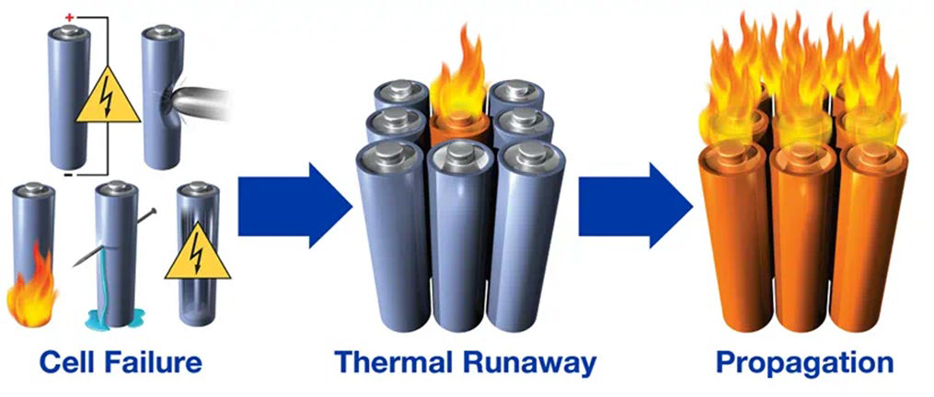
- Hydrogen (30%-50%)

Figure 1: Diagram depicting a cascading thermal runaway event.
- Carbon monoxide (CO)
- Hydrogen fluoride (HF)
- Hydrogen chloride (HCl)
- Hydrogen cyanide (HCN)
- Phosphoryl fluoride (POF3)
- Organic solvent droplets
- Ethane, methane, and other hydrocarbons

Burned or damaged batteries are unpredictable and cannot be considered fully discharged or free of hazards. Reignition from propagation or thermal insult to other cells within a battery is common and can occur 30 to 90 days from an initial thermal runaway event. During transportation, extreme temperatures and mechanical damage (such as puncturing or jostling) can trigger additional thermal runaway events. Batteries, groups of cells, or individual cells that have suffered significant fire damage may be present as a mass of melted or consumed material that

must be evaluated by the Electric Vehicle Task Force to determine if the article has the remaining potential to be a functional cell or battery. When in doubt, the fire damaged article(s) in question must be rendered safe by the Electric Vehicle Task Force (eliminate the hazard) to effectively manage any risks associated with potential future steps, such as: local ground movement/transportation, disposal or remediation, and long-distance carriage by ground, shipping vessel, etc.

NOTE: When a lithium-ion battery is about to undergo thermal runaway, the following may be observed: bulging, cracking, hissing, popping sounds, leaking, rising temperature, and white smoke. The entirety of this process typically occurs within 3-5 seconds.
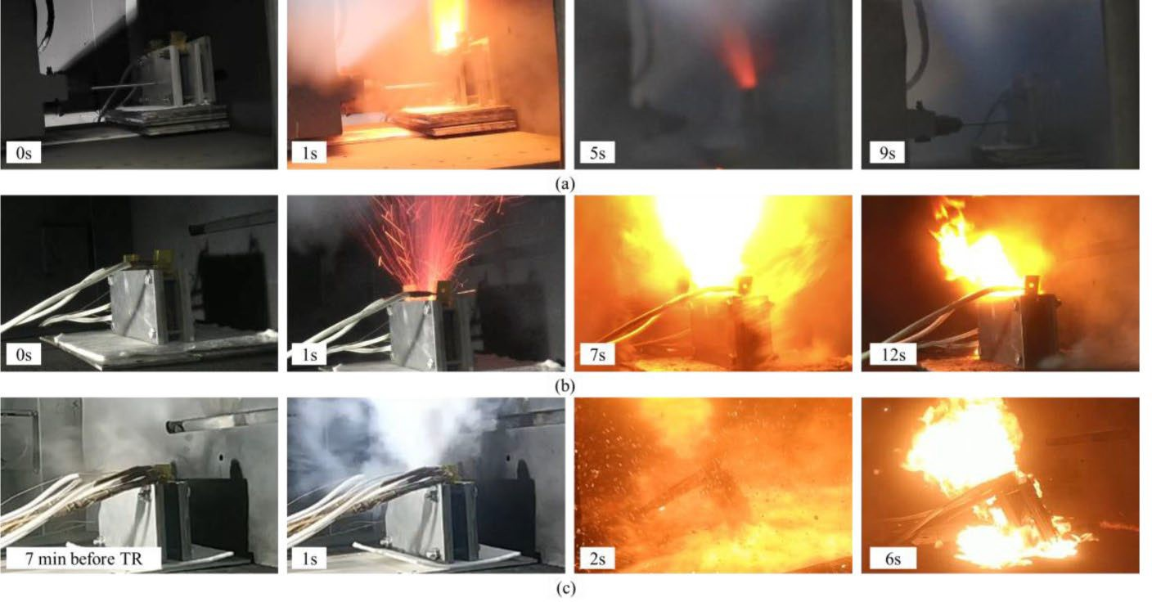
Figure 2: Several views of the stages of lithium-ion batteries in thermal runaway conditions.

EMERGENCY PROCEDURES:

If any of the conditions listed above are observed or if there is a suspected lithium-ion fire event, STOP all work, and quickly evacuate all personnel at least 330 feet in all directions (per PHMSA's 2020 Emergency Response Guidebook’s Guide 147 for lithium-ion batteries large spills).
Do not attempt to extinguish the fire. Water and other smothering agents will not stop the oxidizing chemical reaction. Once in a safe location, contact the local fire department and then Incident Command. Preservation of surrounding areas and materials from any fire may be performed, if safe to do so at an up-wind location.

LITHIUM-ION BATTERY HANDLING AND TRANSPORT
If a household hazardous waste (HHW) collection team encounters a suspected damaged electric or hybrid vehicle¹ (EV) no field team member should touch or disturb the vehicle. Suspected EV/HVs should be annotated in the field logbook and the appropriate Task Force Leader (TFL) should be notified. The TFL will notify the EV Task Force of the location of the vehicle. A dedicated EV Reconnaissance Team will be deployed to assess the vehicle. If it is identified as an EV, a blue lightning bolt will be painted on the sides of the vehicle or on the windows with a grease pencil, depending on the condition of the vehicle. Refer to the Standard Operating Procedure (SOP) for EV Reconnaissance 2023 Maui Wildfire Response for additional details of recon activities.

LITHIUM-ION BATTERY IDENTIFICATION
Lithium-ion batteries can come in different sizes and structures. Technology is constantly evolving the shape, chemistry and power of batteries. The most common lithium-ion batteries that may be encountered include:
- Cylindrical cells (18650 or 2170): The most common battery in micromobility devices (scooters, e-bikes, etc.) are cylindrical batteries. EVs commonly use batteries made up of thousands (5,000+) of cylindrical cells in a series, depending on the make, model, year and option. While some vehicles, specifically Tesla models, will be found primarily with cylindrical cells, other vehicle manufactures use battery technology held in prismatic formation.
- Prismatic cells: Rectangular in shape and larger than the cylindrical cell. These can be found in electric and some hybrid vehicles and hold more charge than a cylindrical cell. Vehicle manufactures tend to place prismatic cells in sequence, held in a sturdy case typically on the bottom of the vehicle chassis. Depending on the vehicle and amount of damage received, these cases may be largely intact.
- Pouch cells: Commonly used in computers and cell phones, however some vehicle manufactures have started using pouch cells to complement existing power or to fully power the vehicle.

¹ For the purposes of this document, hybrid vehicles will be consolidated with electric vehicles and the universe will be identified as EV. While this document focuses on lithium-ion batteries from energy storage systems and fully electric vehicles, hybrid vehicles are also included since it is unknown if the technology of the vehicle is using lithium-ion batteries, nickel metal hydride (NiMH) or a combination. NiMH batteries should also be collected in a similar fashion as lithium-ion batteries.

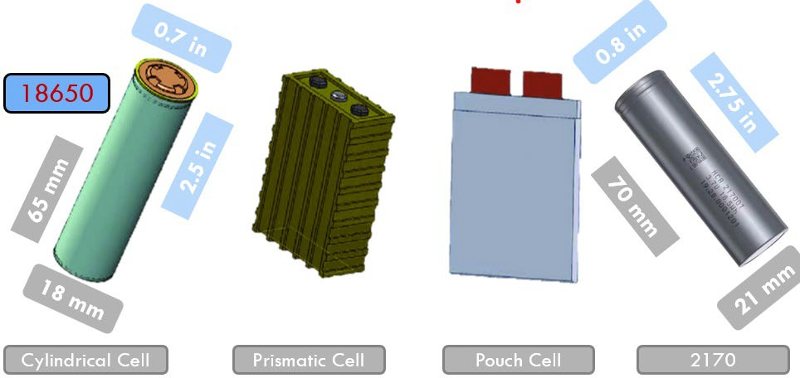
Figure 3: Depiction of lithium-ion battery types.
The different types of lithium-ion batteries depicted in Figure 3 come with pros and cons with regard to stabilization, compartmentalization, and resistance to physical damages. However, these batteries behave similarly during a thermal runaway fire and appropriate precautions should be taken no matter the battery type.
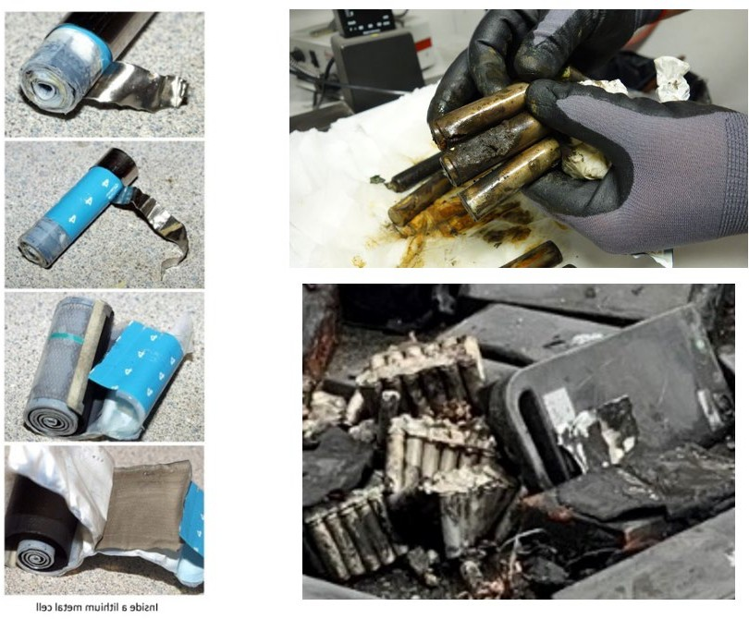
Figure 4: (Left) Lithium metal battery cell (not a lithium-ion battery) depicting a rolled- up strip of lithium metal; (Upper right) burned 18650 cells; (bottom right) fire-damaged cylindrical cells.

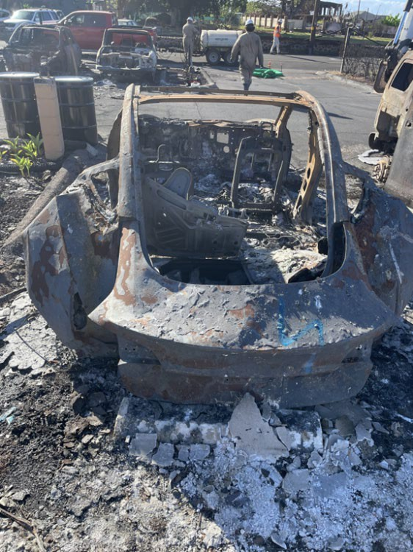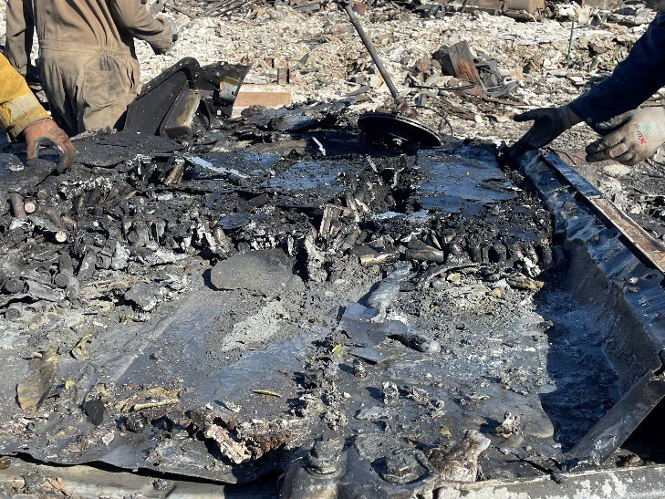
Figure 5: Tesla vehicle damaged by fire (left) and battery pack undercarriage with cylinder cells being harvested. While the battery pack may still be fully intact, the cells may damaged and present a risk of thermal runaway and propagation.
As different vehicles utilize different battery technologies, it is sometime unpredictable on the battery structure one may encounter. Resources, such as pulling the VIN and license plate number and searching online applications, may tell of the vehicle status as an EV. Further, analyzing the vehicle through the National Fire Protection Association (NFPA) Emergency Response Guides may assist in determining battery technology.
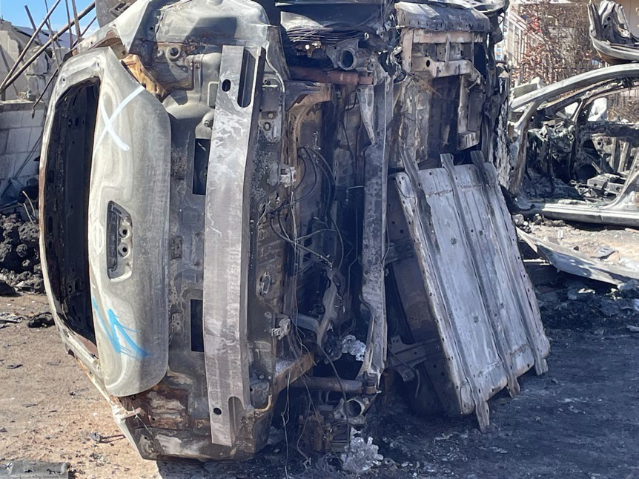
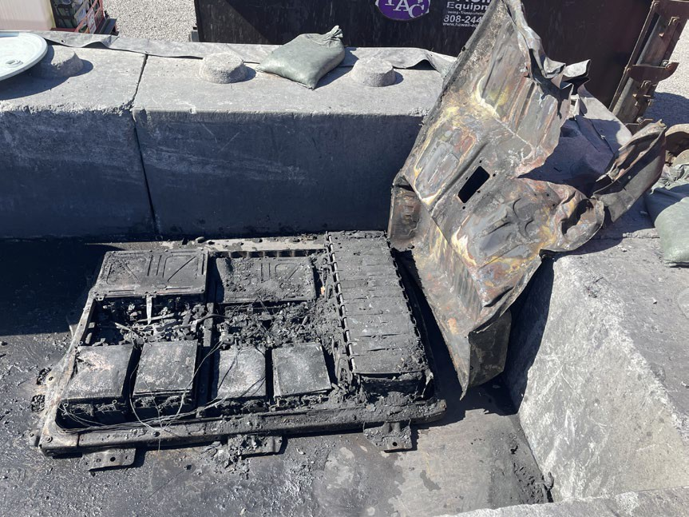
Figure 6: Nissan Leaf electric vehicle with prismatic battery cell technology.

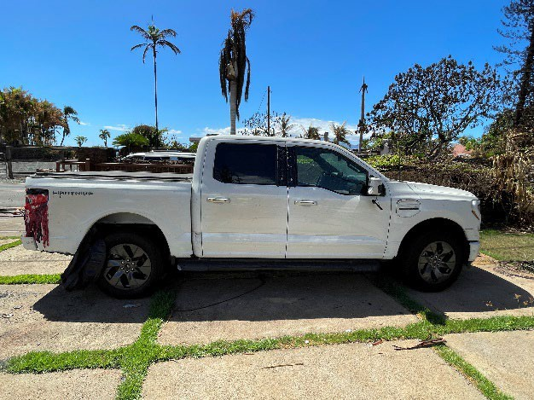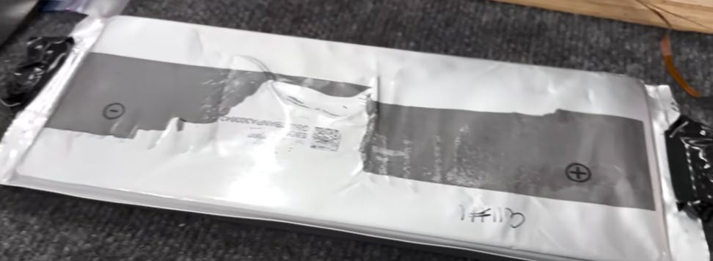
Figure 7: Pouch cell technology has also been identified in use of Ford electric vehicles, such as the Lightning truck model.

ELECTRIC VEHICLE TASK FORCE
An Electric Vehicle Task Force has been established at the 2023 Maui Fire Response specifically to handle High Voltage Batteries, such as lithium-ion batteries and nickel metal hydride (NiMH) batteries from EVs. This task force will be trained on how to safely identify and handle electric vehicles and lithium-ion batteries and will conduct all lithium-ion battery identification, removal, collection, processing, packaging and disposal. The task force will be made up of an EV Recon Team, EV Recovery Team, Battery Processing/Staging Area and will consist of an EPA OSC and/or a Lithium Battery Subject Matter Expert (SME), a qualified electrician, and personnel from Emergency and Rapid Response Services (ERRS) and Superfund Technical Assessment and Response Team (START) as well as an electrician. Once the EV Recon Team has identified an Electric Vehicle, the EV Recovery Team will deploy and conduct the following steps:

- Confirm locations, conditions, and types of electric vehicles including: manufacturer, model, year, hybrid or full electric, additional hazards (trees, etc), and fully burned, insulted, or partially burned.

Considerations for the removal of high voltage batteries from EVs:

  - Safety and site access control options in the exclusion zone for operations when handling electric vehicle batteries,
  - Proximity to bodies of water and unburned structures,
  - Defensive countermeasures for containment of firefighting water,
  - Performance of operations in Lahaina Town footprint vs. off-scene staging area (evaluating risk to exposure),
  - Rough handling risks to EV battery,
  - Risk assessment of on-scene disassembly vs. off-scene disassembly,
  - High voltage electrical hazard assessment and mitigation,
  - Movement of vehicle chassis with EV battery,

  - Safety – Exposure during populated re-entry or Phase 2 vs. removal area and Task Force crew,
  - Workflow efficiency,
  - Access to brine in the field vs. in staging area,
  - Transport vehicle/roll-off availabilities, capabilities and limitations,
  - Containment of hazards, particularly loose battery cells or pouches,
  - Overall risk = hazards X exposure,
  - Forward staging area in Lahaina Town footprint.

- Conduct tailgate safety meeting, establish upwind emergency egress and muster point, assign roles to all personnel. Responsibilities include entry and battery extraction, documentation personnel, support personnel for air monitoring and temperature checking, fire hose operator, heavy equipment operator, electrician, and spotters.

- Entry and support personnel don personal protective equipment (PPE) – including fire resistant clothing, half-face or full-face respirator with acid gas cartridges, hard hat, safety goggles, steel toed boots and protective gloves (leather gloves over nitile). Charge fire hose assembly (a minimum of 1 hose line with 10-40 gallons per minute [GPM] target flow charged) and have fire hose operator stand-ready.
  - Note: if battery condition indicates the possibility of intact cells, the task force will upgrade to the appropriate level of PPE specified in the Site HASP, including Level B PPE with full-face respirators, SCBAs, and fire-resistant clothing.

- The electrician and support personnel enter and confirm batteries are not energized, inspects the battery temperature and cuts any wiring. Thermal imaging is recommended, if available. Over time, it has been found that those vehicle batteries which are completely thermally insulted do not elevated in temperature when handled for removal, however temperature checks should be perform periodically to ensure that a thermal runaway is not evident.

- Air monitoring with a multi-gas meter should be performed around the battery casing to determine if any off-gassing or release of toxic vapors is occuring.

- Options for addressing EVs include whole vehicle transport to a staging area for battery removal, separation of the battery from an EV at the point of origin, separation of the battery from as much of the frame of the vehicle as possible, and collection of any individual battery cells which were loose and became separated from the battery casing.

  - Option 1 – Vehicle Transport

    - Personnel = EPA OSC, START, ERRS (1 Operator, 1 Truck Driver, 2-3 Laborers, and 1 Electrician).
    - PPE = Flame Retardant Clothing and Level C
    - Tools, Equipment, Supplies = General, Heavy Equipment (Excavator or Telehandler), Cribbing
    - Safety Measures = Water Source, Fire Blanket, and Fire Appliances
    - Lift Vehicle In/On Transport Vehicle, Trailer, or Roll-off Container

  - Option 2 – Separation of high voltage battery from EV for transport
    - Personnel = EPA OSC, START, ERRS (1 Operator, 1 Truck Driver, 3-4 Laborers, and 1 Electrician).
    - PPE = Flame Retardant Clothing and Level B & C
    - Tools, Equipment, Supplies = General, Heavy Equipment (Excavator or Telehandler), Cribbing, Extrication Tools
    - Safety Measures = Water Source, Fire Blanket, Tyvek Wrapping, and Fire Appliances
    - Lift High Voltage Battery In/On Transport Vehicle, Trailer, or Roll-off Container

  - Option 3 – Separation of high voltage battery and portion of vehicle chassis for transport
    - Personnel = EPA OSC, START, ERRS (1 Operator, 1 Truck Driver, 3-4 Laborers, and 1 Electrician).
    - PPE = Flame Retardant Clothing and Level B & C
    - Tools, Equipment, Supplies = General, Heavy Equipment (Excavator or Telehandler), Cribbing
    - Safety Measures = Water Source, Fire Blanket, Tyvek Wrapping, and Fire
    - Lift High Voltage Battery and Chassis In/On Transport Vehicle, Trailer, or Roll-off Container

  - Option 4 – Collection of loose batteries that have separated from case
    - Personnel = EPA OSC, START, ERRS (1 Operator, 2 Laborers).
    - PPE = Flame Retardant Clothing and Level C
    - Tools, Equipment, Supplies = General, Heavy Equipment
    - Safety Measures = Water Source
    - Place Material into Metal Container

- Material and Supplies List
  - Roll-off Containers 40yd and/or 30yd
  - Trench Boxes

  - Eco Blocks
  - Liner (Eco Products Maui)
  - Visqueen
  - Shovels
  - Hoe-Ram for Excavator
  - Flashing Tape (6 inch)
  - Roof Underlayment
  - Backer Rod
  - Sawsalls
  - Auto Spreader and Cutter
  - Angle Grinder
  - 4X4 Cribbing
  - 2X4 and 2X6 Wedges
  - Expanded Metal
  - Cable (Fire Wire)
  - Sledge Hammer, Slam Bar
  - Long Handle Electrician Cutters
  - Electrician Insulated Gloves
  - Straps
  - Wood Baffles for Roll-off
  - Tyvek, Tape, Fire Blankets, and Tarps
  - Delineators and Scene Tape
  - Galvanized Pipe with Fittings and Nozzles
  - Water Supply Apparatus

- Refer to the Standard Operating Procedure for Removal of Lithium-Ion and Nickel Metal Hydride Batteries from EVs 2023 Maui Wildfire for procedures on battery removal operations utilized for this response.

- Prepare collection site for the “Lau Lau” battery wrapping process (see Figure 8):
  - Place a protective tarp on the ground or on the bed of the truck/trailer, as applicable.
  - Place several pieces of mule tape (also referred to as electrical conduit pull tape) with slip knot on the tarp for a tie off, as necessary.
  - Place the fire blanket on top of the mule tape.
  - Place a piece of Tyvek house wrap on top of the fire blanket.
  - Place weights to keep the wrap materials from being blown by the wind and in place.

- Identify the battery, if possible. Review technical reference guides provided by the manufacturer to gain an understanding of the type of battery present, options for removal and hazards associated with the specificity of the vehicle.

- Manipulate the vehicle to expose the battery casing or the batteries themselves. This may require heavy equipment.

- Render the vehicle safe. Utilizing the electrician, check to ensure the batteries are not energized. Using a temperature gun or thermal camera will aid in determining if heat is increasing; a sign that a thermal runaway or other reaction may be occuring. If smoke or an increase in temperature is observed, refer to the Emergency Procedures in Section 2.1 of this document.

- Recover the individual batteries or battery casing containing batteries. Using heavy equipment or power tools, attempts to maintain the integrity of the battery casing should be performed. If the battery case can be recovered without spilling batteries onto the ground, this would be the preferred method. If extraction requires a more aggressive approach, the casing should be handled in a manner as to not lose contents. Using shovels, loose battery cells and prismatics should be collected and containerized in 55- gallon steel drums for transport to the staging area. Poly drums should not be used as steel drums will hold integrity longer in case of a fire.

- Move intact battery casing onto a prepared “Lua Lau” collection wrap (see Figure 8). Remove mechanical assist rigging. Wrap the battery with Tyvek house wrap and tape to secure. Use tape to label the battery with the Assessor’s Parcel Number (APN) of the battery location along with battery type (li-ion or NiMH) and vehicle type. Wrap with the fire blanket and secure the wrap with the mule tape as needed.
  - Note: if the condition of the battery indicates the possibility of intact cells, label the Tyvek house wrap with red tape or red paint to assist with handling at the staging area.

- If the battery was wrapped on the ground, use lift straps and 4 personnel to move the wrapped battery onto the transport trailer. If the battery was wrapped on the trailer, use lift straps and 4 personnel to move the wrapped battery to the appropriate position for transport. Alternatively, heavy equipment may be used to move the battery case onto the transport trailer. Secure the wrapped batteries to the trailer.

Caution: Do not puncture, break, tear, or force open any lithium-ion batteries or battery packs. Doing so can initiate a thermal runaway or violent reaction scenario.

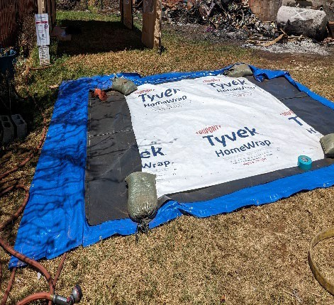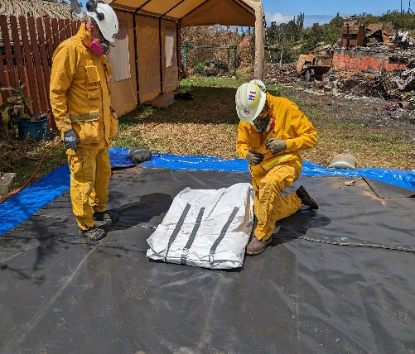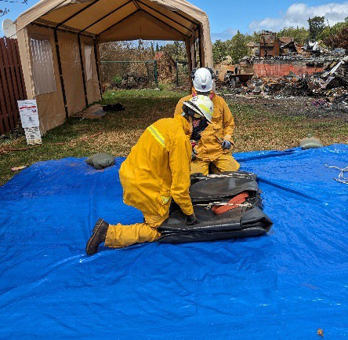
Figure 8: “Lau Lau” wrapping process as described above.

Loading and Transport to Staging Area
Batteries need to be packaged properly for transport to the staging area and handled with care to prevent mechanical damage (such as puncturing or jostling during transport) that would lead to thermal runaway. The local fire department must be notified before starting the operation. The following should be considered to help prevent a cascading thermal runaway event during transport to the staging area:
      - Small lithium-ion batteries should be transported in a drum packed with cell block (see Figure 9) to prevent a cascading thermal runaway in transport to the staging area.
      - Battery casings should be loaded directly into a dump truck or metal trailer and “Lau Lau” packaged covered with a fire blanket to help contain a thermal runaway event during transport. Battery casings should not be stacked or torn apart during handling or loading. As possible, a few large battery casings should be loaded, without stacking, onto one truck for transportation. A priority should be placed on transporting items to the battery staging area before picking up additional loads.
      - The Battery Task Force will transport only EV batteries (including NiMH) to the staging area and should not simultaneously transport any other HHW such as lead-acid batteries, flammable compressed gas cylinders or other flammable materials.
      - Travel as a caravan (with flashers on) to transport the batteries to the staging area. Caravan order:
        - Battery transport vehicle
        - Water buffalo vehicle as spotter
        - Other responder vehicles
        - Any other vehicles
      - Maintain radio communications with all team members and vehicles during transport to the staging area.

If a battery ignites during transport, the transport vehicle will pull over onto the road shoulder, where safe and exit the vehicle. The situation will be assessed to determine the response and local emergency services will be called immediately. If the event is small enough to be contained, the water vehicle will provide defensive firefighting support to prevent spread to other non-battery items as much as possible. If the event is significant, all parties will muster upwind and await arrival of emergency services.

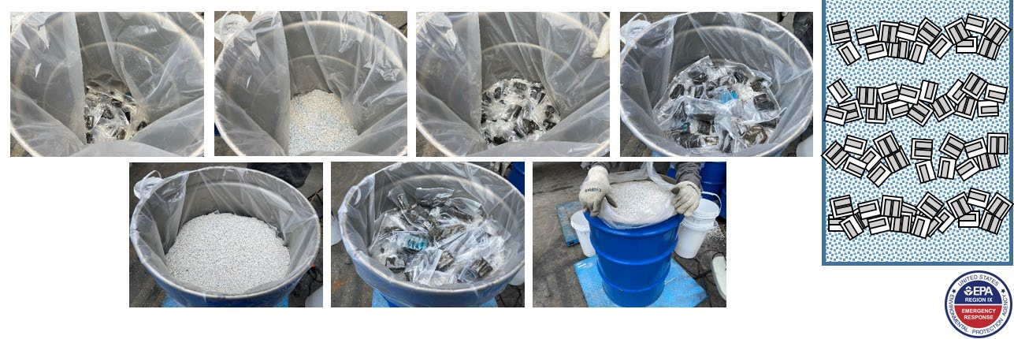
Figure 9: Small lithium-ion batteries can be transported according to Department of Transportation (DOT) Special Permit-16532 in a regular drum with cell block packing materials.

LITHIUM-ION BATTERY STAGING AREA REQUIREMENTS

- Recon and technical reference items of concern to confirm process: photos.
- Investigate to determine probability of stranded energy.
- Processing site selection and management is completed including but not limited to:
  - State approved permit to perform processing with requested oversight.
  - Selection of site.
  - Pre-Sampling
  - Build out site with BMPs/hierarchy of controls including secondary containment.
  - Site specific AHA/JHA and HASP
  - SOP
  - Appropriate Hazwoper trained/certified personnel, equipment, PPE and decon:
    - Li-Ion Battery SME; Environmental/T&D; Heavy Equipment Operator(s); Technicians; experienced AC/DC/BESS/EV/PV Electrician.
    - Level C with FR and/or SFR coveralls as appropriate; half or full-face respirator with acid gas cartridges; eye pro; under gloves, nitrile; over gloves-cut resistant; rubber or other safety boots.
    - Decontamination area with equipment/supplies.
  - Notifications (Local, State, Federal) as necessary and best practice.
  - Profile(s) for material and disposal/recycling discharge approval as required:
    - Not batteries which are not a regulated material or hazardous waste under 49 CFR or 40 CFR.
    - Brine water
    - Brined material sludge
    - PPE
    - Scrap metal for recycling (crushed drums, BESS casings).
    - E-waste (wires and intact BESS electrical components).
    - Other
  - Shipping paperwork.
  - Other.
- Stranded energy or low potential for stranded energy:
  - If stranded energy is suspected in a particular BESS, the brining process will be utilized prior to destructive harvesting and crushing of battery chemistry. (For BESS):
    - Electrician will assess the BESS and remove the upper tunnel components.
    - Ventilation plugs will be removed and adhesive seal will be failed to allow brine solution to freely enter the BESS when submerged into brine.
    - Brine (5% sodium chloride and 5% sodium bicarbonate in fresh water, “Duke Sauce”).
    - Rope, cinch strap, or other rigging will be utilized to control BESS during placement and removal from brine container.
    - After a minimum of 72 hours of submersion in the brine solution the BESS may be removed for further stranded energy evaluation and destructive processing.
    - At any point in the process, if stranded energy is still suspected or of concern the BESS or individual battery cell material may be placed back into the brine solution via direct loading or “fry basket”.
  - If stranded energy potential is low or non-existent due to fire impacts upon a particular BESS, the brining process may not be necessary/utilized prior to destructive harvesting and crushing of battery chemistry:
    - Destructive processing may begin, utilizing heavy equipment such as a mini excavator and drum roller on specially designed processing pads that ensures the containment of solid material and liquids used as engineering controls.
    - A portable water tank with pump that can support 1.5” hose water flows and garden hose flows, shall be utilized as an engineering control for dust and heat.
- During and after battery cell material is removed from the BESS housing:
  - Methods for destructive removal of battery cells, direct destructive processing, or after brining destructive processing are intended to present and manage the cell material in such a way as to prevent, eliminate, limit, or control thermal runaway events that would produce fire conditions and the release of expected smoke, gases, particulates.
  - Cells material shall be placed in lined drums with bungs removed and the ring bolt managed to allow for safe movement of drum(s) to crushing pad area.
  - Upon staging at crushing pad area for storage or processing, the ring bolt shall be loosened or removed so as the drum lid can be easily removed.
  - Destructive crushing commences via excavator bucket or drum roller with appropriate volume and finishing of cell material.
  - Finished not battery cell material shall be placed into lined drums with bungs removed and ring bolt loosened or removed so as the drum lid can be easily removed.
  - Not battery material in the drum(s) shall be assessed for a minimum duration of 24 hours prior to final transport.
- Site processing area/equipment and material in raw form or processed in drums shall be managed for containment concerning inclement weather conditions or other hazardous conditions.
- Approved transportation and disposal/recycling movement plan commences.
- Site is decommissioned and repeat and biased post sampling is conducted.
- Final approval to demobilize the site is received from the State.
- After action review recommended.
- Review and utilization of any or all current/updated EPA Li-ion battery SOPs is encouraged/expected to provide guidance on the particular details to conduct this type specific or overall BESS render safe and disposal/recycling operation.
- EPA Region 9 encourages and will be available for reach back for technical reference and technical support.

Damaged lithium-ion batteries should be stored a safe distance (minimum 330 feet according to ERG Guide 147 evacuation requirements for large spills) from other hazardous materials, and/or the general public. Ideally, a separate lithium-ion battery staging area will be identified to allow sufficient operating distance to prevent propagation during a cascading thermal runaway and subsequent release of toxic vapors. It is suggested that the appropriate Fire Department tour the staging area and provide input on the storage locations of damaged lithium-ion batteries.
The following should be taken into consideration when choosing an appropriate staging area:
- Safe ingress/egress for workers and emergency services should be implemented so that in the event an of an emergency, workers can evacuate quickly and firefighting resources will have the space needed to respond.
- Distance from residents, schools, houses of worship, cultural sensitivities, businesses, and vegetation.
- Work should be conducted in a well-ventilated area, preferably outdoors.
- A staging area should allow ample space to separate batteries from each other to prevent propagation during an emergency.
- A security guard should be posted during off hours to prevent access to the site and notify the Fire Department in case of emergency or fire when no other parties are on- site.
- Monitor battery temperature periodically throughout the day. It is theorized that 140°F (60°C) is the critical temperature, above which lithium-ion batteries are prone to failure. Unmanned aerial systems (UAS) thermal imaging should be considered.
- Conduct perimeter air monitoring several times during the day using particulate and 5-gas meter units (X-Site, MultiRAE, AreaRAE, DustTrak).
- Conduct worker air monitoring using 5 gas (MultiRAE, X-Site) and toxic vapor meters (SPM Flex with acid gas Chemcassette® tape).
- Move the batteries to the designated storage containment area and begin unloading. For the batteries:

  - Remove the straps
  - Unwrap the fire blanket
  - Move the battery into an upright position
  - Cut an X in the Tyvek house wrap at each end of the tunnel
  - Insert the mechanical assist rigging
  - Use mini excavator to move the battery pack to the containment area
  - Remove the mechanical assist assembly
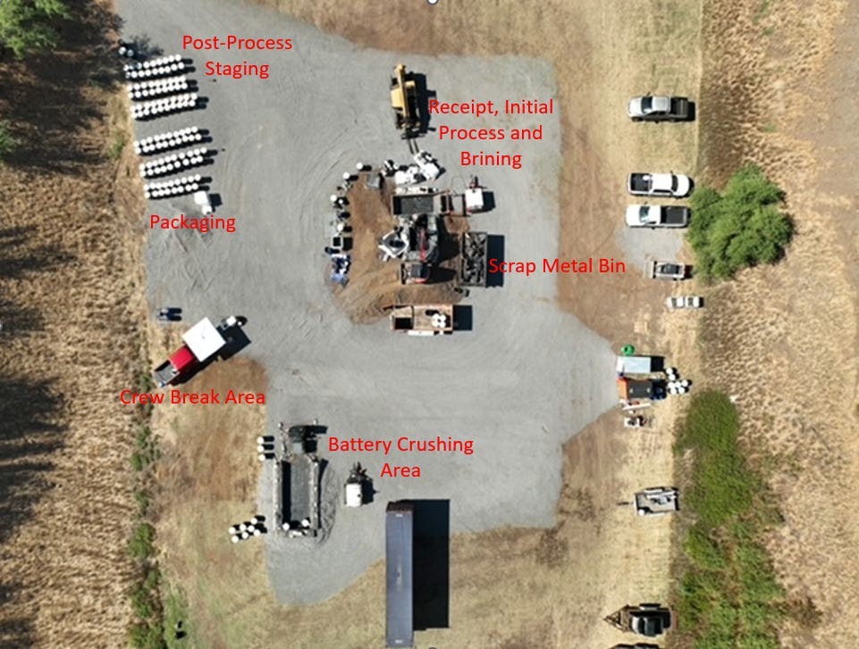
Figure 10: Example of a lithium-ion battery staging area with processing area, de-energizing baths/brining, battery crusher, staging and packaging areas.

LITHIUM-ION BATTERY DECONSTRUCTION
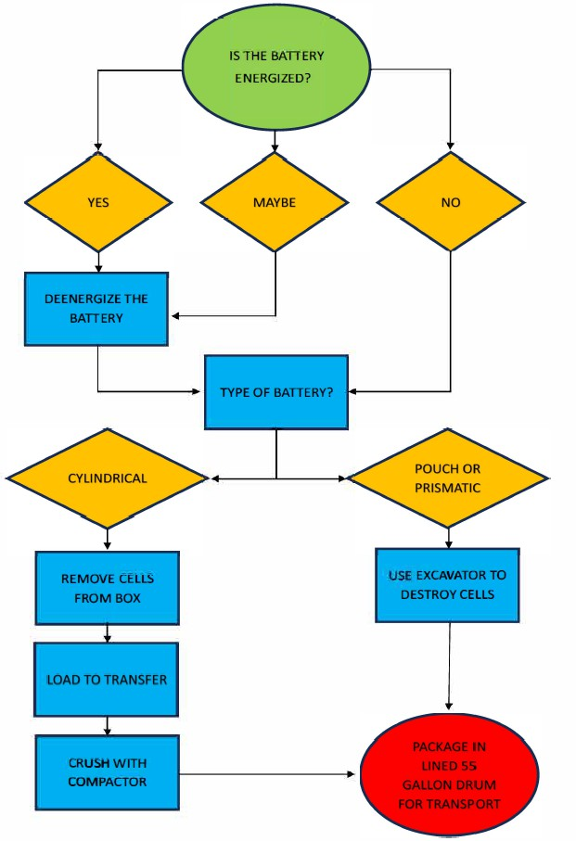

BATTERY DE-ENERGIZING OPERATIONS

Battery pack and individual batteries brought to the staging area should be evaluated for the potential that the battery cells are intact and energized. Err on the side of caution and de-energize battery systems unless it obvious that the cells are not energized (heavy damage and burning on the outside of the battery casing may indicate the internal cells are de-energized). The de- energizing process should last approximately three (NaCl) to seven days (bicarbonate), depending on the solution used. De-energized batteries that are cool to the touch should be tested at least 24 hours after treatment to ensure full discharge and should contain zero volts, or as close as possible before being shredded, crushed or packaged for transport and disposal/recycling.
De-energizing batteries can release toxic vapors such as HF, CO, Cl2, and HCl. Appropriate health and safety procedures (including donning appropriate PPE, respiratory protection, and air monitoring) according to the site Health and Safety Plan (HASP) should be implemented during these operations. Samples of the brine solution should be collected and analyzed for Toxic Characteristic Leaching Procedure (TCLP) Resource Conservation and Recovery Act (RCRA) metals prior to disposal.
Several brine solutions were created and tested as part of determining the best practice for de- energizing batteries. The most effective brine solution identified is made of 5% sodium chloride (NaCl) and 5% sodium bicarbonate (NaHCO₃) in 3 gallons of water. This solution showed to have rapid corrosion to the battery, lowering the voltage to below 1 volt and having minimal LEL vapors following processing (crushing)². At a minimum, allow the batteries to de-energize for 3 days the brine solution. Additional contact time may be necessary depending on the battery chemistry. Observations should be made to ensure the voltage of the batteries is lowering and if there is reaction continuing to occur, such as the release of hydrogen bubbles while in solution.
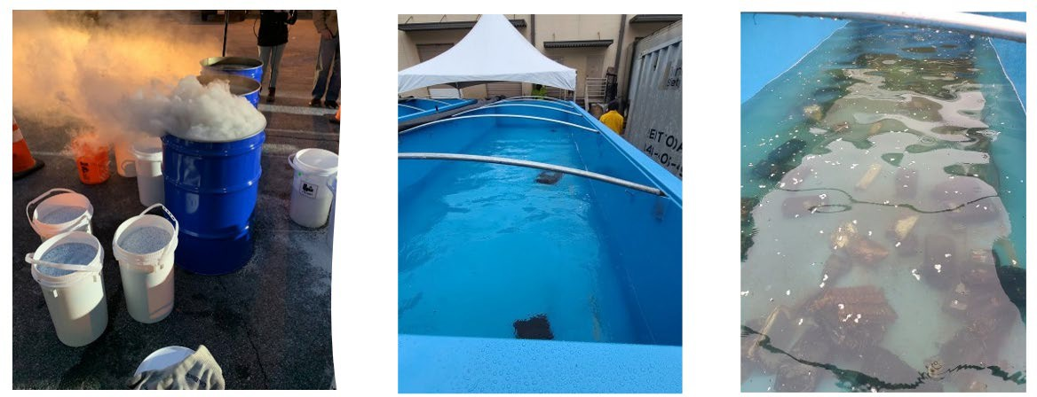
Figure 11: (Left) Small scale brining operations; (Center/Right) Large scale brining operations.

It should be noted that corrosion of the battery may occur while in contact with the brine solution. Leads may no longer be effective for measuring voltage based on the amount of

² Field tests were performed from September 2023 through November 2023 using various brine solutions and checking the effect on voltage. Refer to the DRAFT Effectiveness of Various Bicarbonate and Soldium Chlorine Brine Solutions to De-Energize Lithium-Ion Batteries for details on the tests.

corrosion. Further, corrosion should not be used as a single observation for determining is a battery has been rendered stable.

Cylindrical Cell De-Energization Process
If batteries are not already loose, remove them from the battery casing and inspect to determine if they are fully thermally insulted. For those that are fully thermally insulted, proceed to Section
  - of this document. Place all loose batteries in a perforated drum to dunk in a brine solution. If a perforated drum is not available, one can be created by cutting a poly drum and drilling holes towards the bottom of it.

5.1.2 Pouch and Prismatic Cell De-Energization
Loose pouch and prismatic cells can be placed directly in the brine solution. If they are contained in a larger outer box, you may need to open the box to ensure the brine can reach the appropriate battery terminals. It is best practice to use perforated drums (similar to a fry basket) to place materials in and safely lower the materials into a brine solution.
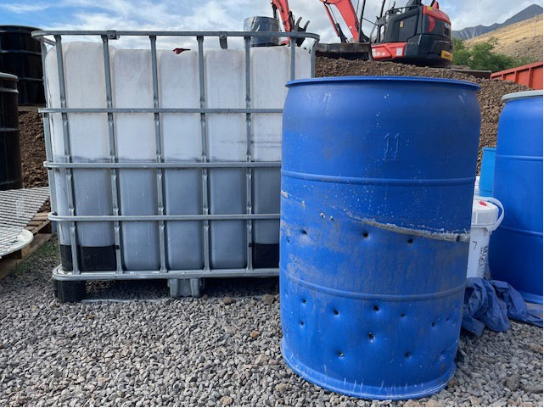
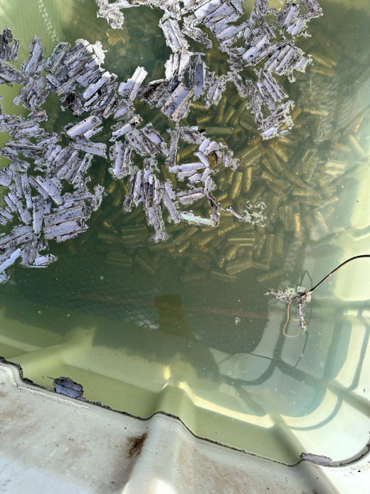
Figure 12: Brining options using a perforated drum (left) and tote (right).

BATTERY TERMINATION
If end-point recycling facilities are not an option or de-energized batteries cannot be transported, battery termination should be considered. Battery termination renders the cells no longer considered batteries³, allowing for easier shipping of the materials.

Battery termination operations will greatly increase the risk of thermal runaway, explosion, and release of toxic vapors. As such, appropriate health and safety procedures according to the site HASP should be implemented during these operations, including

³ Per EPA definition in 40 CFR 273.9 and DOT definition in 49 CFR 171.8

donning appropriate PPE, conducting air and temperature monitoring, and having clear and appropriate emergency procedures in place.

BATTERY SHREDDING
To terminate the batteries by the process of shredding, the batteries must be completely discharged, and the batteries must be shred to 0.5” or smaller pieces. Battery shredding is not an option on Maui, as the transport and purchase-point cost for a shredder exceeds the benefit-cost ratio.

BATTERY SMASHING
To terminate the batteries by smashing, the batteries must be completely discharged, and the batteries must be smashed until they are obviously failed (e.g. one end of the cylinder is no longer attached to the battery, the battery is split through the side, the battery is split in half, etc). The process of smashing pouch/prismatic will be done differently from cylindrical cells.
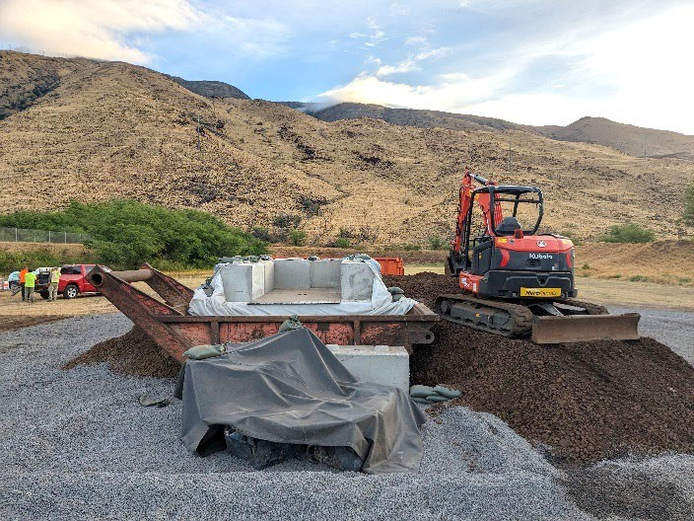
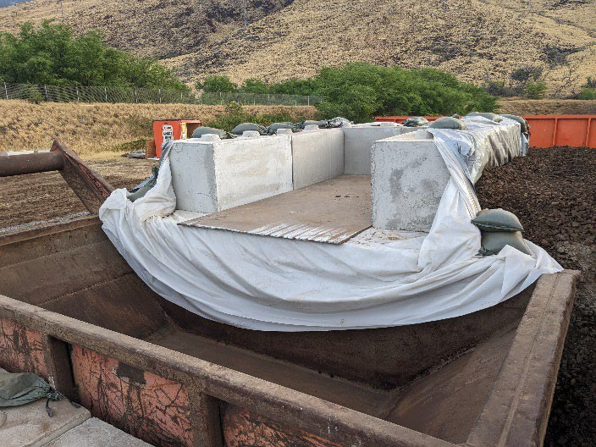
Figure 13: Battery termination setup where batteries are first processed to determine if de- energizing is necessary.

Cylindrical Cell Smashing
Cylindrical cells can be smashed using a smooth drum roller.
First use an excavator to remove the cells from the outer box. Cylindrical cells should be placed in a thin window (about the width of the shovel head or less) on the trench plate and rolled with the smooth drum roller. Unburned cells are best smashed with a 12-ton smooth drum roller. Due to the strength of the cells, adding too many cells will lead to only partial destruction of the cells making the process take much longer.

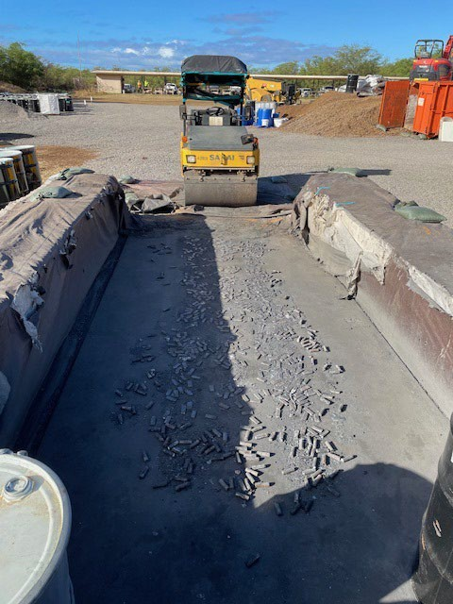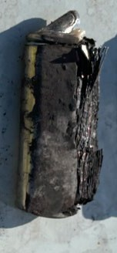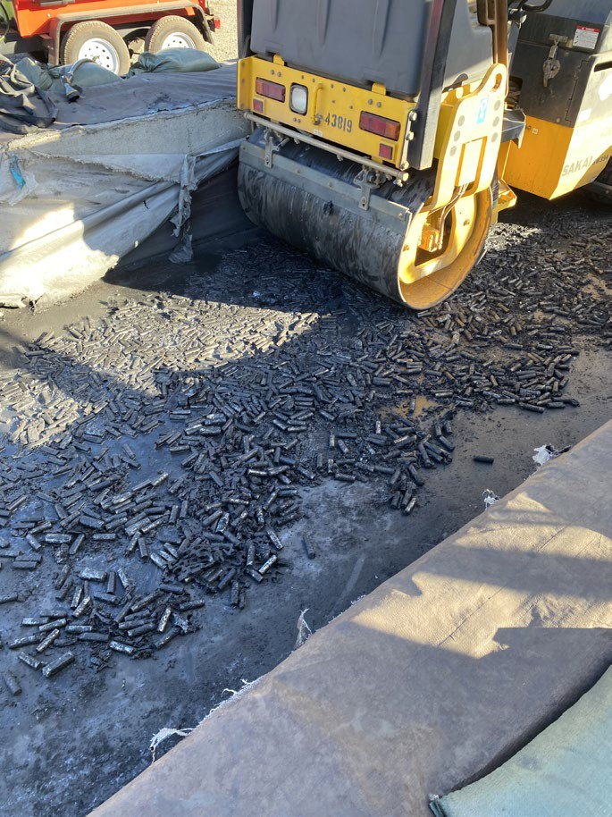
Figure 14: Using a drum roller to crush cylindrical batteries (left and right) and get to a final product for disposal (center).

Pouch and Prismatic Cell Smashing
Pouch and prismatic cells can be smashed using an excavator with a thumb. The excavator should be used to rip the batteries apart. Water may be applied during the process for dust control, however oversaturation of water is not recommended as it may contribute to potential issues.

LITHIUM-ION BATTERY PACKAGING FOR T&D
Batteries may be de-energized and converted into scrap metal by shredding or smashing (no longer batteries). This waste stream should be characterized as hazardous or non-hazardous waste based on TCLP sample results. Transportation and Disposal will be managed based on the waste profile that is generated.

De-energized batteries can be packaged and transported to end point recycling facilities according to DOT Special Permits 16532 and 21329, packaging instructions and transporters specifications. These permits require a submittal to DOT for approval and can take 7-90 days to be approved. Permits can be issued to individual companies, or they can be issued to a specific site. De-energized batteries should be characterized as hazardous or non-hazardous waste based on TCLP sample results. Transportation and disposal will be managed based on the waste profile that is generated.

EPA and contractors have been working with shipping and recycling facilities on appropriate packaging of post-processed materials. Since post-processed material has been shown to off-gas in sealed drums, potentially through the release of hydrogen gas, an appropriately ventilated container should be used. One option is to take a cubic yard box placed in a supersack. The

interior cubic yard box should have a thin gauge plastic bag that can be glued to the sides. To provide ventilation while attempting to keep water out, a sorbent pad can be rolled, inserted into the box and taped to the thin plastic liner to the rolled sorbent pad. These steps will allow for ventilation of crushed material to properly ventilate. If materials are placed in a sealed container, such as a drum, the air space may build up with flammable gas. Ensure that the box is not filled too high or exceed any weight restrictions.
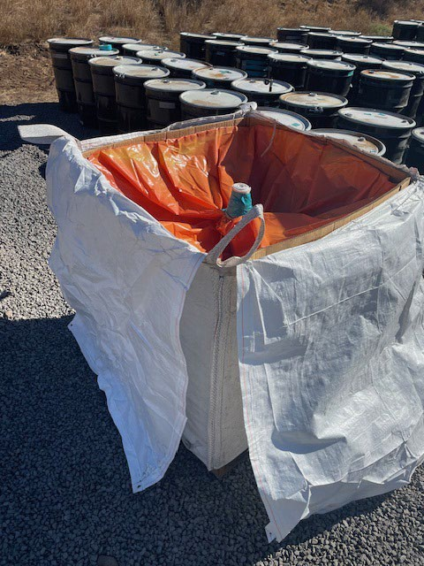
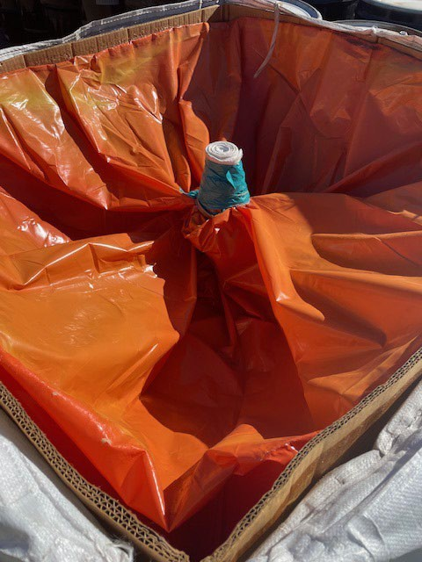
Figure 15: Cubic yard boxes with liners inserted into a supersack. A sorbent pad is tightly rolled and inserted in the middle of the box to provide for ventilation and protection from water intrusion.
An additional option for packaging material can include the use of 55-gallon drums. It is recommended to utilize steel drums in case of fire or reaction while in transport. Crushed material should be placed within an inner liner, consisting of a low-density gauge poly to allow for ventilation. The drum lid should be placed on the drum and properly secured. The 2” bung should be removed and replaced with a PVC angled fitting. The fitting will allow the interior space of the drum to ventilate while providing protection from water intrusion.

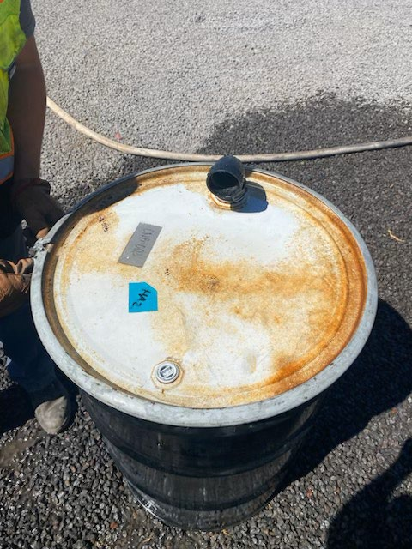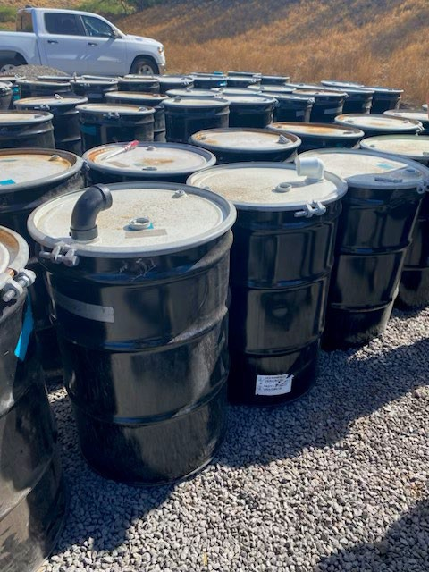
Figure 16: Using 55-gallon drums equipped with a ventilation snorkel can be used to safely store and transport material.
Containers, whether cubic yard boxes, 55-gallon drums or other appropriate containers should be placed in open top shipping containers, equipped with tarps. Containers (drums, boxes, etc.) should not be stacked on top of each other and no other materials, particularly household hazardous materials, should be carried in the same sea-land box. If possible, segregation of package type should also be performed. Shipping containers must be transported above deck to ensure additional ventilation of materials.
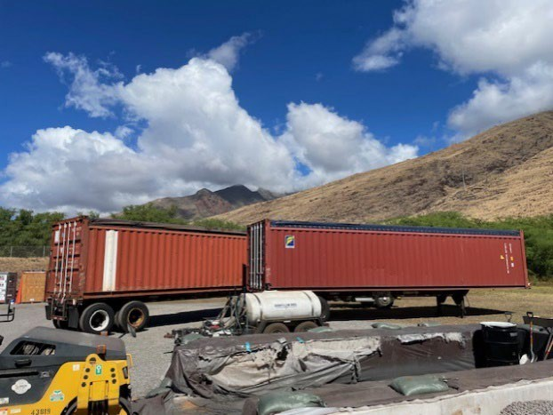
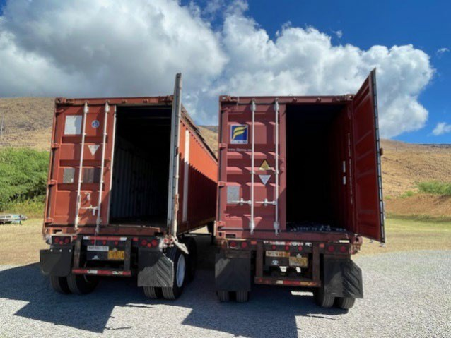
Figure 17: Transport containers that are open top with tarps. These should be placed above-deck when using barge or ship services.

CONCLUSION
Fire-impacted lithium-ion batteries are unpredictable and must be addressed with caution. This document provides guidelines in reducing hazards and protecting response personnel and the

public. While some of these techniques were developed in the field where limited resources were available, they were the best options available at the time. Practices developed in response to the 2023 Maui Wildfires should be built upon, further tested and improved.

The Aloha Spirit was instrumental to the successful operations at the 2023 Maui Wildfire Response.

SUPERFUND TECHNICAL ASSESSMENT RESPONSE TEAM STANDARD OPERATING PROCEDURE FOR RECONNAISSANCE OF ELECTRIC VEHICLES
2023 MAUI WILDFIRE RESPONSE OCTOBER 27, 2023

OBJECTIVE
This Standard Operating Procedure (SOP) describes the process to determine the presence and location of hybrid and electric vehicles (EVs) impacted by the 2023 Maui Wildfires. Identification of EVs in a burn zone is necessary to ensure the proper handling and recycling/disposal of lithium ion and nickel-metal hydride batteries. The objective is to identify and log all hydrid and EVs within the burn zone. This includes vehicles with partial or no visible impacts by fire since temperatures as low as 150 degrees fahrenheit can compromise the batteries. The purpose of the battery reconnaissance (recon) is to:
  - Understand the scope of the EV project and collect specific data in the site database which can then be queried for information;
  - Assist the battery recovery process;
  - Inform EPA’s discussions of the disposition of EVs with interested third parties such as owners, insurance companies, local police and city officials, local auto recovery companies;
  - Plan battery processing activities; and
  - Plan disposal/recycling of EV batteries.
The Battery Recon Team will be followed by the Battery Removal Team which will be responsible for assessing the condition of the vehicle and the battery, if the battery should be removed, or if the owner of the vehicle or insurance company should be contacted (e.g., if the vehicle appears not to be impacted). The Battery Recon Team will typically be made up of 2-3 START personnel with oversight by a Federal On-Scene Coordinator. The Battery Recon Team is part of the EV Task Force.

SUMMARY OF METHOD
Recon is done by a team of trained hazmat responders familiar with vehicle manufacturers, models, and mechanical and battery technology. Teams will survey burned areas looking for vehicles with either hybrid or all electric drivetrains. Once a vehicle is positively identified with hybrid or EV technology, it is marked physically with paint or grease pencil, with a blue colored lightning bolt (typically paint can be used on burned vehicles and the grease pencil on non-burned vehicles on the windshield or glass) and digitally entered into electronic field collection and mapping software (QuickCapture via Field Maps). Additional methodology can be found in the Maui

Wildfires 2023 Damaged Lithium-Ion Battery Management Guide for Electric Vehicles & Mobility Devices.

HEALTH & SAFETY
Qualified personnel should have completed adequate training to enter a disaster area, including HAZWOPER, OSHA, site-specific safety, and cultural training. Many hazards exist when performing reconnaissance of burned vehicles. Some of these hazards include sharp edges, broken glass, puncture hazards, structurally unsafe walls, beams, and roofs, high voltage hazards, toxic dust, compromised trees, heat/cold stress, and many more. The recommended PPE for this task is: long pants and shirt, hardhat, safety toe boots with steel shank, cut resistant gloves, eye protection, high visibility vests, and a dust mask or respirator. Higher level PPE such as Tyvek and boot covers is recommended when conditions require entry into ash footprints. Refer to the Health and Safety plan locate don the 2023 Maui Wildfires Teams page, Section 1.6 Safety Officer for additional precautions.

GENERAL RECON PROCEDURES
- Locate regions or areas of concern via mapping software, usually target areas will be conveyed via management or an operations lead. Locations of properties may also be supplied by other parties such as Maui County, self- assessment forms, Hotline calls, insurance companies, motor vehicle agencies, etc.

- Observe every vehicle in the area. Use clues to quickly eliminate certain vehicles from being potential EVs. For example, vehicles older than 20 years are unlikely to contain battery technology. Having a good understanding of manufacturers is key to identify possible EVs and hybrids. It can be challenging to identify burned vehicles. Observe the silhouette of the body to identify or narrow down the vehicle make and model. If a vehicle is suspected to be a possible EV or hybrid a closer look is needed.
- Mark the EV vehicle with an EV/hybrid identification mark. For this project, a blue lightning bolt should be painted on the driver and passenger doors, if no doors are present then mark on the front quarter panels and/or trunk and hood. If the vehicle is in the requested survey zone but little to no visible damage is present, do not mark the car with paint; rather use a blue grease pencil to mark the windshield with a blue lightning bolt. The recon team does not make the determination if a battery is to be removed, rather they solely identify the batteries in the area of concern and current conditions. Determination of battery removal processes, including applicability, will be determined by the Battery Removal Team.

- Log the EV into the parcel universe: Open Field Maps, select the “+” on the bottom right of the screen to access QuickCapture (do not open QuickCapture directly. Only enter data via Field Maps). Place the point as accurately as possible, take a photo, enter all available information (make, model, license plate, VIN), and select vehicle status. Status definitions are as follows:

  - Needs Assessment – a burned EV that has been identified but not yet processed by battery removal team
  - Complete – An EV that has been processed by the battery removal team
  - Deferred – An EV that cannot have its battery removed due to technical issues such as safe access
  - Archived – An EV that has been moved or removed (not by EPA) since marked as “Needs Assessment”; vehicle is no longer there
  - Follow Up Required – An EV that cannot have its battery removed without EPA leadership approval. Typically, EVs in the burn zone with minimal to no observed fire and/or heat damage.
  - Not In Universe – An EV that was not located, confirmed to not be an EV, or will not have its battery removed per EPA leadership.
Lists from various entities including County offices, local police departments, the National Insurance Crime Bureau, insurance representatives, and tow companies may be able to assist with identification of vehicles located in the burn areas. These lists can be used to contact owners, determine EV and hybrid vehicles, or QA/QC the reconnaissance operation.
EV and Hybrid Vehicle Identification Notes:
- Common EVs are the Tesla Model S, Tesla Model 3, Nissan Leaf, Chevy Bolt, Volkswagen ID.4, and numerous lithium-ion battery powered golf cart or recreational style vehicles.
- Common plug-in hybrid vehicles are the Chevy Volt, Kia Nero plug-in hybrid, Lexus NX plug-in, and Ford Escape plug-in hybrid.
- Common hybrid vehicles are the Toyota Prius, Toyota Rav-4 hybrid, Toyota Sienna hybrid, Honda Insight, Honda CRV hybrid, Subaru Crosstrek hybrid, Ford Escape hybrid, and Ford Fusion hybrid.
- Hybrid and fully electric vehicle batteries can be located in trunks, behind rear passenger seats, underneath driver and/or passenger seats, or located underneath the vehicle.

- A high voltage charge port in lieu of a fuel filler location will indicate a fully electric vehicle. Charge ports can be in the front of a vehicle, in front of the driver door in the front quarter panel, rear driver quarter panel, or rear passenger quarter panel. A vehicle with both a fuel filler location and a high voltage charge port will indicate a plug-in hybrid vehicle. Charge ports can be differentiated from fuel filler necks due to their high voltage cables and lack of a physical pipe running to a fuel tank.

- The absence of a gas motor can often be an indication of an electric vehicle. Check the rear of a vehicle as well, as some manufacturers install rear mounted gasoline engines. Even after a severe fire, a gasoline or diesel engine has distinguishing characteristics such as exhaust manifolds, catalytic converters, ignition coils, camshafts, and crankshafts. A full EV does not have these components. A hybrid vehicle will have those components. Further inspection of the transaxle is needed to identify the presence of an electric motor.

- Clues such as VIN number or a license plate can be used to search vehicle make/model/year online. Faxvin.com is a free license plate and VIN search tool. Many of the burned vehicles have no identification on them, so this step cannot be used. License plates fall to the ground when a composite or plastic bumper burns. If the insurance company has inspected the vehicle, they often write the VIN number on it.
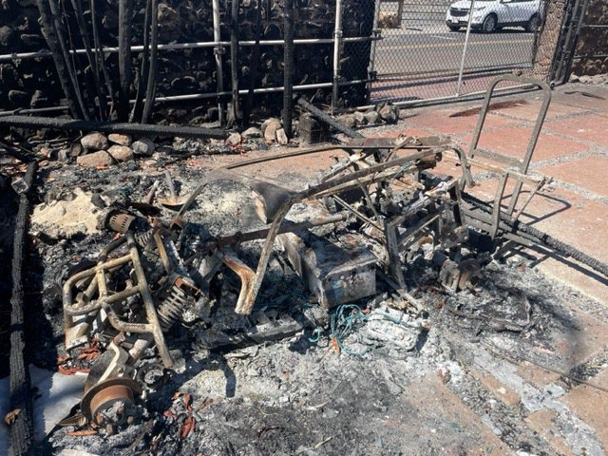
Electric Golf Cart with Lithium-Ion Battery Pack

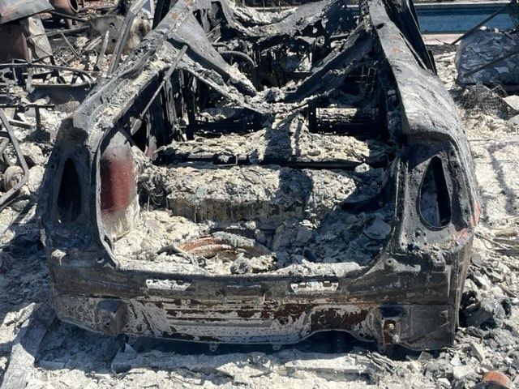
Toyota Prius battery pack located behind rear seat.

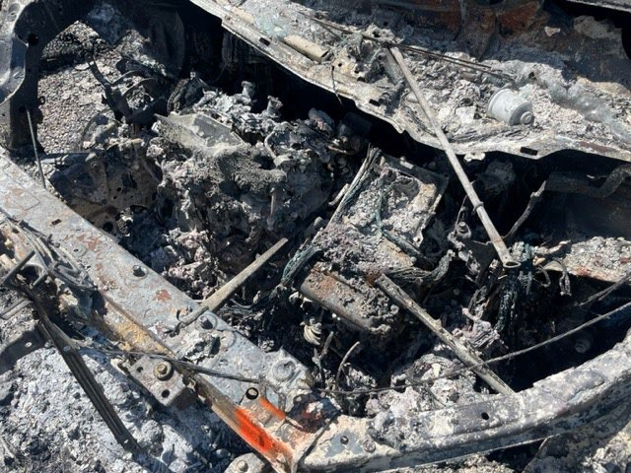
Toyota Sienna hybrid engine bay. Note electric motor components above transaxle coupled with typical 4- cylinder gasoline engine.

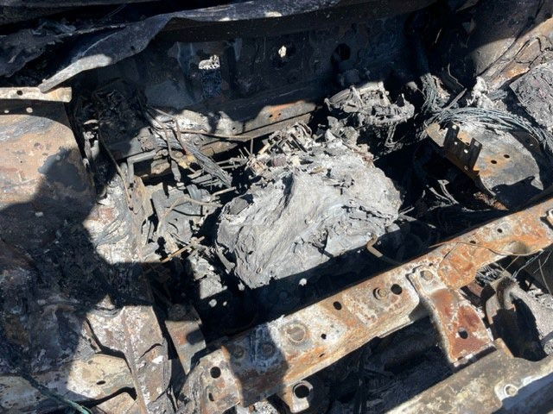
Nissan Leaf full electric vehicle engine bay. Note none of the components of a gasoline engine can be distinguished.

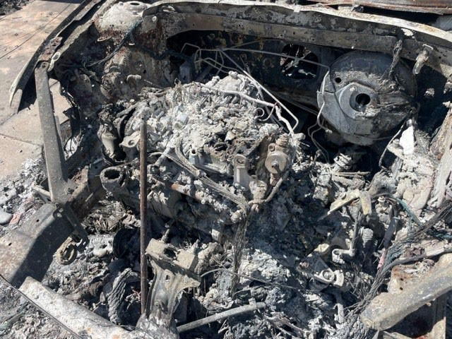
Volkswagen Golf Non-Hybrid Non-Electric engine bay.

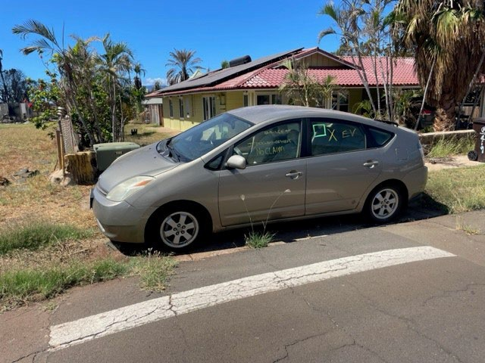
Toyota Prius with no visible burn evidence but located in survey zone. Note: plants and structures unburned nearby.

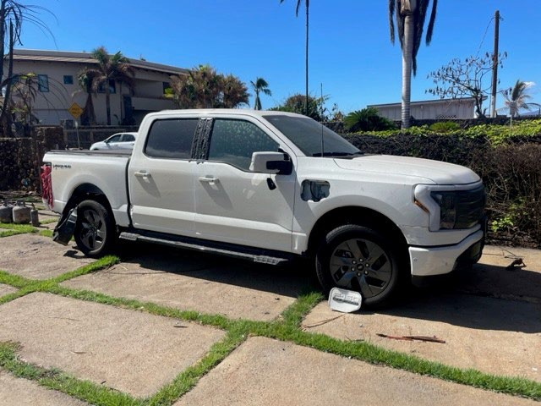
Ford F150 Lightning with visible heat damage. Taillights melted, wheel wells melted, discoloration of paint, plastic trim melted. Nearby structure fire.

Electrical Vehicle Status Guide
The entire universe of this doto set is electric vehicles identified by the EV Team.

@ Needs Assessment - An electric vehicle that has been identified, but not yet processed by removal team.

@complete -An electric vehicle that has had its battery recovered.

@Deferred-An electric vehicle that cannot have itsbattery removed by EPA due to technical issues, such as the inability to access the vehicle safely.

@Archived -An electric vehicle that has been moved since a "Needs Assessment" point was created.
@ Follow Up Required -An electric vehicle that cannot have its battery recovered without EPA leadership's decision.
® Not in Universe -After "Follow Up Required" resolution, an electric vehicle that will not have its battery recovered as decided by EPA leadership; or EV battery not found at location.

SUPERFUND TECHNICAL ASSESSMENT RESPONSE TEAM STANDARD OPERATING PROCEDURE FOR REMOVAL OF LITHIUM-ION AND NICKEL METAL HYDRIDE BATTERIES FROM ELECTRIC VEHICLES
2023 MAUI WILDFIRE RESPONSE

October 27, 2023

OBJECTIVE
This standard operating procedure (SOP) describes a set of general guidelines for the removal of batteries from hybrid and electric vehicles (EVs) impacted by the 2023 Maui Wildfires. This SOP also includes safety procedures for the removal and transportation of extracted batteries. The objective is to extract lithium-ion (Li-ion), nickel metal hydride, (NiMH) and other batteries used in EVs and transport them to a secure area where they may be stored and prepared for recycling or disposal. The handling of damaged Li-ion and NiMH batteries from thermally insulted and fire damaged vehicles presents significant hazards to response personnel and should be handled with extreme care. The EV Battery Removal Team generally consists of the following: Federal On-Scene Coordinator (OSC), START personnel, certified electrician, battery subject matter expert, heavy equipment operator, and 2-3 support team members (air monitoring, water hose operation, supply handler). The EV Battery Removal Team is part of the broader EV Task Force.
The purpose of this SOP is to outline field techniques for the safe removal and transportation of fire damaged Li-ion and NiMH batteries identified in the field. This SOP is geared towards the following sources of Li-ion and NiMH batteries: EVs, limited mobility devices, golf carts, all- terrain vehicles, scooters, bikes, mopeds, and larger transportation vessels.

SUMMARY OF METHOD
Removal and transportation of extracted batteries is done by a team of trained hazmat responders familiar with vehicle manufacturers, models, and mechanical and battery technology. Personnel from the Emergency Response and Removal Services (ERRS) contract will be responsible for the physical removal of the batteries and Superfund Technical Analytical Response Team (START) personnel will be responsible for the documentation of activities in field logbooks and electronic field collection and mapping software. Additional contractors will be responsible for electrical and temperature checks.

HEALTH AND SAFETY
Qualified personnel should have completed adequate training to enter a disaster area, including HAZWOPER, OSHA, site-specific safety, and cultural training. Numerous chemical and physical hazards are present during vehicle battery recovery. Chemical hazards include acid gases and occasional lead-acid. Physical hazards include heavy lifting of tools, sharp metal, risk of fire or explosion from thermal runaway of a battery, heat stress, ash and chemical exposure, and dehydration. Level C PPE will be used for this operation: half-face respirator utilizing acid gas/P100 dual cartridge, flame retardant clothing (FRC), cut resistant gloves, hard hat, and safety glasses. Tyvek suits are only utilized during lead-acid battery removal. A Job Hazard Analysis (JHA) has been generated by the Safety Officer for inclusion in the Health and Safety Plan, which is housed on the 2023 Maui Wildfires Teams page, Section 1.6 Safety Officer, managed by the US Environmental Protection Agency (EPA).

PROCEDURE
  - Vehicle and Battery Inspection
The EV Battery Removal Team will mobilize to EVs previously identified in the field by the Battery Reconnaissance (recon) Team and marked with a painted blue lightning bolt. Vehicle make/model (if known), along with any other identifying features of the vehicle are provided by the Recon Team in QuickCapture via Field Maps. The vehicle will be assessed by team supervisors to determine if the condition of the vehicle is a candidate for battery removal. In some circumstances, vehicle batteries may not be impacted enough for removal and may be outside the scope of this SOP. A determination of battery collection opportunity will be performed by the OSC, SME, or other project supervisor.
  - Vehicle and Battery Identification
Hybrid and EV battery removal personnel should use information available on the National Fire Protection Association website: https://www.nfpa.org/training-and-events/by-topic/alternative- fuel-vehicle-safety-training/emergency-response-guides to predict battery location and chemistry if field observations are inconclusive. Possible battery locations include inside the trunk, under the rear seat or underneath the vehicle. Additionally, a lead-acid battery may be located either in proximity to the battery pack or under the vehicle hood. Images presented in this SOP are for general information only since the variety of battery configurations are numerous and are dependent on vessel make, model, option and year.
  - Render Safe Procedure
Batteries may continue to hold a charge or be energized even after being thermally impacted. It is extremely important to ensure that batteries are de-energized prior to removal of any component of the vehicle, particularly the battery. A certified electrician will determine whether any stored energy remains in the battery pack before field personnel proceed to the removal step. If a charge is remaining, additional tactics such as physical separation or sever of the main power cable may be necessary. A review of the technical specifications of the specific make and model of the vehicle prior to such event to ensure appropriate and safe separation is essential. The vehicle should not be touched or disturbed until de-energizing of the battery is performed. An infrared thermometer or thermal imaging should also be used to ensure the temperature of the battery is not elevated or increasing. Once it has been shown that there is no risk of electrocution or fire to personnel, the team may proceed with the physical removal of the battery.
In addition, support personnel should be performing air monitoring with a multi-gas unit at various points of battery extraction. The area should be monitored prior to any personnel coming upon the vehicle in addition to consistent monitoring for changes in ambient conditions around the battery during the removal process.
Temperature checks should also be performed throughout the battery recovery process. Using a laser temperature gun or thermal imagery camera, temperature checks should be performed upon initial assessment, during manipulation of the vehicle, extraction of the batteries and within any container used to store batteries for the transportation process.

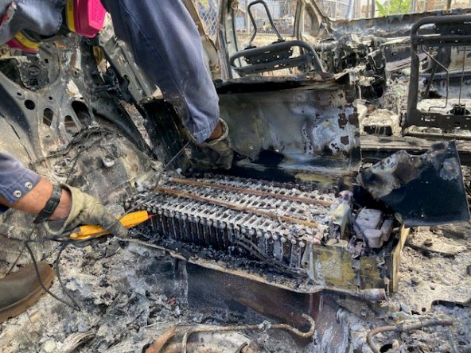

Certified electrician testing Ni-MH battery pack for remaining battery charge prior to removal
  - Accessing the Battery
Access to the batteries will depend on the type and condition of the vehicle. Most EV battery compartments will be found intact or partially intact. Location of each battery will be dependent on the year, make, and model of the EV. Some battery packs are located on the bottom of the vehicle and will require the EV to be placed on its side or have its roof removed (for stability) and rolled on its top. Others have batteries located under the back seat and may require the roof to be peeled back to access the battery. Each EV will be assessed to determine the most appropriate method to access and recover the battery.
A combination of power tools and hand tools will be used to remove batteries from EVs. Fire responder tools (spreader and cutter) are also utilized for accessing damaged vehicles and rendering the vehicle structurally safe for battery access. Doors and/or the roof of the vehicle may be removed for easier battery access or to safely flip the vehicle to access undercarriage batteries. A mini excavator with thumb attachment is also used for repositioning vehicles as well as assisting with access by removing seats or other obstructions. Dust suppression is provided prior to and during vehicle repositioning by a support vehicle with water buffalo trailer, however the batteries are not to be oversaturated with water.

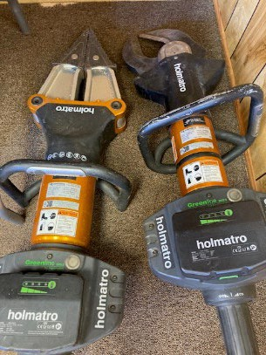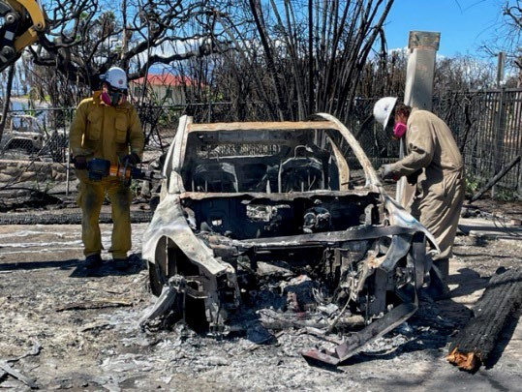

(Left) Rescue spreader and cutter. (Right) Cutting roofing support beams (A, B, C pillars) prior to flipping vehicle for battery pack access on some vehicles.
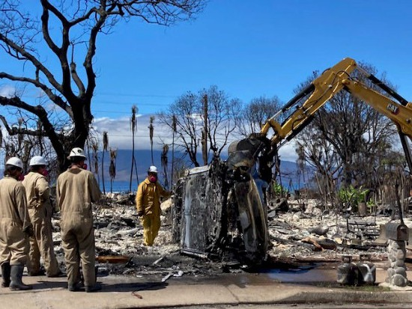
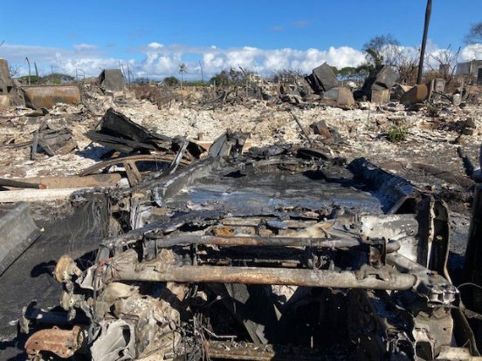

Flipping Tesla Model S to access batteries in undercarriage.

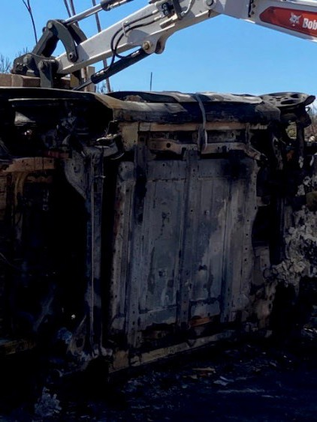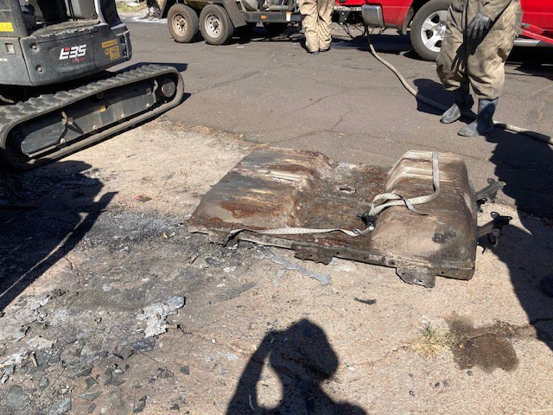

(Left) Nissan Leaf li-ion battery pack in undercarriage. (Right) Nissan Leaf battery pack after removal.

FIRE CONCERNS AND RESPONSE PLAN
The Battery Removal Team must be prepared to respond to an EV battery fire. A water buffalo with a minimum of 1 hose line with 10-40 gallons per minute (GPM) target flow must be onsite. All personnel should be upwind if possible. In the event of fire, all personnel will egress upwind and emergency services will be called immediately. If safe to do so, the fire hose operator will secure the perimeter of the fire to prevent propagation until emergency services arrive. Should a fire occur while the batteries are in transport to the staging area, the vehicle is to pull over to a safe location, drivers are to evacuate the transport vehicle, keep people a minimum distance of 330 feet and use the water buffalo to protect the area around the vehicle, if safe to perform. The local fire department must be contacted immediately and then incident command. Additional considerations are detailed in the 2023 Maui Wildfires Damaged Lithium-Ion Battery Management Guide for Electric Vehicles and Mobility Devices.

POST REMOVAL
  - Waste Management
Battery chemistry (Li-ion, NiMH) and condition of the battery determines the method for safe transportation to the staging area for deconstruction. Intact battery packs will be “Lau-Lau wrapped” (see 2023 Maui Wildfires Damaged Lithium-Ion Battery Management Guide) prior to transport. Loose batteries will be containerized on-scene using shovels and placed in 55- gallon steel drums. Batteries will be sorted according to the waste stream and placed into appropriate containers. The sorted batteries will then be placed on a flatbed trailer and labeled with the respective Assessor’s Parcel Number (APN) for tracking at the Staging Area.

  - Battery Removal Tracking

Once battery removal is complete, a white lightning bolt is painted over the blue lightning bolt and a post removal photo is collected. The data point is updated to “Complete” in QuickCapture via Field Maps, and additional information is placed in the database. If the

battery is not able to be removed, the data point will be updated to the appropriate status based on the following definitions:

    - Needs Assessment – a burned EV that has been identified but not yet processed by battery removal team
    - Complete – An EV that has been processed by the battery removal team
    - Deferred – An EV that cannot have its battery removed due to technical issues such as safe access
    - Archived – An EV that has been moved or removed (not by EPA) since marked as “Needs Assessment”; vehicle is no longer there
    - Follow Up Required – An EV that cannot have its battery removed without EPA leadership approval. Typically, EVs in the burn zone with minimal to no observed fire and/or heat damage.
    - Not In Universe – An EV that was not located, confirmed to not be an EV, or will not have its battery removed per EPA leadership.

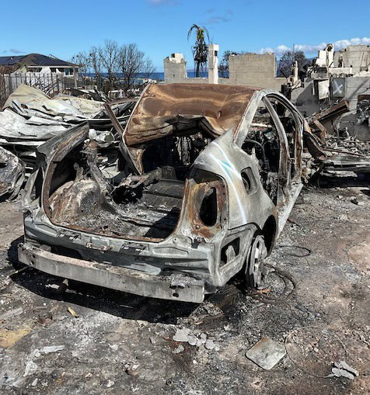

White lightning bolt painted over blue lightning bolt indicating that battery has been removed.

Electrical Vehicle Status Guide
The entire universe of this doto set is electric vehicles identified by the EV Team.

@ Needs Assessment - An electric vehicle that has been identified, but not yet processed by removal team.

@complete -An electric vehicle that has had its battery recovered.

@Deferred-An electric vehicle that cannot have itsbattery removed by EPA due to technical issues, such as the inability to access the vehicle safely.

@Archived -An electric vehicle that has been moved since a "Needs Assessment" point was created.
@ Follow Up Required -An electric vehicle that cannot have its battery recovered without EPA leadership's decision.
® Not in Universe -After "Follow Up Required" resolution, an electric vehicle that will not have its battery recovered as decided by EPA leadership; or EV battery not found at location.

