STANDARD OPERATING PROCEDURE 402:
LITHIUM-ION BATTERY SHREDDER
2025 SOCAL WILDFIRE RESPONSE
March 13, 2025
1. OBJECTIVE
This standard operating procedure (SOP) outlines the safe and effective operation of the lithium-ion (Li-ion) battery shredder for the 2025 Southern California Wildfire Response. This SOP provides guidelines for equipment assembly, startup, operation, maintenance, and storage to ensure proper processing of fire-damaged and end-of-life batteries.
The objective is to process Li-ion battery types by shredding them in a controlled manner to reduce volume, mitigate hazards, and facilitate recycling or disposal. Safe operation of the shredder requires strict adherence to procedures for material loading, monitoring power sources, preventing jams, capturing shredded material, and protecting equipment from environmental exposure.
Additionally, this SOP includes health and safety protocols, startup activities, and maintenance procedures to minimize risks such as thermal runaway, fire, and hazardous material exposure. The Battery Shredding Team, which may include a Federal On-Scene Coordinator (OSC), START personnel, battery subject matter experts, heavy equipment operators, and safety specialists, is responsible for implementing these procedures in accordance with established environmental and safety guidelines.

2. SUMMARY OF METHOD
The shredding of the batteries is done by a team of trained personnel familiar with vehicle manufacturers, models, and mechanical and battery technology. Personnel from the Emergency Response and Removal Services (ERRS) contract will be responsible for the physical shredding of the batteries and Superfund Technical Assessment Response Team (START) personnel will be responsible for the documentation of activities in field logbooks and monitoring post processed material prior to disposal or recycling. Response Engineering and Analytical Contract (REAC) will be responsible for air monitoring of the process and battery pad perimeter.

3. HEALTH AND SAFETY
Qualified personnel should have completed adequate training to enter a disaster area, including 40-Hour HAZWOPER, site-specific safety training, and cultural training, if necessary. Numerous chemical and physical hazards are present during battery shredding activities. Chemical hazards include acid gases, occasional lead-acid gas, and heavy metals. Physical hazards include the operation of heavy equipment, heavy lifting of tools, sharp metal, risk of fire or explosion from thermal runaway of a battery, heat stress, ash and chemical exposure, and dehydration. Level C PPE will be used for this operation: half-face or full-face respirator utilizing acid gas/P100 dual cartridge, hard hat, ANSI-rated safety glasses, and flame resistant clothing (FRC).

3.1 Approach and Monitoring

Air monitoring with a multi-gas meter should be performed during approach to determine if any off-gassing or release of toxic vapors is occurring. Due to cross-sensitivities between carbon monoxide (CO) and hydrogen, as well as volatile organic compounds (VOCs), the CO and VOC sensors should be especially monitored. Monitoring for changes in ambient conditions around the battery pad during the shredding operation should be conducted as well. Air monitoring on the pad can be conducted with an air monitoring station with multi-gas and single-gas meters connected with a remote telemetry system such as VIPER.
An operational exclusion zone boundary of 330 ft. should initially be established, consistent with ERG Guide 117 for stable but present batteries on-site. A “fall back” exclusion zone/muster point should be identified by the field team and used if a cascading thermal runaway event occurs while operations are occurring on-site. This perimeter is designed for public safety and the off-site migration of contaminants of concern, but operational engineering controls and PPE should be used during all activities. If the public or other adjacent working teams are present, notification of the operation and contingencies that may be required include shelter-in-place or other appropriate protective distances shall be communicated by the field team leader.

4. GENERAL PROCEDURE

4.1 Assembly
The operational footprint of the shredder is situated at the southern end of the pad. It rests on a metal sheet, with a white liner and a large fire blanket underneath to prevent fires. The area is enclosed by concrete blocks to manage runoff. The shredder consists of three components: the hopper, the shredder itself, and the control panel. The hopper sits atop the shredder, while the control panel is located just outside the containment area, secured to wooden stakes on a concrete base. Additionally, a large generator is positioned outside the containment area, supplying power to the shredder, and a water buffalo is used to spray the shredded batteries, helping to control particulates and maintain temperature.

4.2 Start Up Activities
The start-up activities for the shredder begin with an electrician coming to connect the motor to the control panel and the control panel to the generator. This is followed by a visit from the vendor to ensure the correct functionality and wiring of the control panel. During this visit, the vendor also provides the crew with a detailed explanation of how to operate the shredder and the proper procedures to follow before beginning operations. To initiate the shredding process, the first step is to power on the generator, which provides the necessary energy to the shredder. Following this, the generator must be turned on via the main breaker located on the control panel, followed by pressing the start button. The shredder will then begin its start-up process by running in reverse for two seconds before engaging in normal operation.

- Start the motor with the load disconnected. Check direction of rotation. Interchange any two leads of a three-phase motor to change the direction of rotation.
- Connect the load and operate for an initial period of at least one hour. Check for any unusual noise, vibration or hot spots. These items should also be checked periodically as a part of a maintenance schedule even after a successful start-up. Acceptable vibration levels at no load condition are defined in: - NEMA MG1-7: 2-6 pole: 0.15in/s peak 8 pole: 0.12in/s peak
- Check the operating current against the nameplate current. Be careful not to exceed the value of the nameplate amperes under continuous load. Motors with a service factor greater than 1.0 can be operated continuously with the current not exceeding the nameplate value multiplied by the service factor, however, the life span of the insulation system may be reduced.
- When operating 208-230/460 voltage motors at 200 volts, the slip of the motor will increase by approximately 30%, and the torques will be reduced (20% to 30%). Before starting the unit, make certain the motor will start and accelerate the load without injurious heating and adequate torque. Contact WorldWide Electric for assistance.

4.3 Operations and Battery Processing

4.3.1 Shredder Placement and Site Setup
The battery shredder must be meticulously positioned on the battery processing pad to maximize efficiency, safety, and compliance with environmental and fire safety standards. Optimal placement considers equipment maneuverability, space for auxiliary machinery, and safety protocols related to hazardous material handling. Key considerations include:
- Generator Placement: Position the generator at a safe distance from the shredder and other equipment to mitigate risks associated with thermal events. Ensure the generator is electrically grounded and equipped with a lockout/tagout (LOTO) system to safeguard personnel.
- Water Buffalo System: Place the water buffalo (portable water tank) with high-volume hoses strategically to facilitate effective dust suppression and manage potential thermal events.
- Heavy Equipment Access: Arrange the shredder location to allow safe operation of skid steer loaders, forklifts, and other material handling equipment (MHE), ensuring adequate space for maneuvering and loading/unloading operations.
- Secondary Containment: Implement a robust secondary containment system:
  - Concrete Barriers: Surround the shredder base with reinforced concrete barriers to contain debris and prevent environmental contamination.
  - Steel Plate and Plastic Liner: Install two high-density polyethylene (HDPE) liners, to provide a durable and impermeable layer that prevents leachate migration, overlaid by a steel plate.
  - Fire Containment Blanket: Place a fire-resistant blanket, such as a fire containment blanket or fire suppression blanket, over the HDPE liner. This blanket, typically made from high-temperature-resistant materials like fiberglass, serves to suppress fires by cutting off the oxygen supply, thereby enhancing the safety of the containment area.
- This multi-layered approach ensures comprehensive protection against physical, chemical, and thermal hazards, aligning with industry BMPs

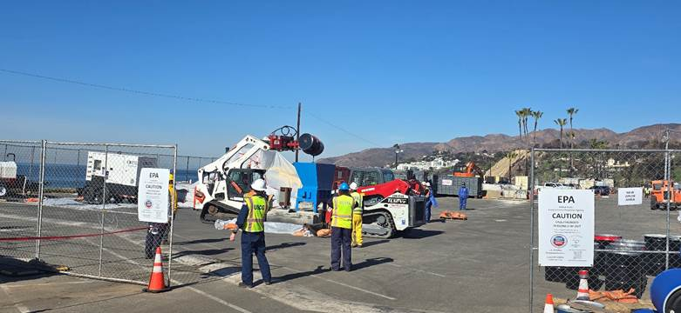

4.3.2 Personnel and Safety Equipment
Given the hazardous nature of the materials being processed, it is imperative that all personnel adhere to strict Personal Protective Equipment (PPE) standards that comply with Occupational Safety and Health Administration (OSHA) and Environmental Protection Agency (EPA) guidelines for hazardous material handling.
- Fire-Resistant (FR) Clothing and Tyvek Suits: Workers must wear FR coveralls, such as Nomex® or Proban®, to protect against the heat and potential flame exposure from thermal runaway events. In cases of extreme exposure, Tyvek® Flame Resistant suits offer a secondary layer of protection and may be worn over traditional FR clothing. This can aid in keeping FR clothing free from exposures.
- Acid Gas Respirators: Operators handling shredded materials are required to wear APR (air-purifying respirators) with dual Acid Gas/P100 filters to protect against airborne toxic fumes, including sulfur dioxide, hydrogen fluoride, and other volatile organic compounds (VOCs) that may be emitted from the batteries.
- Thermally Resistant Gloves: Gloves should be made from Kevlar® or Nomex®, with additional chemical resistance for safe handling of potentially ruptured or leaking batteries.
- Chemical-Resistant Boots: Workers must wear steel-toe boots with a rubber or PVC (polyvinyl chloride) coating to protect against both physical hazards and chemical exposure.
- Eye and Face Protection: Workers must be equipped with chemical splash goggles or glasses and full-face shields to provide a physical barrier against electrolyte leaks, flying debris, and chemical splashes.

The Control Box Operator assumes a critical role, managing the start/stop of the shredding operation. The operator uses emergency shut-off protocols to immediately stop the shredder in the event of an emergency such as overheating, jammed materials, or thermal runaway.
Thermal imaging devices can be useful in identifying the location of batteries that are at risk of experiencing thermal runaway or are currently in the process of releasing gases. These devices work by detecting and visualizing heat signatures, which can help users identify hotspots or areas of concern within a battery system or the operational process of terminating batteries.
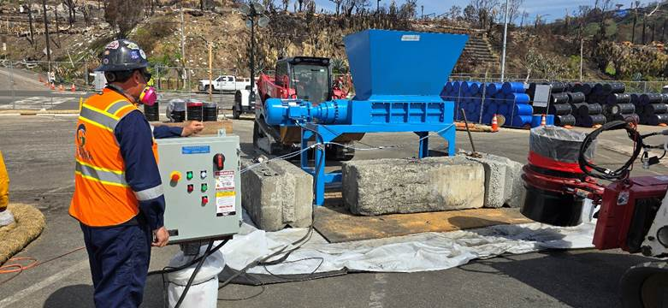

4.3.3 Battery Loading Process
Battery loading into the shredder requires precise operations to ensure the safe and efficient processing of materials while minimizing risk to personnel and equipment. The skid steer loader, equipped with a drum holder attachment, is used for the transfer of battery containers (drums) to the shredder intake.
- Loading Procedure:
  - The skid steer loader with the drum holder attachment is used to transport a prepared drum filled with batteries. The drum is moved over the shredder with precision to prevent tipping or spillage.
  - The drum is tilted slowly to ensure that the batteries are fed directly into the shredder intake. The process must be gradual to avoid overloading the shredder or causing a material blockage.
  - Skid Steer with Bucket Attachment: A second skid steer with a standard bucket attachment is placed beneath the shredder to collect the shredded material. The operator should continuously monitor the bucket's fill level to prevent overfilling, which could lead to inefficient processing or backfeeding.
  - Flow Regulation: The flow of batteries should be regulated by the operator to ensure uniform shredding. Overloading the shredder can lead to inefficient operation or mechanical failure due to jammed materials. The flow must be balanced, with operators using hand signals to communicate speed adjustments and emergency stops when necessary.
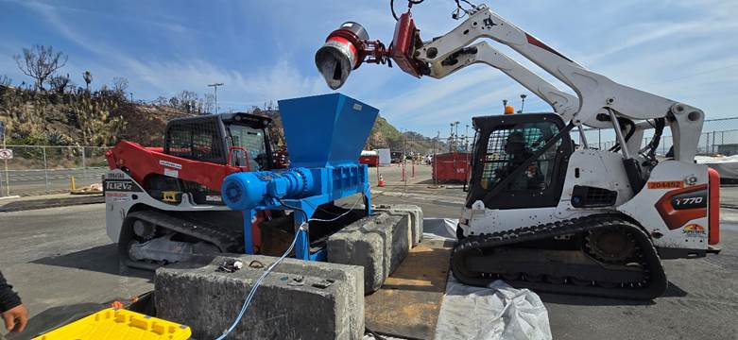
4.3.4 Shredding and Thermal Runaway Mitigation
Shredding operations must be constantly monitored to detect and mitigate risks associated with battery breakdown, particularly thermal runaway. Effective mitigation involves both physical and procedural controls.
- Shredder Activation and Material Feeding:
  - Battery materials, including Li-ion cells, should be shredded until no large cells remain, reducing the potential for thermal propagation.
- Thermal Runaway Detection and Mitigation:
  - The water buffalo system operates continuously to provide water misting and direct cooling to reduce the temperature of the shredded materials and prevent fires.
  - In the event of thermal runaway, water application should be targeted at the shredded battery debris to cool the hot spots, while avoiding direct water contact with non-thermal materials to prevent hazardous reactions.
  - Fire extinguishers and Class D fire suppression systems are strategically placed around the shredder for immediate activation if water suppression fails.

4.3.5 Collection and Sorting of Shredded Material
After the shredding process, the resulting material is carefully sorted to remove non-compliant items and to facilitate proper disposal or recycling. This process requires precise handling and manual labor to ensure all contaminants are removed before storage.
- Sorting Procedure:
  - The shredded material is collected in the skid steer bucket and transported to the sorting pad.
  - The sorting area is equipped with a steel plate floor covered with HDPE liner to provide containment and prevent material spillage.
  - The ERRS team sorts the shredded material to remove uncrushed batteries, including unshredded cylindrical cells.
  - Sifting Equipment: Manual sifting tools or mechanical vibratory screens can be used to separate non-shredded items, which are then either processed further or discarded.

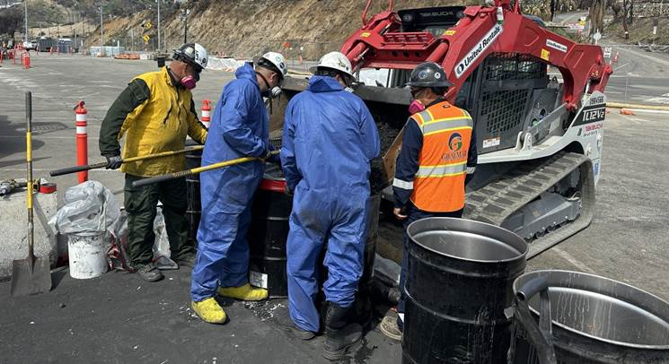
    - Dust Prevention and Suppression
Effective dust prevention and suppression are critical components of safe battery shredding operations. Dust generated during the shredding of lithium-ion (Li-ion) and other battery types may contain hazardous particulates, including fine metals, electrolyte residues, and carbonaceous materials. These particulates present a risk of respiratory exposure, equipment damage, fire, and environmental contamination if not adequately controlled.
Dust suppression is achieved primarily through the use of a water buffalo system, supplemented by administrative controls and PPE requirements.
- Water Buffalo Operation: A water buffalo, equipped with a high-volume hose and adjustable nozzle, is deployed adjacent to the shredder during active battery processing. The hose operator maintains a continuous or intermittent mist over the hopper and discharge area to:
    - Minimize airborne dust during material drop-in and shredding.
    - Reduce visible emissions and localized particulate concentrations.
    - Suppress potential ignition sources and provide rapid cooling in the event of a thermal event.
- Personnel Safety Measures: All personnel working within proximity of the shredder must wear appropriate respiratory protection, including acid gas and particulate filters (e.g., full-face respirators with P100 cartridges). This PPE is required regardless of active water suppression, as a precaution against airborne metals and combustion byproducts.
- Operational Controls:
    - The water buffalo system must be fully charged and function-checked at the start of each shift.
    - The suppression hose must remain manned throughout shredding operations and be immediately deployable during visible dust generation or fire events.
    - Operators must adjust hose position and spray intensity to account for wind direction, material density, and dust levels.
    - Hand signals are used to coordinate suppression needs between the hose operator, equipment operators, and Control Box Operator.
- Housekeeping and Containment: To prevent secondary exposure and cross-contamination:
    - Work areas should be wet-wiped or cleaned with HEPA-rated industrial vacuums at the end of each operational period.
    - Shredded material should remain contained within lined, vented drums and sealed immediately after sorting.
Dust suppression activities are conducted in parallel with jam clearing, fire mitigation, and material handling procedures outlined in Sections 4.3.2, 4.3.3, and 4.3.7. All personnel must be trained in water buffalo operation and emergency response coordination before being assigned to the suppression role.

    - Final Containment and Storage
Once the material has been sorted, it is prepared for final storage. Proper containment and labeling are essential to ensure that the materials are safely stored before transportation.
- Shredded material is transferred into sealed, vented drums that comply with EPA hazardous waste storage standards.
- Drums are sealed with tamper-proof lids and are fitted with vent ports to allow for the release of gases during storage.
- The final product is transferred into roll-off bins or drums are placed into roll-off bins or rollover soft-top containers that are equipped with spill containment capabilities. These bins are prepared for transportation to authorized recycling or disposal facilities for battery material reclamation or final disposal.
- All drums and containers must be labeled with appropriate hazardous material warnings, including UN numbers, hazard class labels, and storage dates to ensure regulatory compliance.

4.3.7 Emergency Procedures and Communication
Effective emergency procedures are crucial to maintaining safety during operations. All personnel should be trained in emergency response protocols and familiar with hand signal communication in the event of a mechanical failure, fire, or other hazardous situations.
- Emergency Stops: The Control Box Operator has the authority to stop the shredder immediately in case of overload, thermal runaway, or any other condition.
- Fire Suppression: In the event of a fire or thermal runaway, the fire suppression team should be notified immediately through emergency communication systems. The water buffalo system should be activated to suppress any flames and cool down affected areas. The team should also be ready to use Class D fire suppression systems or dry chemical fire extinguishers as required for additional fire control.
- Hand Signals and Communication: Standard hand signals should be reviewed and practiced regularly by all operators, particularly in high-noise environments where verbal communication may be impractical. This ensures that critical information regarding hazardous situations, such as jams or fire, can be communicated efficiently and safely.

4.3.8 Addressing a Shredder Jam
A shredder jam is a critical event that can halt processing and must be addressed quickly and safely. Jams can occur without immediate notification, making it essential for operators to be alert and follow a systematic approach for clearing the blockage. Below is the detailed procedure for addressing a shredder jam:
4.3.8.1 Identifying a Jam
The first indication of a jam is when material is no longer falling through the bottom of the unit. This can be misleading, as the operator might mistakenly assume that all the material has been processed. However, when a jam occurs, the motor will stop, and the shredding process will pause.
4.3.8.2 Jam Sequence and Response
When a jam occurs, the shredder will attempt to resolve the blockage automatically by reversing the combs to clear the jam. The following sequence will take place:
- Motor Pause: The motor will stop for approximately 20 seconds3.
- Comb Reversal: The combs will rotate in reverse for approximately 3 seconds to attempt to clear the material blocking the shredding mechanism.
- Forward Rotation: After the reverse rotation, the combs will run forward.
- Additional Attempts: If the jam is not cleared, the reverse and forward motions will repeat 3 additional times for a total of 4 attempts.
- Activation of the TRIP Light: If the jam persists after 4 attempts, the TRIP light on the control panel will activate, and the motor will stop completely. The system will not restart until the TRIP light is cleared.

4.3.8.3 Clearing the TRIP Light and Manual Intervention
The TRIP light is the only visual indicator that a jam has occurred. When this light is illuminated, the operator must follow the procedure to clear the blockage:
- Press the Stop Button: Hold the STOP button on the control panel for approximately 3 seconds to reset the system and clear the TRIP light.
- TRIP Light Goes Off: Once the TRIP light goes off, the system is reset and ready for action.
- Press the Run Button: Press the RUN button to engage the motor and immediately reverse the combs for approximately 2 seconds.
- Stop the Combs: After the 2 seconds, press the STOP button.
- Flashing Green Running Light: The green RUNNING light will flash, indicating that the system is in reverse mode.
- Repeat Reverse Process: After the flashing stops, press the RUN button again to reverse the combs for approximately 2 seconds. Repeat this process for a total of 4 reverse actions.
- Return to Normal Operation: After the fourth reverse action, press the RUN button again to resume normal operation. The shredder will continue its regular sequence of reverse and forward motions.

4.3.8.4 When to Shut Down the System
If the TRIP light reactivates during operation, indicating that the jam has not been cleared, follow the shutdown procedure to safely address the blockage:
- Shut Down All Power: Disconnect all power sources to the shredder, including the control panel main power and the generator.
- Manual Blockage Removal: After disconnecting power, proceed with manually clearing the blockage or contact qualified personnel for assistance.
- Restart Procedure: Once the blockage is cleared, restart the system using the normal startup procedure.

4.3.8.5 Preventative Measures and Operator Awareness
It is essential for personnel to be familiar with the jam clearing procedure to prevent delays in operations. Operators should always remain within hearing distance of the motor while loading the shredder and keep visual attention on the process to detect signs of a jam promptly.
In addition, team members must work together and communicate effectively to ensure that the proper hand signals are used in case of a jam. This ensures that the team can efficiently manage the situation, clear the blockage, and resume operations with minimal downtime.

4.4 Maintenance and Storage

Appropriate maintenance and care of the shredder is important to ensure future integrity and operability of the unit. Prior to disassembly of the unit, an inspection should be performed to ensure larger pieces of material have been processed appropriately or have been removed. While the hopper is still on, spraying the interior with water will assist in cleaning out residual material, however rinse water should be collected and disposed of appropriately. Applying rinse water while the motors are running may provide better cleaning of the combs and teeth. The operating manual does not explicitly provide options or recommendations for cleaning the combs either in a general sense or specifically following the destruction of batteries. Thought needs to be placed into whether a soap and water solution or other cleaning agent should be used following the processing of batteries and/or prior to disassembly and storage of the shredder.

Maintenance activities should be followed according to the manufacturers recommendations as detailed in Operating Manual, Taskmaster TN2300, Model 2342, Section 6 Maintenance and Spares and Operating Manual, Taskmaster TN3000, Model 3042, Section 7 Maintenance and Spares generated by Franklin Miller. The operations manual provides recommendations for daily, weekly, monthly, quarterly, semi-annual, and annual inspections and maintenance. Most activities involve visual inspection and application of lubrication. More frequent inspections are recommended if the unit is being operated under harsh conditions. Below is a table indicating the frequency and type of inspection.

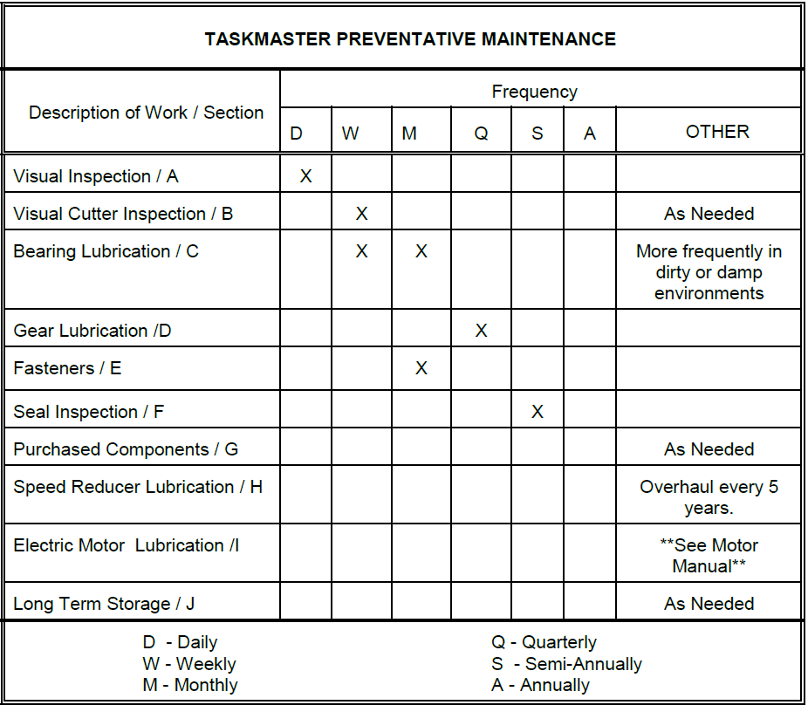

- Visual Inspection: The Taskmaster should be visually inspected once per day. While inspecting the machine the user should pay particular attention to excess process material collecting on the equipment, stack tightness, and obvious signs of damage to the equipment.
- Visual Cutter Inspection: The Taskmaster cutters should be visually inspected once per week. They will need to be replaced or re-ground as required for the proper operation.
- Bearing Lubrication: Lubricate drive & tail bearings with DuPont Teflon® with Moly (-10° to +350° F) Heavy Equipment Grease (McMaster-Carr Part # 8708T22). For tail bearings, grease through fitting with two (2) pumps of grease. For drive bearings, grease with two (2) pumps of grease. The frequency of greasing and
- the amount of grease must be increased for dirty or wet conditions.
- Gear Lubrication: The gears must be lubricated with Dow Corning® 1122 Open Chain & Gear Lube quarterly. Remove Reducer Adapter (260) and re-lubricate.
- Fasteners: Inspect the fasteners once a month. DO NOT OVER-TIGHTEN FASTENERS - only check for
- tightness of bolts. Over-tightening fasteners could result in breakage of hardware.
- Seal Inspection: Inspect the bearing seals once every (6) months. Replace as needed.
- Purchased Components: Maintenance schedules must be constructed by the end user by reading the Operations & Maintenance manuals for the purchased components at end of this manual.
- Speed Reducer Lubrication: See reducer manufacturer’s operation & maintenance manual at end of manual.
- Electric Motor Lubrication: See motor manufacturer’s operation & maintenance manual at end of the manual.
- Long Term Storage:

Motor: The motor should be rotated manually to prevent problems with the bearings.
Procedure:
- Remove Fan Cover.
- Rotate Shaft 360° (100 revolutions) every 30 days.

Reducer: The reducer should be filled with oil.

Procedure:
- Store in a sheltered area away from chemical vapors or steam
- Spray oil on exposed shafts & seals. Remove oil on start-up.
- Cover.
- Do not store in sunlight or near high heat.

Long Term Storage
In addition to the recommendations above, long term storage should be performed in a manner to keep the shredder away from inclement weather, such as rain, sleet, and snow. The area should be dry and if possible, not go through extreme temperature fluctuations. The shredder components, including the control box, connection cables, and combs should be covered tightly in plastic sheeting or wrap to prevent dust and debris accumulation when not in service.

Disassembly
For the purposes of this section, disassembly refers to a breakdown of components to transport the unit off-site or moved to a different location for storage or other purposes. Disassembly will work in the opposite manner of assembly of the unit:
- Disconnect all power to the control panel. If a generator is being used to supply power to the control box, a physical disconnection of the control box and generator should be performed.
- Remove the hopper. Remove the hex head bolts and lock washers and use machinery to physically remove the hopper from the table.
- Secure wires and cables. If the power box is mounted to the table of the unit, ensure that all wires and cables are securely attached to the frame of the unit. If the control box is not mounted to the table, it may be either disconnected or secured to the table along with all wires and cables.

For disassembly of the cutters, spacers, frame, and other components refer to the O&M Manual on appropriate techniques.

Appendix: Lithium-ion Battery Shredder Wildfire Response Equipment/Personnel List

Equipment – Battery Termination (Purpose: Processing, terminating and preparing for disposal)
- Water buffalo
- Tyvek sheeting
- Fire blankets
- Duct tape/Gorilla Tape
- Metal open top drums with bungs
- Ratchet straps for securing loads
- Metal open-top trailer
- Hand tools including, but not limited to: 12-16lb sledgehammer
- Mechanics toolset including bits and sockets etc.
- Non-sparking tools including bung wrench

- Temperature gun/sensor
- Thermal camera
- Battery tools such as impact driver and Sawzall w/appropriate metal cutting blades
- Steel pipe, chain rigging set-up
- Rope, webbing and load-capable carabiners
- 6’ fiberglass A frame ladder
- Extrication tools

Personnel – Recovery and Transport
- 1 – Equipment operator (mini excavator/skid-steer)
- 1 – Equipment operator (skid-steer)
- 1 – Water buffalo tech
- 2 – Tech roustabouts for shoveling batteries, managing drums and other tasks
- 1 – Electrician with PV training/experience
- 1 – Shredder operator

Air Monitoring
- SPM Flex with acid gas tapes
- 5 Gas – MultiRae

- Viper – A fixed array can be set up at the staging area and managed through Viper, while Recovery teams can carry handheld instruments for use as needed.

Note 1: this list is dynamic and subject to change based on field team needs.

Appendix A

JHA
JHA #: TBD |  |  |  | Name of Task: Shredding with Taskmaster Shredder (Model: TM2342) |  |  |  |  |  | Location: 2025 SoCal Wildfires
Task Description: Shredding/grinding of lithium batteries |  |  |  |  |  |  |  |  |  | Task Duration: Daily
Physical Hazards
Hazard |  |  | Source |  |  |  | Control Measures |  |  |  | Exposure Potential
 |  |  |  |  |  |  |  |  |  |  | H | M |  | L | Unk | N/A
Stored Energy (Electricity) / Fire and Explosion |  |  | - Electric/Power supply lines  - Energy Storage Systems (Tesla and other brands or homemade versions)  - Lithium batteries |  |  |  | - Risk of stored energy should be low since the batteries should have been discharged prior to shredding/grinding.
Being pulled into shredder |  |  | Rotating shredder blades |  |  |  | - Identify and understand parts of the equipment which may cause crushing, pinching, rotating or similar motions.  - Assure guards are in place to protect from these parts of equipment during operation.  - Never operate the shredder without the hopper in place.  - Never place hands, arms, or other body parts into hopper while shredder is in operation.  - Never wear ill-fitting, baggy or frayed clothing when working around or on any of the drive system components.  - Never wear ID lanyard while operating the grinder.
Cuts or loss of limbs or digits |  |  | Mechanical jamming and/or failures |  |  |  | - ABSOLUTELY NEVER PLACE HANDS, ARMS, OR OTHER BODY PARTS INTO EQUIPMENT TO REMOVE A BATTERY JAM OR FIX A FAILURE!  - Always shut down and follow lock out procedures on equipment before performing necessary activities to remove jams or repair the equipment.  - Shut off and lock out power on electrically driven machines and wait for all moving parts to stop before servicing, adjusting, or repairing.
Projectiles from shredder |  |  | Kickback of batteries and/or material from powerwalls |  |  |  | - Assure guards are in place to protect from these parts of equipment during operation.  - Never operate the shredder without the hopper in place.  - “Fall back” to exclusion zone/muster point.
Electrocution |  |  | Electric shock when operating shredder |  |  |  | - Use licensed electricians to hook up / disconnect electrical feed circuits.  - Inspect all electrical wiring from generator to the shredder daily for structural integrity, ground continuity, and damaged  - insulation.  - Cover or elevate electric wire or flexible cord passing through work areas to protect from damage from heavy equipment operation.  - Inspect all electrical power circuits prior to commencing work.
Chemical Exposure |  |  | By-product of fires involving lithium batteries |  |  |  | See Chemical Hazards section below
Biological Hazards
Hazard |  | Source |  |  |  | Control Measures |  |  |  |  | Exposure Potential
 |  |  |  |  |  |  |  |  |  |  | H | M |  | L | Unk | N/A
N/A |  | N/A |  |  |  | N/A
Chemical & Radiological Hazards
Hazard | Source |  |  |  |  | Control Measures |  |  |  |  | Exposure Potential
Hazard |  |  |  |  |  |  |  |  |  |  | H | M |  | L | Unk | N/A
Hydrogen Fluoride | By-product of fires involving lithium batteries |  |  |  |  | - Partially burned, partially insulated, intact, but suspected insulated power walls : SCBA required for respiratory protection while handling power walls.  - Completely charred or Completely charred and bulged wall mounted energy storage system: organic gas/acid gas filters required for respiratory protection.  - FR clothing required for potential fires.  - In the event a reaction occurs during handling, immediately drop the power wall and vacate the area to safety.  - Keep a fire extinguisher next to the shredder.
PPE
Level A |  |  |  |  | Level B  Partially burned, partially insulated, intact, but suspected insulated power walls: (SCBA for respiratory protection combined with FR clothing). |  |  | Level C  Completely charred or completely charred and bulged power walls: (Organic gas/acid gas filters required for respiratory protection combined with FR clothing.) | Level D Mod |  |  |  | Level D
Other
None

Flame Resistant Clothing: The implications of using disposable vs reusable FRC should be considered in the health and safety plan and field procedures. Appropriate decontamination or disposal of FRC should be implemented in the field prior to entering vehicles so ash and other contaminants do not contaminant vehicles, cut resistant or shock resistant gloves (as appropriate), hard hat, protective boots and safety glasses. A Job Hazard Analysis (JHA) has been generated by the Safety Officer for inclusion in the Health and Safety Plan, which is housed on the 2023 Socal Wildfires Teams page, Section 1.6 Safety Officer, managed by the US Environmental Protection Agency (EPA).
Timeframes listed here are approximations for use of the Franklin-Miller TM-2342 model. For larger models, such as the TM-3042, timeframes will be longer.
Technical Support 8am – 7pm Eastern for Routine Assistance + 24/7 Emergency Breakdown Support 844-WWE-SERV
Timeframes listed here are approximations for use of the Franklin-Miller TM-2342 model. For larger models, such as the TM-3042, timeframes will be longer.

