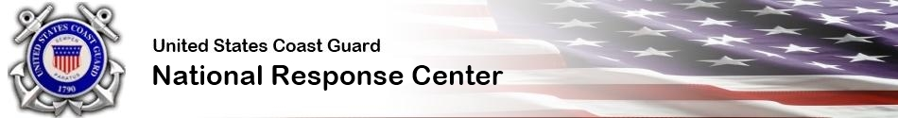

Anyone witnessing an oil spill, chemical release or maritime security incident should call the NRC hotline at
1-800-424-8802

