Name:___________________________________________________
Agency:__________________________________________________
Date__________________________________ Score: __________
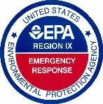
Please take the survey and email it back to Robert Wise at wise.robert@epa.gov. This survey is very important as it will help EPA continue to make improvements to it. Please rate on the scale with 1 being poor and 5 being excellent.
Rating | 1 | 2 | 3 | 4 | 5 | Comments
- Were the directions easy to follow?
- Were the classes easy to access?
- Was the class easy to use?
- Did the content meet your needs?
- Where there any major issues or problems with the class?
- Would you use the class again?

- Please provide your overall impression of the class.

