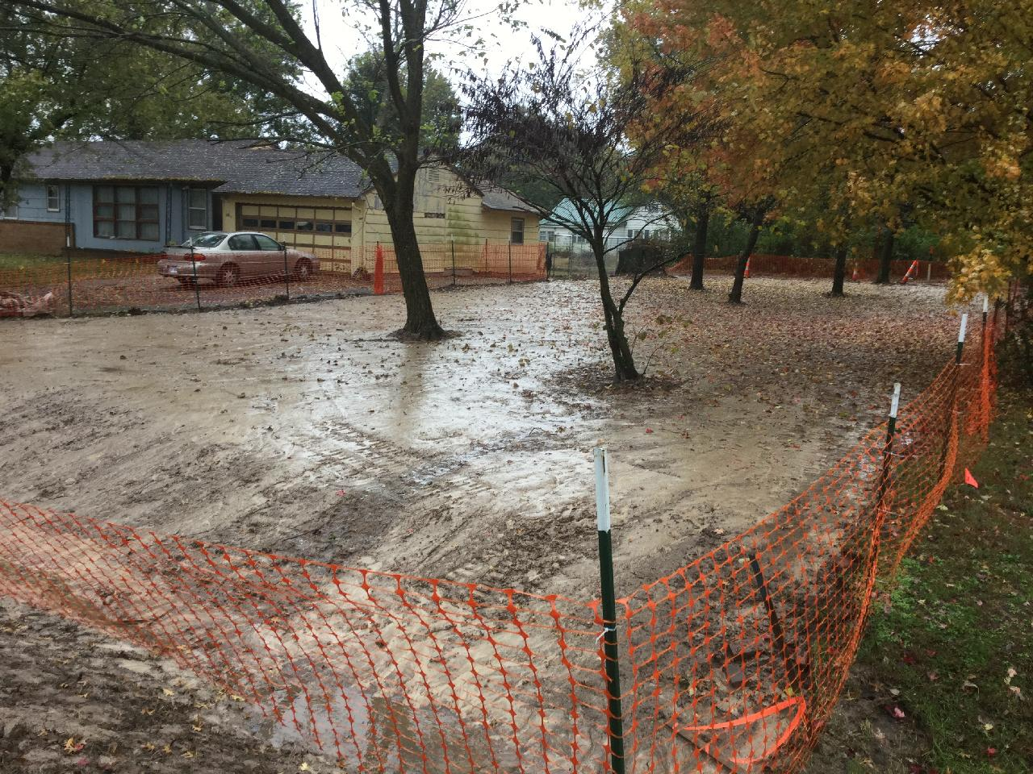

Photo No.: |  |  | Date and Time: Wed Oct 30 09:28:37 2019 GMT-0500
Photographer: James A. Johnson |  |  |  |  |  | Direction: Southeast
Device ID: cf86d62934934fe1a1018ee9dd8b605b
Latitude: | 37.310003 |  |  | Longitude: | -94.765449 |  | GPS Receiver: | From Camera
Description: 508 E Main. Site conditions as they appear today. Awaiting topsoil and sod. Weather related conditions have hampered removal actions. Note the water “sheet” runoff from S-to-N.

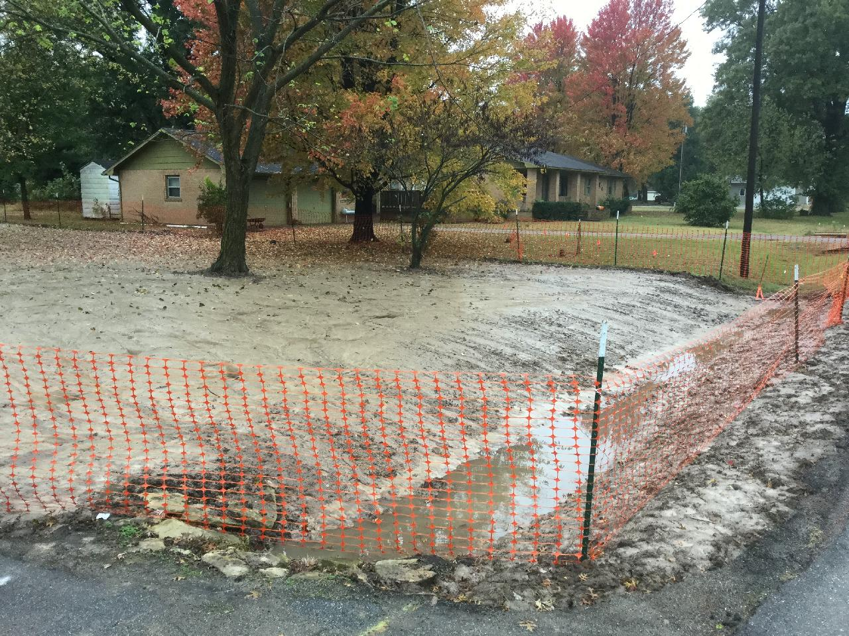

Photo No.: |  |  | Date and Time: Wed Oct 30 09:32:02 2019 GMT-0500
Photographer: James A. Johnson |  |  |  |  |  | Direction: Southwest
Device ID: cf86d62934934fe1a1018ee9dd8b605b
Latitude: | 37.309954 |  |  | Longitude: | -94.765184 |  | GPS Receiver: | From Camera
Description: 508 E Main. Current site conditions. Photo taken along Main Street, looking southwest. Standing water in yard. The property is waiting for drier conditions so that we can finish by adding topsoil and grass sod.

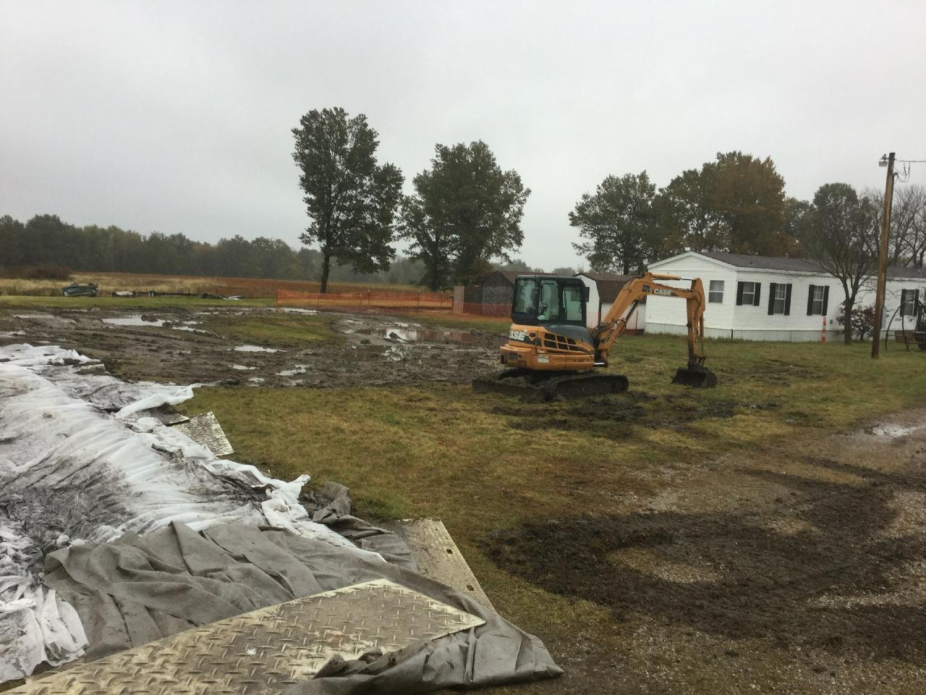

Photo No.: |  |  | Date and Time: Wed Oct 30 09:35:09 2019 GMT-0500
Photographer: James A. Johnson |  |  |  |  |  | Direction: Northeast
Device ID: cf86d62934934fe1a1018ee9dd8b605b
Latitude: | 37.310128 |  |  | Longitude: | -94.766059 |  | GPS Receiver: | From Camera
Description: 505 E. Main. Site conditions. The recent rains made this property nearly impossible to finish. Rainy wet conditions almost caused property to go to nearly "mud". Soil track out is an issue at this location.

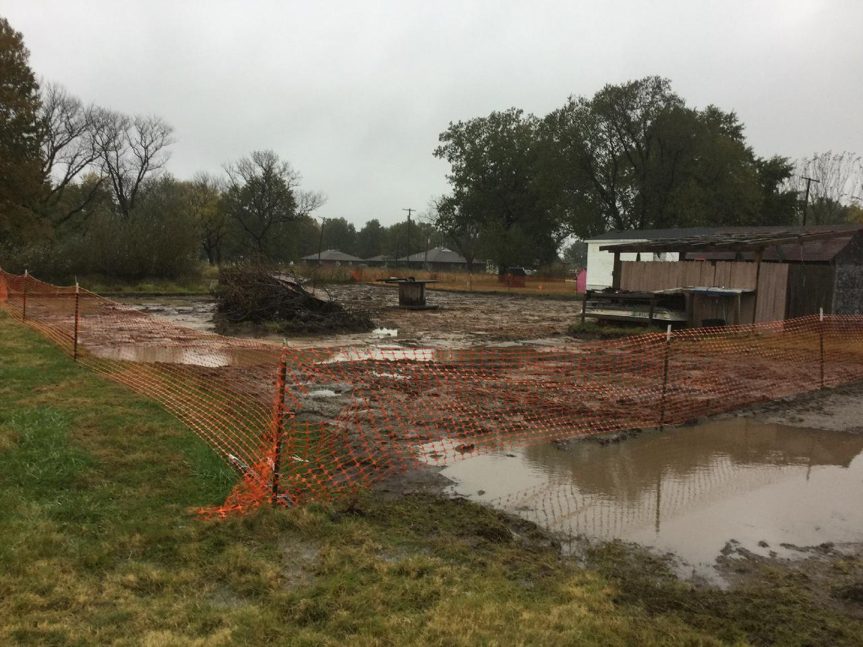

Photo No.: |  |  | Date and Time: Wed Oct 30 09:36:57 2019 GMT-0500
Photographer: James A. Johnson |  |  |  |  |  | Direction: Southeast
Device ID: cf86d62934934fe1a1018ee9dd8b605b
Latitude: | 37.310695 |  |  | Longitude: | -94.765863 |  | GPS Receiver: | From Camera
Description: 505 E. Main. Backyard. The burn pit area was not remediated at property owner’s request. Area has firebrick under/around it and Owner did not want it disturbed. The farm pond in the northeast corner of the property was undisturbed as well.

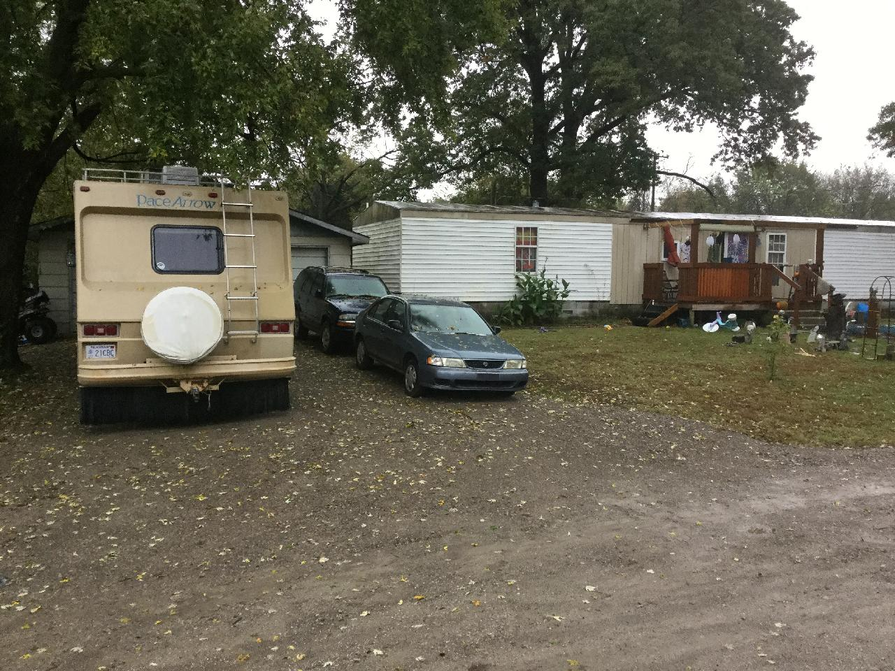

Photo No.: |  |  | Date and Time: Wed Oct 30 09:43:02 2019 GMT-0500
Photographer: James A. Johnson |  |  |  |  |  | Direction: Southeast
Device ID: cf86d62934934fe1a1018ee9dd8b605b
Latitude: | 37.308652 |  |  | Longitude: | -94.767598 |  | GPS Receiver: | From Camera
Description: 401 E Oak. This property was remediated.

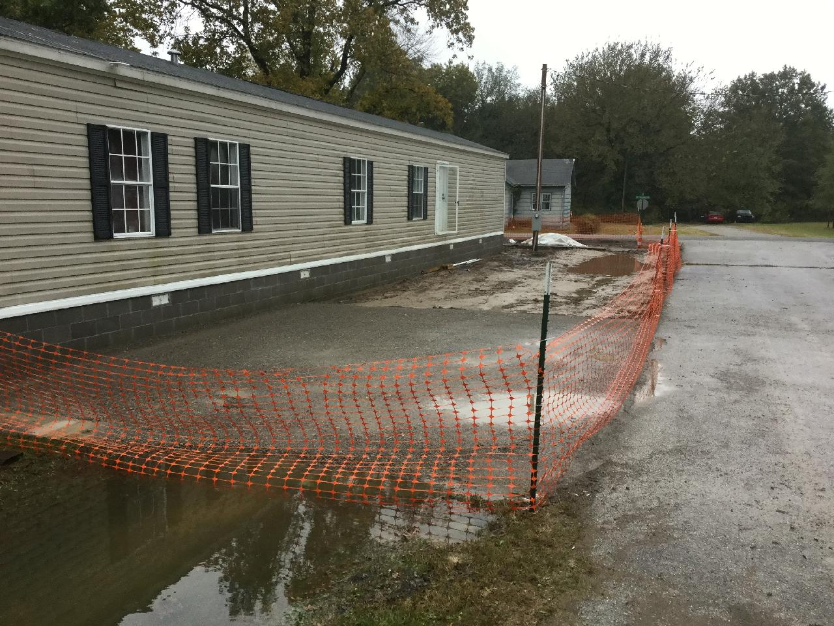

Photo No.: |  |  | Date and Time: Wed Oct 30 09:47:13 2019 GMT-0500
Photographer: James A. Johnson |  |  |  |  |  | Direction: Southwest
Device ID: cf86d62934934fe1a1018ee9dd8b605b
Latitude: | 37.305799 |  |  | Longitude: | -94.77122 |  | GPS Receiver: | From Camera
Description: 602 S. Washington. Photo shows site conditions. The driveway has gravel in it and was compacted and completed. The underdrain was repaired along the north side right of way. Waiting for rain to stop so we can topsoil and sod. Note the standing water within the property boundary.

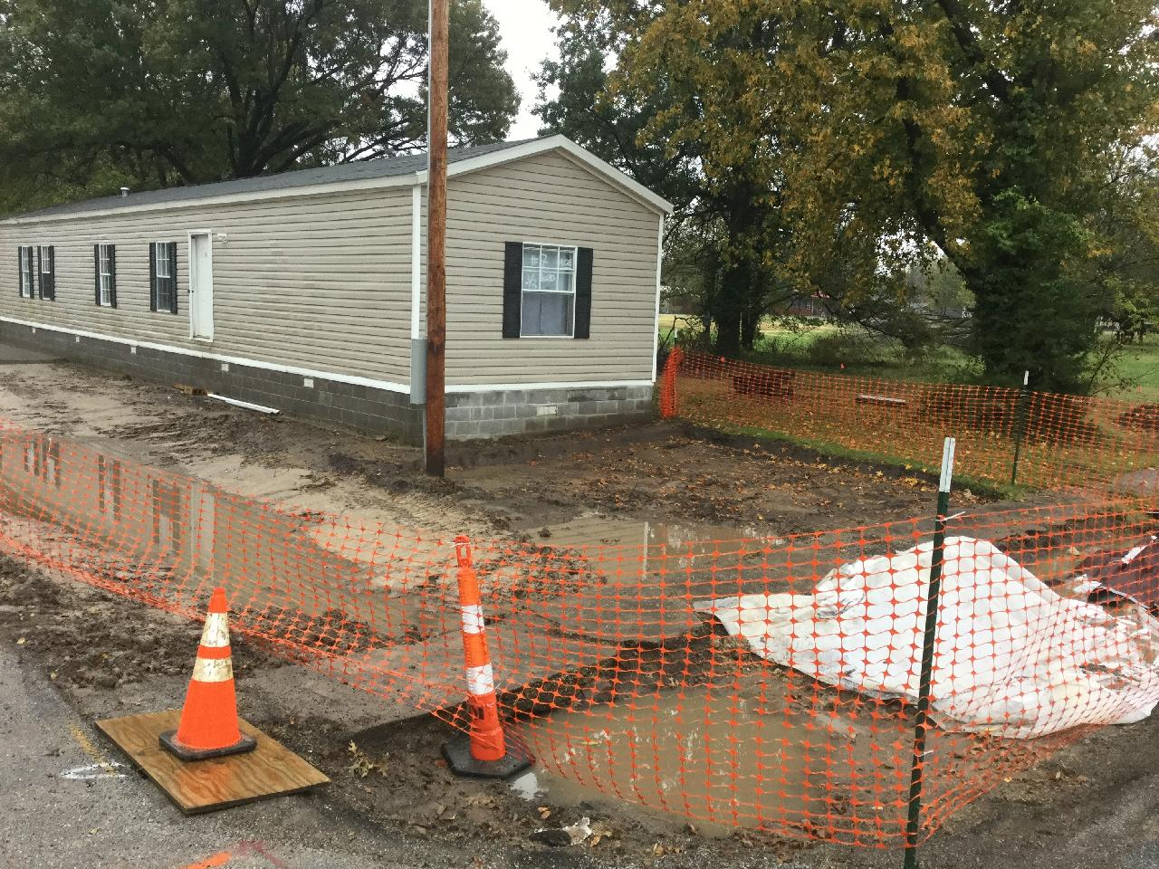

Photo No.: |  |  | Date and Time: Wed Oct 30 09:50:23 2019 GMT-0500
Photographer: James A. Johnson |  |  |  |  |  | Direction: Southeast
Device ID: cf86d62934934fe1a1018ee9dd8b605b
Latitude: | 37.305799 |  |  | Longitude: | -94.771622 |  | GPS Receiver: | From Camera
Description: Another view of 602 S. Washington. The photo shows how rain has impacted site operations.

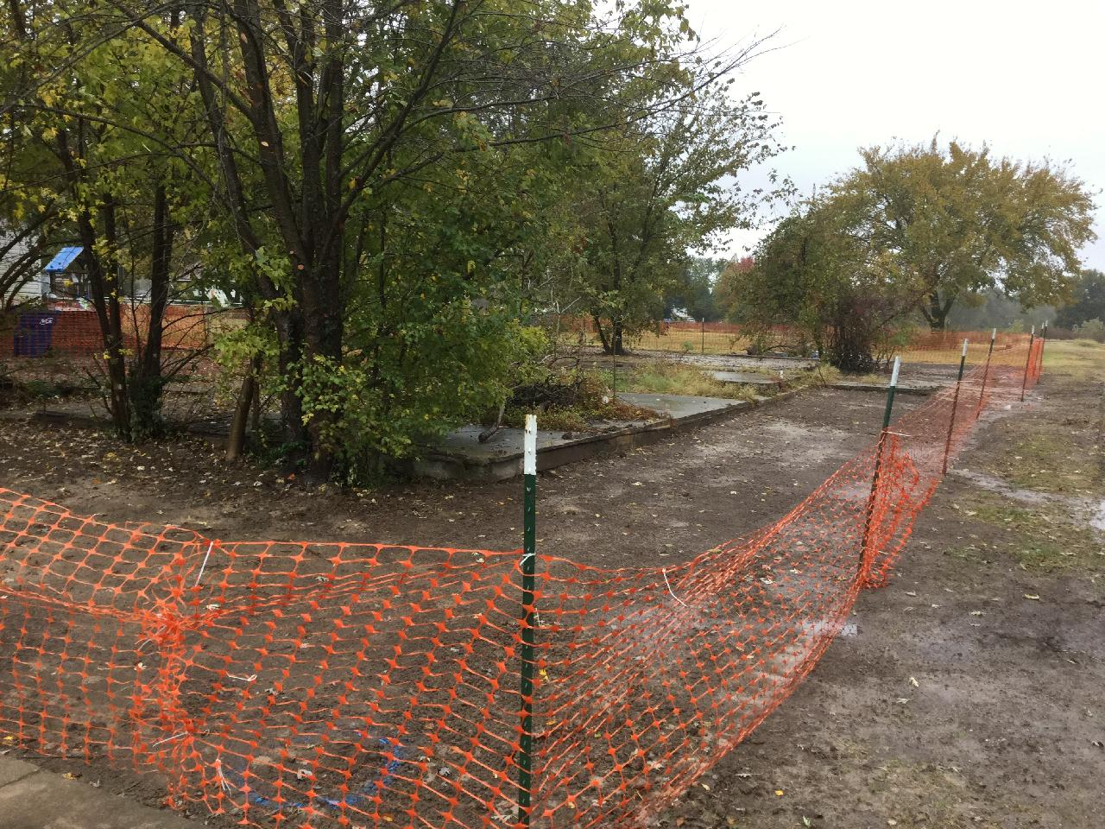

Photo No.: |  |  | Date and Time: Wed Oct 30 10:21:14 2019 GMT-0500
Photographer: James A. Johnson |  |  |  |  |  | Direction: Southeast
Device ID: cf86d62934934fe1a1018ee9dd8b605b
Latitude: | 37.310047 |  |  | Longitude: | -94.775208 |  | GPS Receiver: | From Camera
Description: 304 W. Main. There are two areas that need to be remediated. Both sections are awaiting for the addition of topsoil and sod once the rain moves out of the area and the property has a chance to dry out.

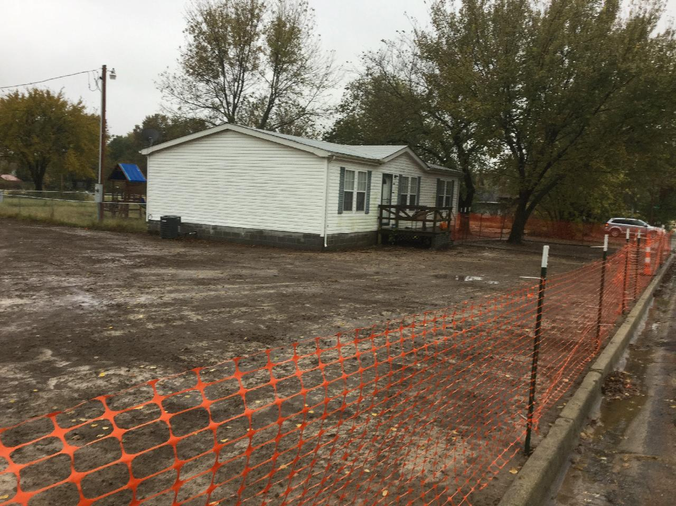

Photo No.: |  |  | Date and Time: Wed Oct 30 10:23:10 2019 GMT-0500
Photographer: James A. Johnson |  |  |  |  |  | Direction: Southwest
Device ID: cf86d62934934fe1a1018ee9dd8b605b
Latitude: | 37.31004 |  |  | Longitude: | -94.774599 |  | GPS Receiver: | From Camera
Description: 304 W. Main. Site conditions. Waiting for topsoil and sod.

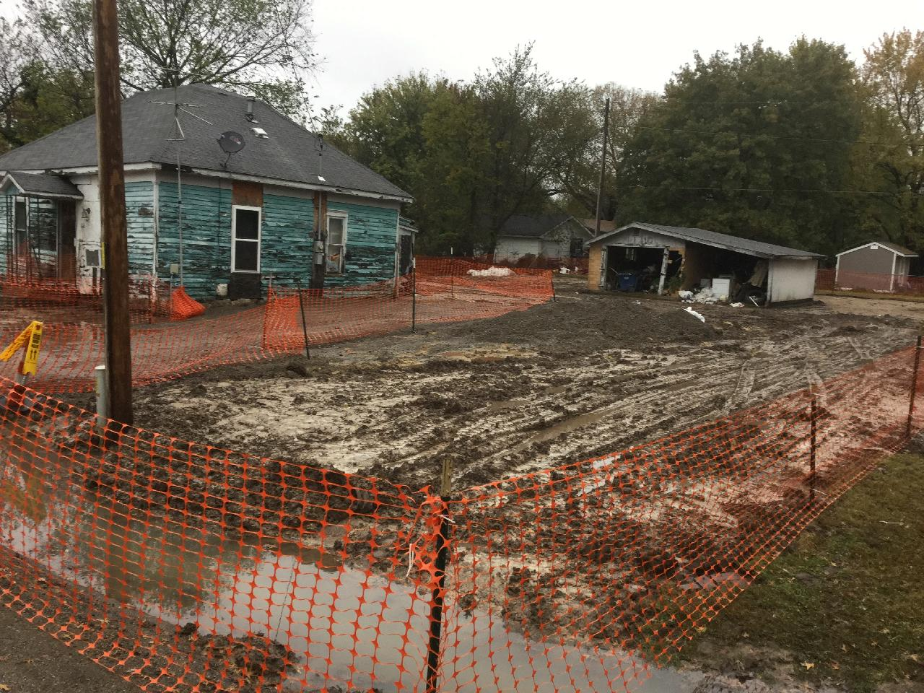

Photo No.: |  |  | Date and Time: Wed Oct 30 10:27:37 2019 GMT-0500
Photographer: James A. Johnson |  |  |  |  |  | Direction: Northwest
Device ID: cf86d62934934fe1a1018ee9dd8b605b
Latitude: | 37.310105 |  |  | Longitude: | -94.77963 |  | GPS Receiver: | From Camera
Description: 613 W. Main. Rain has hampered removal actions. This area has standing water throughout. It appears that most of the property is below the water table because it has consistently stayed wet thru the removal process. The muck has made excavation challenging.

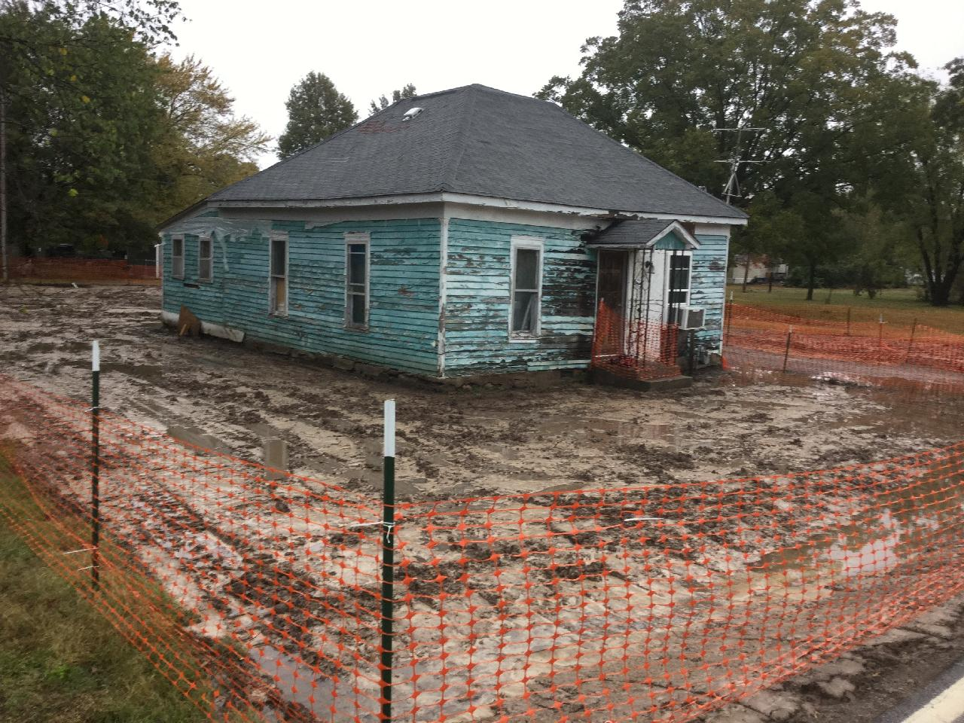

Photo No.: |  |  | Date and Time: Wed Oct 30 10:29:35 2019 GMT-0500
Photographer: James A. Johnson |  |  |  |  |  | Direction: Northeast
Device ID: cf86d62934934fe1a1018ee9dd8b605b
Latitude: | 37.310109 |  |  | Longitude: | -94.779951 |  | GPS Receiver: | From Camera
Description: 613 W. Main. Another view. Yard is basically mud. See photos 10 & 12.

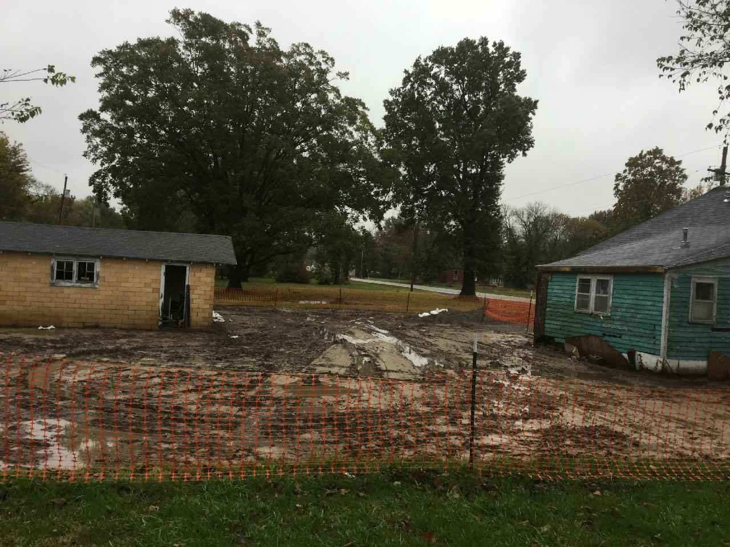

Photo No.: |  |  | Date and Time: Wed Oct 30 10:34:22 2019 GMT-0500
Photographer: James A. Johnson |  |  |  |  |  | Direction: Southeast
Device ID: cf86d62934934fe1a1018ee9dd8b605b
Latitude: | 37.310427 |  |  | Longitude: | -94.779993 |  | GPS Receiver: | From Camera
Description: Backyard of 613 W. Main. Note the standing water throughout the property boundary.

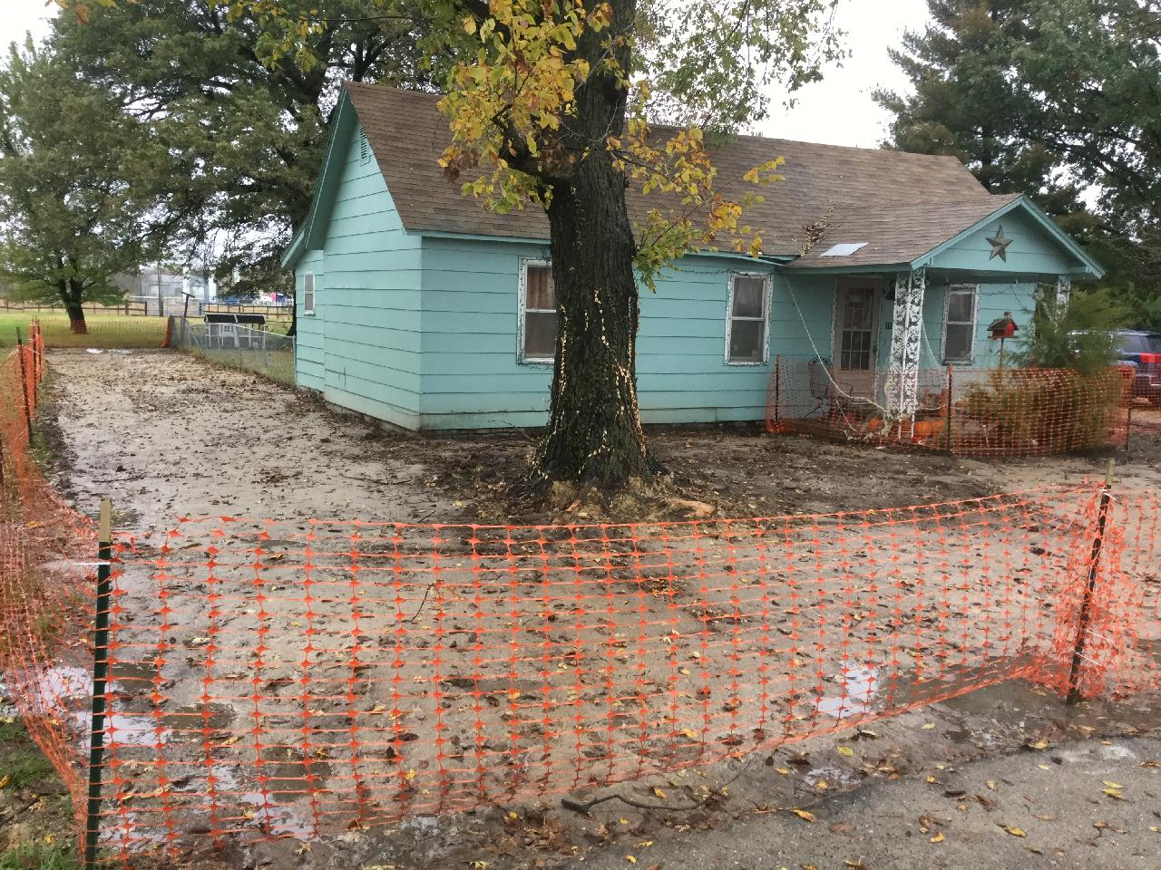

Photo No.: |  |  | Date and Time: Wed Oct 30 10:39:55 2019 GMT-0500
Photographer: James A. Johnson |  |  |  |  |  | Direction: Northeast
Device ID: cf86d62934934fe1a1018ee9dd8b605b
Latitude: | 37.310914 |  |  | Longitude: | -94.772242 |  | GPS Receiver: | From Camera
Description: 101 W. Forest. Awaiting topsoil and sod. Rain and bad weather conditions have impacted our ability to complete the removal action.

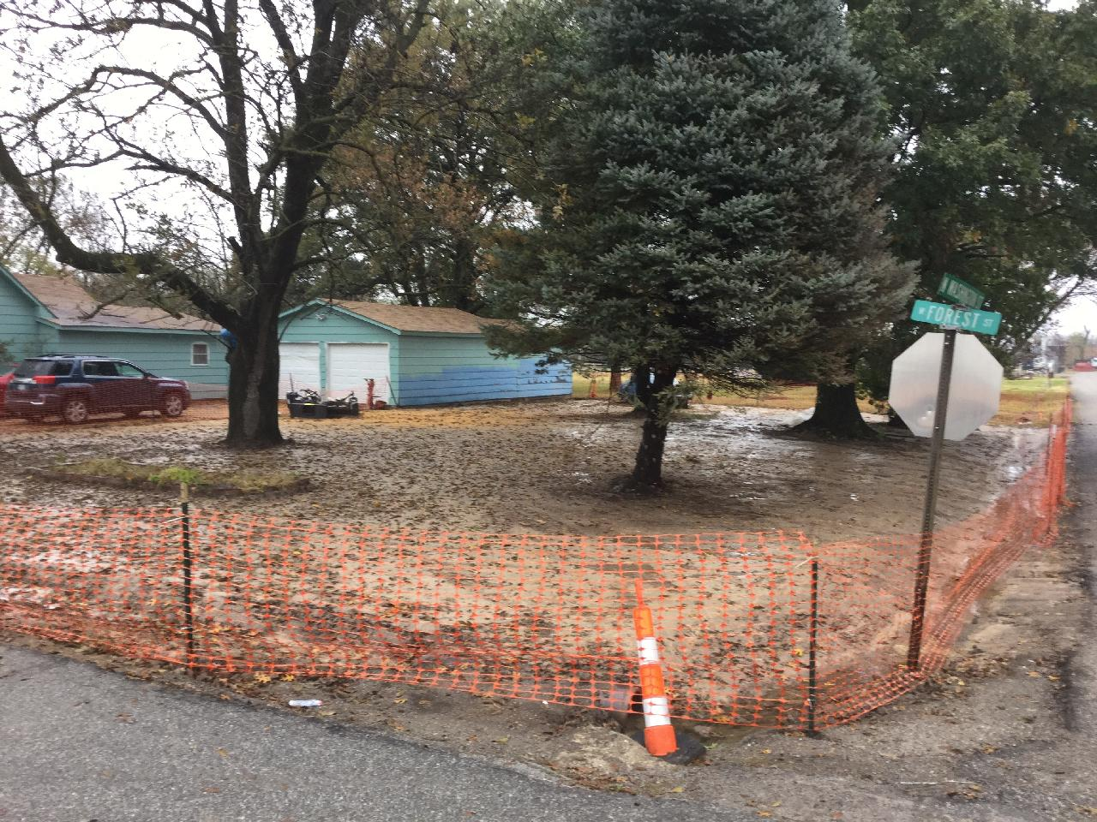

Photo No.: |  |  | Date and Time: Wed Oct 30 10:42:00 2019 GMT-0500
Photographer: James A. Johnson |  |  |  |  |  | Direction: Northwest
Device ID: cf86d62934934fe1a1018ee9dd8b605b
Latitude: | 37.310953 |  |  | Longitude: | -94.771771 |  | GPS Receiver: | From Camera
Description: 101 W. Forest. Taken at the intersection of Forest and Washington streets.

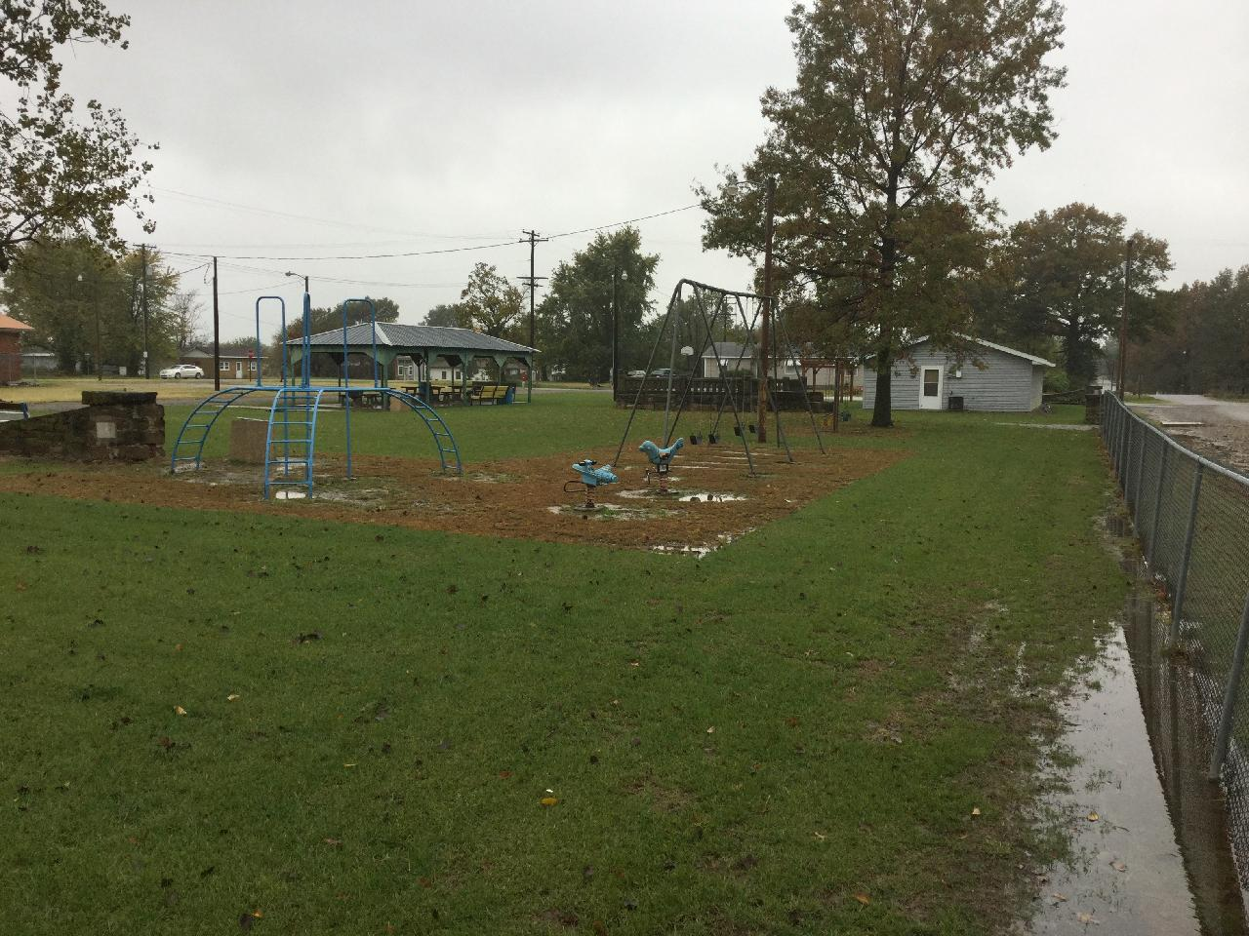

Photo No.: |  |  | Date and Time: Wed Oct 30 10:44:35 2019 GMT-0500
Photographer: James A. Johnson |  |  |  |  |  | Direction: Southwest
Device ID: cf86d62934934fe1a1018ee9dd8b605b
Latitude: | 37.310854 |  |  | Longitude: | -94.771812 |  | GPS Receiver: | From Camera
Description: City of Weir park. Photo documents site conditions. ER is in talks with the City concerning property restoration.

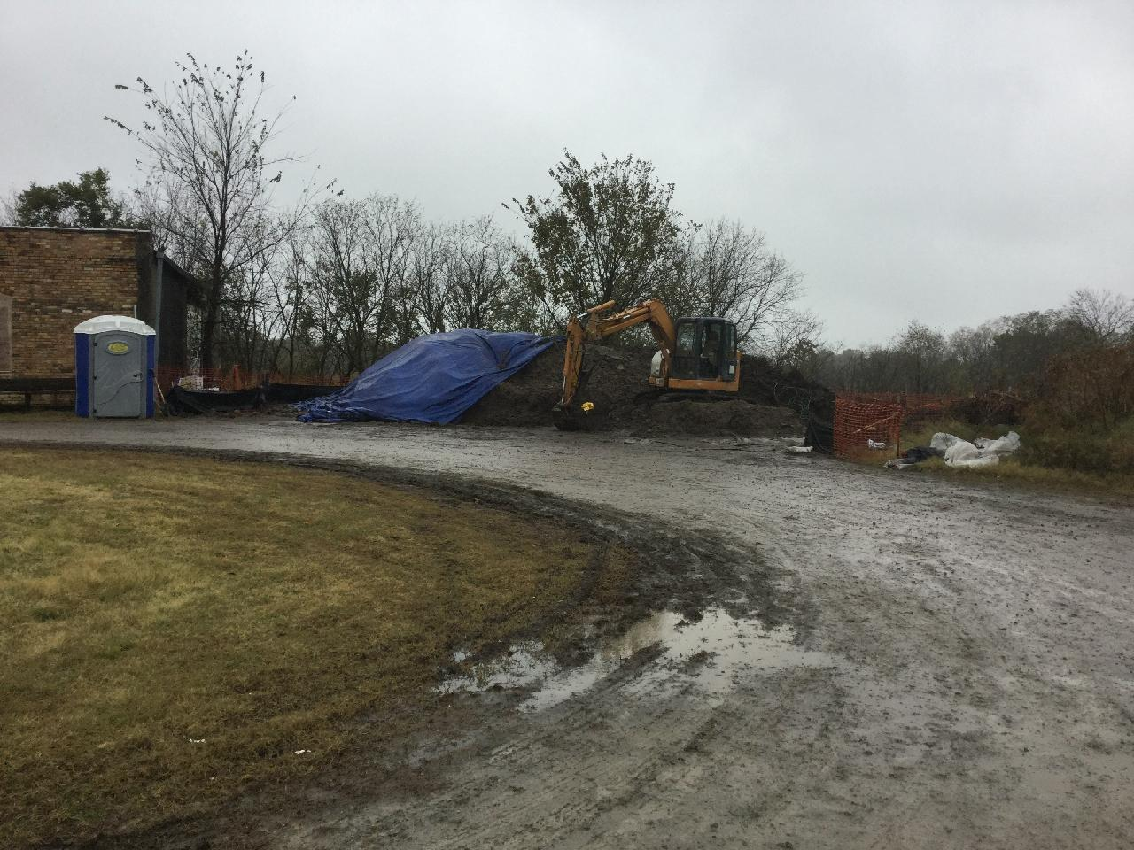

Photo No.: |  |  | Date and Time: Wed Oct 30 10:49:33 2019 GMT-0500
Photographer: James A. Johnson |  |  |  |  |  | Direction: North
Device ID: cf86d62934934fe1a1018ee9dd8b605b
Latitude: | 37.31311 |  |  | Longitude: | -94.771407 |  | GPS Receiver: | From Camera
Description: ER lead contaminated soil staging area. Soil is staged here until enough material is accumulated to make runs to the transportation and compaction facility in Baxter Springs, Kansas (roughly 30 miles south of this point). This area has a secure gate and ER is staging their equipment here as well.

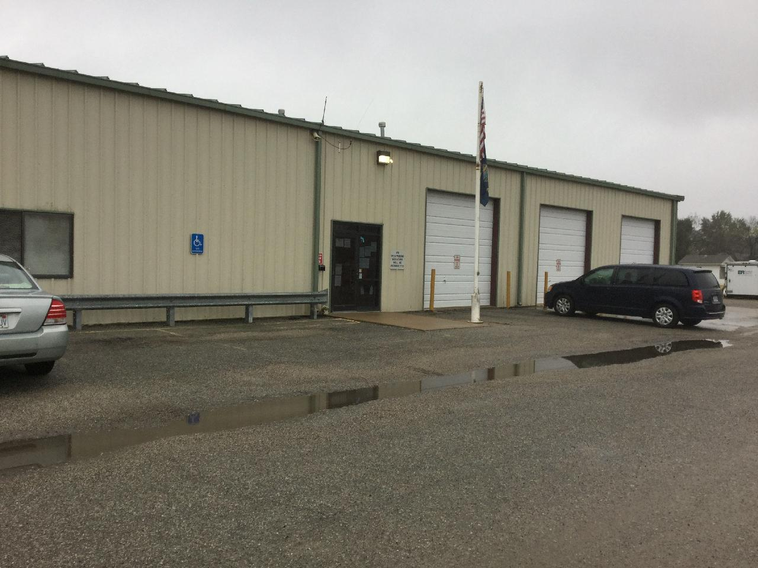

Photo No.: |  |  | Date and Time: Wed Oct 30 10:53:28 2019 GMT-0500i
Photographer: James A. Johnson |  |  |  |  |  | Direction: Southeast
Device ID: cf86d62934934fe1a1018ee9dd8b605b
Latitude: | 37.312639 |  |  | Longitude: | -94.771786 |  | GPS Receiver: | From Camera
Description: Weir County Clerks Office. 413 N. Washington Street. Weir, Kansas 66781

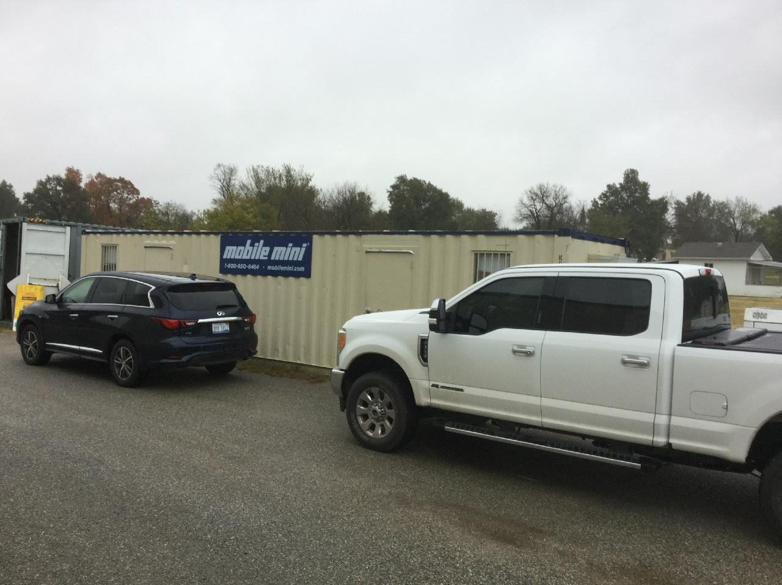

Photo No.: |  |  | Date and Time: Wed Oct 30 10:59:00 2019 GMT-0500
Photographer: James A. Johnson |  |  |  |  |  | Direction: Southeast
Device ID: cf86d62934934fe1a1018ee9dd8b605b
Latitude: | 37.312315 |  |  | Longitude: | -94.771631 |  | GPS Receiver: | From Camera
Description: ER operation center. Next to City of Weir Clerks office. ER has an equipment trailer and storage connex box here also.

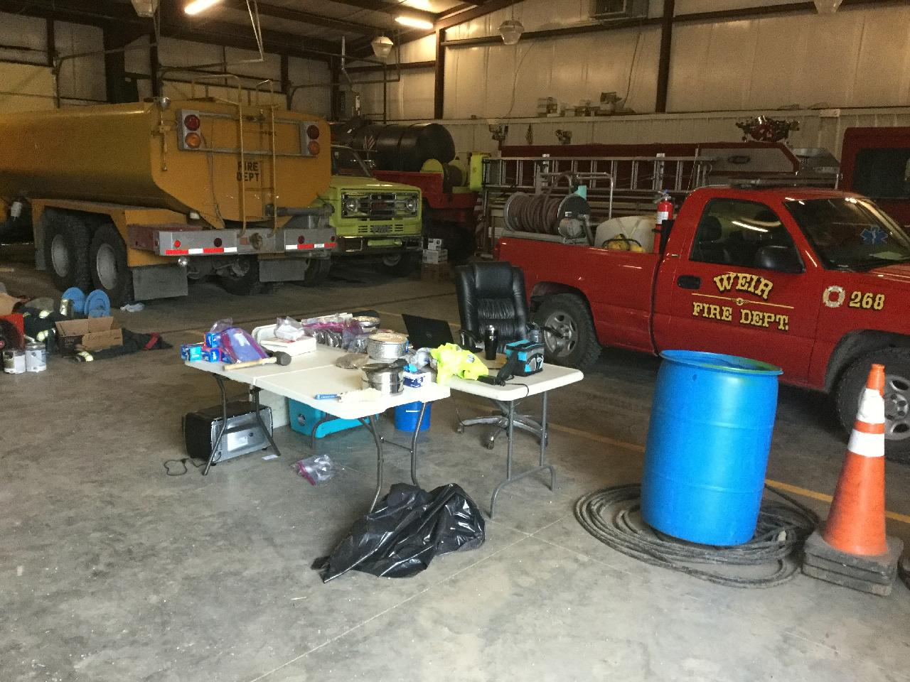

Photo No.: |  |  | Date and Time: Wed Oct 30 11:00:56 2019 GMT-0500
Photographer: James A. Johnson |  |  |  |  |  | Direction: Southeast
Device ID: cf86d62934934fe1a1018ee9dd8b605b
Latitude: | 37.312487 |  |  | Longitude: | -94.771669 |  | GPS Receiver: | From Camera
Description: START field office and operations area inside the garage at the City Hall.

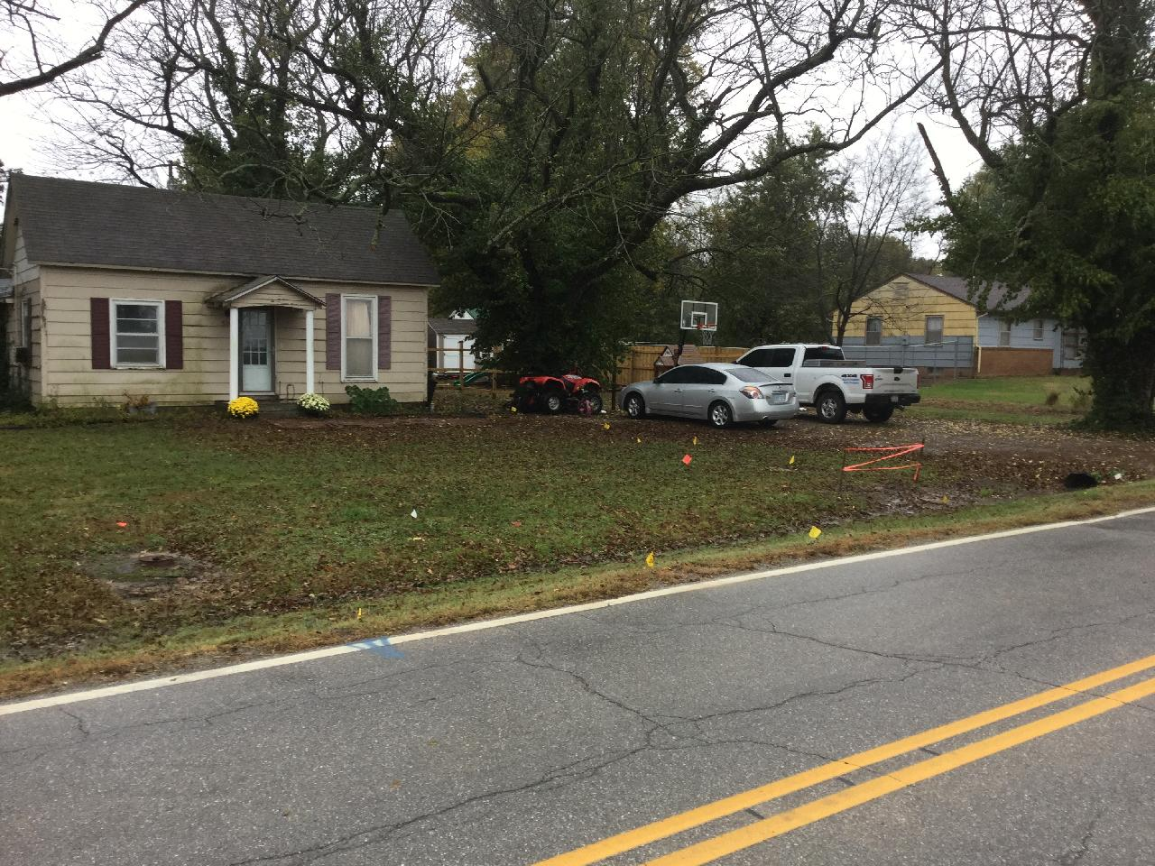

Photo No.: |  |  | Date and Time: Wed Oct 30 11:42:40 2019 GMT-0500
Photographer: James A. Johnson |  |  |  |  |  | Direction: South
Device ID: cf86d62934934fe1a1018ee9dd8b605b
Latitude: | 37.310052 |  |  | Longitude: | -94.764524 |  | GPS Receiver: | From Camera
Description: 510 E. Main. Property owner initially granted access to conduct removal action. Property owner reminded access on 10/4/2019.

