ENVIRA
Aquaculture Fisheries Environmental
P.O. Box 2612, Ramona, California, USA 92065
Phone 619-885-0236 E-mail PHVERGNE@AOL.COM

Biological Assessment
for the Redlands Shooting Club Lead Shot Recovery Project
San Bernardino County, California

Project History
Environmental Reclamation Services-ERS has been engaged by the Redlands Shooting Club-RSC to recover and recycle antimonial lead shot from the drop zone of the Redlands Shooting Park. The Redlands Shooting Club is located in Redlands, San Bernardino County, CA. (Figure1).

On February 20, 2008 ERS started the Conditional Use Permit-CUP application process with the San Bernardino Public Works-SBPW. SBPW indicated that they would have no objection to issuing a permit provided that every other jurisdiction claiming authority also approved.

- On March 30, 2008, ERS submitted to California Department of Fish & Game a project application which was approved June 3, 2008.
- On August 6, 2008, ERS submitted our application to Mr. Geraldo Salas of the Army Corps of Engineers, Los Angeles District.
- On September 25, 2008 ERS was informed that a phase one Biological Resources Assessment would be required to further process the application.
- In November 2008, Philippe Vergne of ENVIRA performed a Phase One Site Evaluation on the property and wrote a report of preliminary findings dated November 15, 2008.
- On December 16, 2008, the completed Assessment was forwarded to Mr. Salas by Certified Mail and a request for Formal Consultation was initiated.
- On September 1, 2009 in reply to the Phase One site evaluation (FWS-SB-09B406-09TA1084), a request for additional data was received from the USFWS.
- On September 26, 2009 Philippe Vergne of ENVIRA, was retained by Environmental Reclamation Services, LLC to carry out a focused resource evaluation survey and Biological Assessment-BA on the RSC target and lead shot drop zone.

Project Background
Environmental Reclamation Services-ERS has been engaged by the Redlands Shooting Club-RSC to recover and recycle antimonial lead shot from the drop zone of the Redlands Shooting Park. ERS proposes to recover the lead shot from the drop zone within the project area.

At the Redlands Shooting Club, clay targets are typically launched for trap or skeet shooting in a trajectory that causes a significant portion of the lead shot fired at the targets to fall into the Santa Ana River Floodplain and within the established Santa Ana Wooly Star Preserve.

Over the years, continued target shooting over the area has leads to a significant accumulation of lead shot immediately adjacent to the Shooting club. Because the lead is relatively heavy, the lead shot becomes embedded in and mixed with the sand, silt material within the drop zone.
As time goes on, the amount of lead in the drop zone steadily increases. Currently, a significant concentration of lead shot is found in the drop zone, from the surface to a depth of eight or more inches. Lead concentrations are highest in front of the target area, but downstream water transport of lead shot has occurred during periods of heavy rain when the secondary water channels on site are active.
The recovery area is subject to a number of land ownership (Figure 2) and regulatory jurisdictions, including the US Army corps of Engineers-Corps, the US Fish and Wildlife Service-USFWS, the California Department of Fish and Game-CDFG, the San Bernardino Flood Control District-SBFCD, and the Environmental Protection Agency- EPA.

The EPA's focus on lead shot is through the Hazardous Waste Compliance Program, which implements the Resource Conservation Recovery Act and amendments to that act.

Reclamation of the lead shot from the floodplain would reduce potential direct environmental hazard.

Initial site investigation (ENVIRA, November 25, 2008) determined that the federally listed as endangered San Bernardino kangaroo rat- SBKR (Dipodomys merriami parvus), and the Santa Ana river wooly star ( Eriastrum densifolium sanctorum) were present on site. Potential habitat also occurs on site for the slender-horned spine lower (Dodecahema leptocerus); and water flow from the ephemeral drainage on site are within the watershed that supply water to critical habitat for the endangered Santa Ana river sucker (Catostomus santaanae).

The proposed project footprint is estimated at 3-acres, of which 2.6 acres are occupied by the San Bernardino kangaroo rat. There are an estimated 275-285 Santa Ana River wooly star plants, in 12 clumps, located within the project footprint area.

Because federally-listed endangered species are present and critical habitat occurs within
the proposed action area, and pursuant a request from the USFWS of September 1, 2009 for more information the current biological assessment- BA was prepared.

Regulatory Background
Special status species are native species that have been afforded special legal or management protection because of concern for their continued existence. There are several categories of protection at both federal and state levels, depending on the magnitude of threat to continued existence and existing knowledge of population levels.

Federal Endangered Species Act
The USFWS administers the federal Endangered Species Act (FESA) that provides a process for listing species as either threatened or endangered, and methods of protecting listed species. The FESA defines as “endangered” any plant or animal species that is in danger of extinction throughout all or a significant portion of its range. A “threatened” species is a species that is likely to become endangered in the foreseeable future. A “proposed” species is one that has been officially proposed by USFWS for addition to the federal threatened and endangered species list.
Section 9 of the FESA prohibits “take” of threatened or endangered species. The term “take” means to harass, harm, pursue, hunt, shoot, wound, kill, trap, capture, or collect, or to attempt to engage in such conduct. The presence of any federally threatened or endangered species that are in a project area generally imposes severe constraints on development, particularly if development would result in “take” of the species or its habitat. Under the regulations of the FESA, the USFWS may authorize “take” when it is incidental to, but not the purpose of, an otherwise lawful act.
Take can be allowed following consultation with U.S. Fish and Wildlife Service (USFWS) pursuant to section 7(a)(2) of the Endangered Species Act (ESA).

California Endangered Species Act
The CDFG administers the California Endangered Species Act (CESA). The State of California consider an endangered species as one whose prospects of survival and reproduction are in immediate jeopardy. A threatened species is considered as one present in such small numbers throughout its range that it is likely to become an endangered species in the near future in the absence of special protection or management. A rare species is one that is considered present in such small number throughout its range that it may become endangered if its present environment worsens. State threatened and endangered species are fully protected against take, as defined above.

Sections 3503 and 3511 of California Fish and Game Code
The CDFG administers the California Fish and Game Code. There are particular sections of the Code that are applicable to natural resource management. For example, Section 3503 of the Code states it is unlawful to take, possesses, or needlessly destroy the nest or eggs of any bird. Section 3511 of the Code lists fully-protected bird species, where the CDFG is unable to authorize the issuance of permits or licenses to take these species.

Migratory Bird Treaty Act
The Migratory Bird Treaty Act (MBTA) makes it unlawful to pursue, capture, kill, or possess or attempt to do the same to any migratory bird or part, nest, or egg of any such bird listed in wildlife protection treaties between the United States, Great Britain, Mexico, Japan, and the countries of the former Soviet Union.

Section 404 of the Federal Clean Water Act
Section 404 of the federal Clean Water Act, which is administered by the Corps regulates the discharge of dredge and fill material into waters of the United States. The Corps has established a series of nationwide permits that authorize certain activities in waters of the United States, provided that a proposed activity can demonstrate compliance with standard conditions. Normally, the Corps requires an individual permit for an activity that will affect an area equal to or in excess of 0.3 acre of waters of the United States. Projects that result in impacts to less than 0.3 acre of waters of the United States can normally be conducted pursuant to one of the nationwide permits, if consistent with the standard permit conditions. The Corps also has discretionary authority to require an Environmental Impact Statement for projects that result in impacts to an area between 0.1 and 0.3 acre. Use of any nationwide permit is contingent on the activities having no impacts to endangered species.

Section 1600 of the California Fish and Game Code
All diversions, obstructions, or changes to the natural flow or bed, channel, or bank of any river, stream, or lake in California are subject to the regulatory authority of the CDFG pursuant to Sections 1600 through 1603 of the Code, requiring preparation of a Streambed Alteration Agreement. Under the Code, a stream is defined as a body of water that flows at least periodically, or intermittently, through a bed or channel having banks and supporting fish or other aquatic life. Included are watercourses with surface or subsurface flows that support or have supported riparian vegetation. CDFG also has jurisdiction within altered or artificial waterways based on the value of those waterways to fish and wildlife, and also has jurisdiction over dry washes that carry water ephemerally during storm events.

Section 401 of the Clean Water Act
Section 401 of the Clean Water Act requires that “any applicant for a federal permit for activities that involve a discharge to waters of the State, shall provide the federal permitting agency a certification from the State in which the discharge is proposed that states that the discharge will comply with the applicable provisions under the federal Clean Water Act.” Therefore, before the Corps will issue a Section 404 permit, applicants must apply for and receive a Section 401 water quality certification from the Regional Water Quality Control Board (RWQCB).

CORPS Jurisdiction and Formal Section-7 Consultation

A braided drainage , with ephemeral water flow, which connects to the main Santa Ana River occurs within the proposed project footprint (Picture One). A length of 330 feet and an average width of 5 feet of drainage will be temporarily impacted by implementation of the shot recovery project.

A 404 permit, and 401 permit from the CORPS (or written waiver) will be required; as will a 1600 permit(or written waiver) from California Department of fish and Game prior to project implementation.

ERS, the project proponent would like to request that the U.S. Army Corps of Engineers, who has jurisdiction within the active flood plain and jurisdictional drainage within the proposed project footprint area take the lead role in initiate formal consultation with the U.S. Fish and Wildlife Service (USFWS) pursuant to section 7(a)(2) of the Endangered Species Act (ESA).

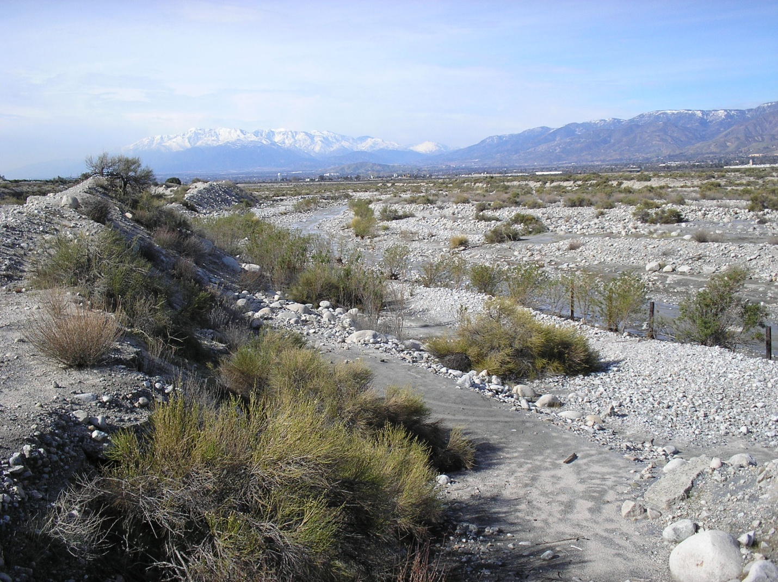

Project Footprint and Shot Recovery Process
A total of 3-acres will be affected by the proposed project, of which an estimated 2.6- acres are occupied by SBKR at a trace to low density. There are an estimated 275 to 285 Santa Ana river wooly star plants, in twelve clumps, within the proposed project area (Figure 3).
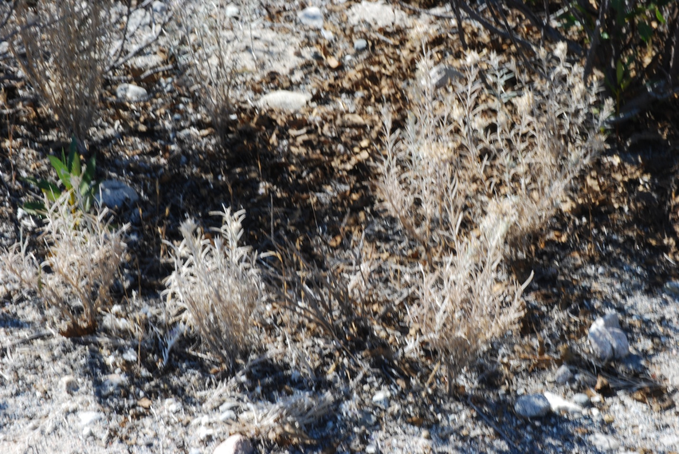

ERS plan for the shot removal operation at this site would be to excavate the areas with lead shot to a depth of 6”-8”. The excavation would occur in the river bed and the adjacent bench areas. The rolling excavation equipment consists of CAT320 steel tracked excavator and rubber tired front end loader.
The excavated material is than transported to a stationary site for separation, using rubber tired loaders. The path way to the stationary equipment would be the same each trip, in order to minimize impacts.
The stationary equipment consists of a screening plant approximate 10’ x 35’, an air filtration plant, approximate 4’ x 4’, a density separation plant approximate 8’ x 21’, a diesel generator and a diesel air compressor.
In order to minimize impacts to sensitive species, ESR proposes to locate the station equipment on the existing roadway used during the construction of the existing levy.
It is estimated that staging and the recovery process will take about three months to complete. The shot recovery process will be repeated every 4-5 years as long as the shooting club is in operation.

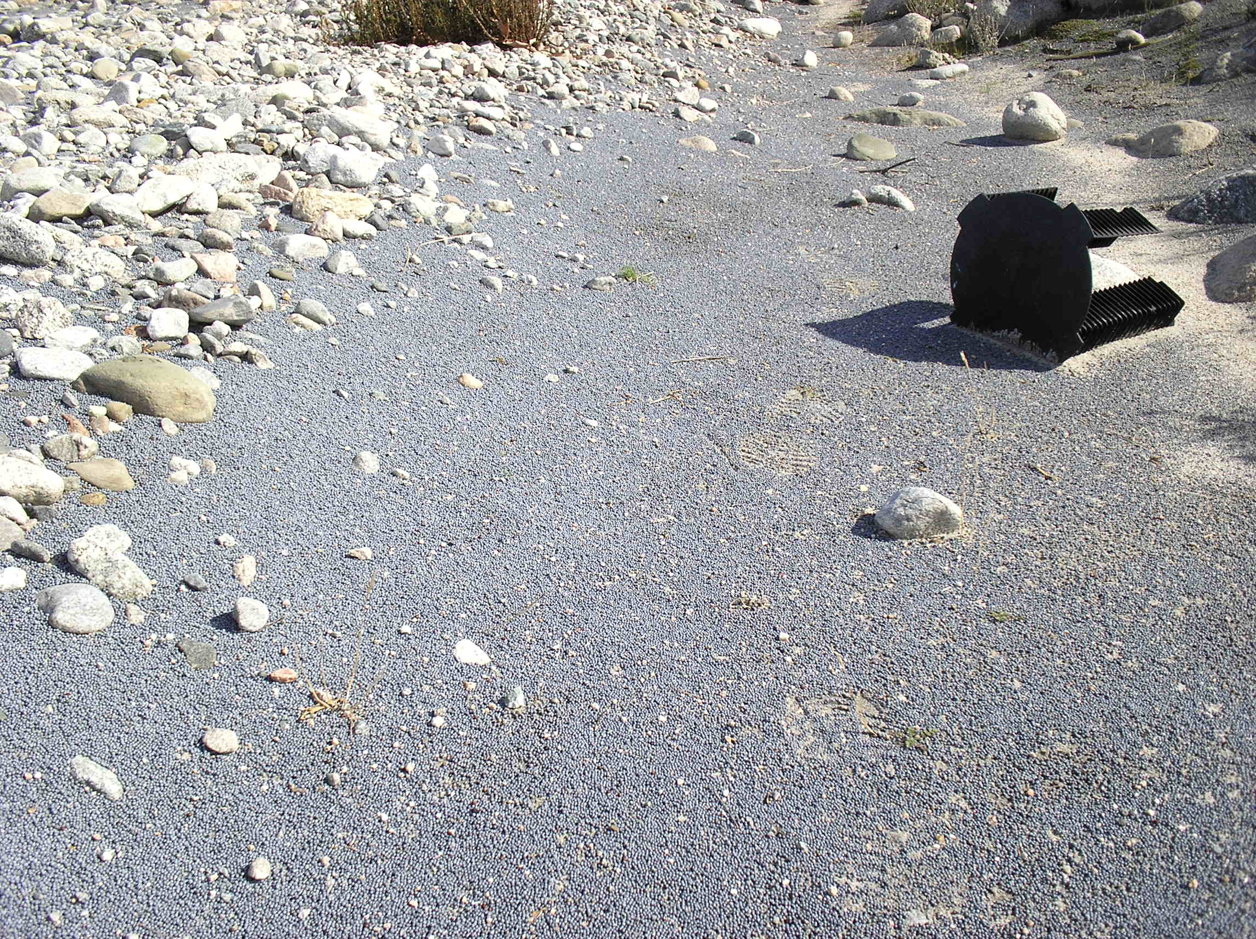

Lead shot on site

SPECIES OF CONCERN
Appendix one lists the potential species of concern, and potential for on-site occurrence for the project quad.
Two of the listed species, the federally endangered San Bernardino kangaroo rat and the Santa Ana River wooly star occur on the project site.

The San Bernardino Kangaroo Rat

This biological opinion does not rely on the regulatory definition of “destruction or adverse modification” of critical habitat at CFR. Instead, we have relied upon the statute and the August 6, 2004, Ninth Circuit Court of Appeals decision in Gifford Pinchot Task Force v. U.S. Fish and Wildlife Service (No. 03-35279) to complete the following analysis with respect to critical habitat.

Listing Status

SBKR was emergency listed as endangered on January 27, 1998, (Service 1998a) because its historic range had been reduced by approximately 95 percent. All remaining populations were considered threatened by habitat loss, degradation, and fragmentation from urban development, sand and gravel (aggregate) mining, flood control, groundwater recharge projects, and vandalism. Upon expiration of the emergency rule, we listed the species as endangered on September 24, 1998 (Service 1998b). Critical habitat was proposed for SBKR on December 8, 2000 (Service 2000) and designated on April 22, 2002 (Service 2002).

Species Description

The SBKR is one of 19 recognized subspecies of Merriam’s kangaroo rat (Dipodomys merriami), a widespread species distributed throughout the arid regions of the western United States and northwestern Mexico (Hall 1981; Williams et al. 1993). There are three recognized subspecies of Merriam’s kangaroo rat within California: D. merriami merriami, D. merriami collinus, and the SBKR. Based on morphological evidence, Lidicker (1960) noted that the SBKR is one of the most highly differentiated subspecies of D. merriami, which may be due to the SBKR’s nearly complete isolation from other members of D. merriami (Lidicker 1960).

Habitat Affinities

In most heteromyids, which include kangaroo rats and pocket mice, soil texture is a primary factor in determining species distribution (Brown and Harney 1993). SBKR require well-drained, sandy substrates where they are able to dig simple, shallow burrows (McKernan 1997). SBKR also occupy gravelly soils (McKernan 1993) and areas where sandy soils are at least partially deposited by winds (e.g., Jurupa Mountains, McKernan 1997). It appears less abundant in areas with silt-clay soils (MEC Analytical Systems 2000).

SBKR density is highest in areas with low to moderate (30 to 50 percent) perennial vegetative cover and greater than 40 percent bare ground although this species can occur within areas supporting higher or lower shrub cover. Areas with a dense cover (greater than 60 percent) of nonnative annual plants and/or litter are typically either unoccupied by SBKR or occupied at low densities. Within otherwise suitable shrub habitat for SBKR, the percent cover of herbaceous vegetation and sand depth can range from very low to very high (McKernan 1997; MEC Analytical Systems 2000).

Within the range of the SBKR, the appropriate mix of sandy soils and low density shrub cover most frequently occurs in alluvial scrub. This vegetation type is found in braided channels (alluvial fans) that are created by sediment transport and scour from mountain drainages. Alluvial scrub is characterized by low growing shrubs and other perennial species tolerant of a relatively sterile, rapidly draining substrate and includes elements from chaparral, coastal sage scrub, and desert communities (Holland 1986). Three phases (pioneer, intermediate, and mature) of alluvial scrub have been described. These phases correlate with flood intervals and overbank flows as determined by elevation and distance from the main river channel (Smith 1980; Hanes et al. 1989). Under natural conditions, flood watesr periodically overtop or break out of alluvial river channels in unpredictable spatial and temporal patterns scouring vegetation and transporting and depositing sands. These hydrogeomorphic processes are necessary to maintain the mosaic of pioneer, intermediate, and mature alluvial scrub associations within the floodplain upon which SBKR rely.

High densities of SBKR have been documented in early successional alluvial scrub (i.e., pioneer and intermediate phases), which generally correlate with areas that have been more recently disturbed by floods (within the last 40 to 70 years) (McKernan 1997). The pioneer phase is subject to frequent disturbance, and vegetation is characterized by sparse shrub and forb cover (Smith 1980; Hanes et al. 1989). The intermediate phase, which has an intermediate density of shrubs and sparse forb cover, is typically found between the active river channel and mature flood plain terraces at higher elevations. The late successional or mature phase occurs in areas infrequently affected by flooding (e.g., upper alluvial terraces) and, as a result, has the densest shrub cover (Smith 1980; MEC Analytical Systems 2000). Areas with mature, dense shrub cover are generally occupied at low densities by SBKR with animals found in scattered microsites (pockets or patches) with more open shrub cover and loose, sandy soils (Braden and McKernan 2000). Areas that receive annual or nearly annual flooding are classified as open channel and are not considered suitable habitat for SBKR.

The presence of both early and late successional alluvial scrub is required to maintain SBKR persistence through flooding cycles (Service 2002). Large flooding events can temporarily eliminate SBKR from densely occupied habitat in early successional alluvial scrub, and SBKR from late successional alluvial scrub provide the source for re-colonization when vegetation returns to flooded areas. Individuals from mature alluvial scrub naturally dispense into their preferred habitat in the lower floodplain as pioneer alluvial scrub returns, and with favorable climatic conditions, SBKR density within the lower floodplain increases dramatically. Because mature alluvial scrub supports only low densities of SBKR, persistence is dependent upon immigration from higher density occupied habitat in early successional alluvial scrub. Therefore , areas that include a mosaic of alluvial scrub successional stages have increased ability to support populations through stochastic events such as flooding.

Life History

Although few studies have specifically addressed life history aspects of the SBKR, other subspecies of D. merriami are relatively well studied, and the following information is drawn primarily form these studies. SBKR are primarily nocturnal and active throughout the year. Individuals typically emerge from their burrows after sunset and may be active at any time during the night. Although reproductive activities peak in June and July, SBKR appear to have a prolonged breeding season. Pregnant or lactating females have been captured between January and November while makes in scrotal condition have been captured between January and August (McKernan 1997). Females are capable of having more than one litter per year, and litter sizes probably average between two and three young (M. O’Farrell, Las Vegas, Nevada, as cited in MEC Analytical Systems 2000).

Typical of kangaroo rats, Merriam’s kangaroo rats are primarily granivorous and often store large quantities of seeds in surface caches (Reichman and Price 1993). Seeds are the primary food source; however, green vegetation and insects appear to be important seasonal food and water sources (Tracy and Walsberg 2002). Seed caching may enable them to endure temporary shortages of food, as has been documented for other species of Dipodomys (Reichman and Price 1993).

SBKR reside in burrow systems each of which appears to be occupied by a single adult. The burrow systems of adults are often clustered in a given area. Little is known about the spatial requirements of SBKR. In other species of Dipodomys, the sizes of home ranges vary depending on habitat features, season, food availability, population density, and gender. Behrends et al. (1986) studied home ranges for the Merriam’s kangaroo rat in Riverside County, California during 3 periods and found that home ranges averaged between 0.52 and 1.06 acres for females and between 0.44 and 1.28 acres for males. Outlying areas of home ranges of neighboring kangaroo rats may overlap, but adults actively defend small core areas near their burrows (Behrends et al. 1986; Jones 1993). Zeng and Brown (1987) and Jones (1989) concluded that Merriam’s kangaroo rats rarely disperse more than 328 feet in any single movement and rarely move more than 1,148 feet over their lifetime. This work also showed that long distance dispersal typically occurs as a series of shifts in centers of activities rather than single long distance movements.

Kangaroo rat population typically exhibit large fluctuations in density in response to temporal variability in plant productivity (Price and Kelly 1994; Brown and Harney 1993; Goldingay et al. 1997), and limited data suggest that SBKR population density is highly variable although causes of this variation are poorly understood (Braden and McKernan 2000). During periods of drought and/or low resource abundance , adults typically forgo breeding and population persistence relies solely upon high survivorship and/or immigration from elsewhere (Brown and Harney 1993). Flooding patterns are also important determinants of SBKR population dynamics. Large flooding events may temporarily eliminate SBKR from their preferred habitat in early successional alluvial scrub. During these events survival is dependent upon occupied habitat in mature alluvial scrub as described previously (Service 2002).

Competition, predation, and disease could threaten remnant populations of kangaroo rats by limiting population growth rates. Competition occurs when individuals of the same or different species utilize common resources (food, space, burrows) that are in short supply; or, if the resources are not in short supply, competition occurs when organisms seeking the resources actively defend territories. Many territorial interactions ensued after Tipton kangaroo rats (Dipodomys nitratoides nitratoides) were translocated into habitat that was already occupied by this species to the detriment of the relocated animals (Goldingay et al. 1997). Specific information on the types and abundances of predators is lacking, but it is likely that predation by urban-associated animals has increased as development encroaches upon SBKR habitat. These factors could be major threats under the current conditions of small, isolated and, potentially inbred populations.

Threats

Threats to SBKR include habitat loss, destruction, degradation, and fragmentation due to aggregate mining operations, flood control projects, ground-water pumping and water spreading (i.e., groundwater recharge), road crossings, off-highway vehicle (OHV) use, agriculture, urbanization, or some combination of these.

Aggregate mining continues to degrade habitat occupied by SBKR along the Santa Ana and San Jacinto rivers and Bautista, City, Cajon, and Lytle creeks. Out-of-stream aggregate mining operations destroy SBKR habitat and may constrain linkages within SBKR populations. In-stream aggregate mining operations cause similar impacts to SBKR and may cause severe alterations in scouring and sediment deposition patterns both upstream and downstream (Scott 1973; Mount 1995; Kondolf 1997).

In-stream mining pits effectively lower river channels and increase upstream flow velocity that in turn increases the rate of sediment scouring. Once the sediment-rich flows reach mining pits, sediment settles to the pit bottoms, and flows that overtop the mining pit are starved of sediment. The net effect is channel down-cutting upstream due to high flow velocity and downstream due to sediment deposition that rejuvenate alluvial scrub are replaced by confined flows in deeply incised river channels.

Flood control structures often confine, isolate, or fragment populations of SBKR, thereby predisposing them to catastrophes and other risks faced by small populations. Conversion of floodplains into narrow, monotypic channels has removed the physical structure (i.e., terracing) as well as the aerial extent of the active floodplain.

Historically, large floodplains supported various phases of alluvial scrub depending on the frequency of scouring from flooding events. With channelization, many floodplains have become more homogeneous than in the past with either active channels that experience frequent flooding (open channel and pioneer alluvial scrub) or historic floodplains that experience very infrequent flooding (mature alluvial scrub). Impacts from dams are similar to those from in-stream mining operations with similar alternations to scour and sediment flow patterns.

Human activities that threaten SBKR include dumping and recreational activities. OHV use directly damages plant communities, the soil crust, and the burrow systems of kangaroo rats. Trespass by off-highway vehicles continues to destroy and degrade hundreds of acres of alluvial scrub communities occupied by SBKR in and near the Santa Ana and San Jacinto river, and City Plunge, Lytle, and Cajon creeks.

Loss and fragmentation of habitat for SBKR continues as the human population increases and urbanization expands in southern California. In the 1950s, the population of Riverside and San Bernardino counties totaled approximately 400,000 people. The current population estimate for this region is approximately 1.8 million. Forecasts by the Southern California Association of Governments indicate that the population in San Bernardino County may reach 2.8 million by the year 2020. Further habitat losses resulting from development or alteration of the landscape will likely have a significant advesre effect on the viability of remaining populations of SBKR.

All remaining populations of SBKR are at risk due to their small size and isolation. Small populations have a higher probability of extinction than larger populations because their low abundance renders them susceptible to: 1) stochastic (random, naturally occurring) events such as inbreeding; 2) the loss of genetic variation; 3) demographic problems like skewed variability in age and sex ratios; and 4) catastrophes such as floods, droughts, or disease epidemics (Lande 1988; Frankham and Ralls 1998; Saccheri et al. 1998). Isolated populations are more susceptible to extirpation by accidental or natural catastrophes because the ability to re-colonize has been precluded.

Status and Distribution

Historically, the range of SBKR extended from the San Bernardino Valley in San Bernardino County to the Menifee Valley in Riverside County (Lidicker 1960; Hall 1981). Within this range, SBKR were known from over 25 localities (McKernan 1997). From the city 1880s to the early 1930s, SBKR were common in the San Bernardino and San Jacinto Valleys (Lidicker 1960). By 1997, however, SBKR were only known to occur within an area of approximately 3,247 acres (1,299 hectares) in six widely separated sites (McKernan 1997). Three sites (the Santa Ana River and its tributaries; Lytle and Cajon creeks; the San Jacinto River and Bautista Creek) supported higher densities of SBKR and were estimated to include the largest areas of occupied habitat (McKernan 1997). Three sites (the Etiwanda alluvial fan; Reche Canyon; and the Jurupa Hills) supported only small, remnant populations. SBKR have not been observed in Reche Canyon or the Jurupa Hills since 1997.

Santa Ana River

The Santa Ana River population (Unit 1 USFWS-SBKR Critical Habitat) (Figure 4) includes SBKR occupied habitat within the Santa Ana River floodplain and its major tributaries (City, Mill, and Plunge creeks). At the time of listing, this was considered the largest population throughout the range of SBKR in terms of both area occupied (1,725 acres) and relative abundance (McKernan 1997)(Figure Three).

Off-road vehicle use and out of stream aggregate mining operations were threats to SBKR at the time of listing and continue to degrade habitat quality. Operation of the Seven Oaks dam has drastically reduced scouring and sediment deposition associated with flooding events from the Santa Ana River. Without active management, much of the alluvial scrub in this area will continue to mature beyond the early successional stages that support high SBKR population growth. In addition, dust deposition, pollution and loss of scouring have changed soil texture and chemistry and promoted the expansion of non-native grasslands within the Santa Ana River floodplain further degrading SBKR habitat.

Several conservation efforts have been initiated to offset project-related impacts within the Santa Ana River floodplain. Conservation areas that were established to protect SBKR and other species along the Santa Ana River include the 764-acre Santa Ana River Woollystar Preserve (FWS-SB-1000.10), approximately 1,012 acres designated as Bureau of Land Management Areas of Critical Environmental Concern (ACEC), and a 268-acre area set aside by the U.S. Air Force (Service 1996).

SBKR are excluded from large portions of these conservation areas by river channels, active aggregate mining operations, and unsuitable habitat. Long-term SBKR conservation within the Santa Ana River will require active management into the future; however, no effective management strategy has been implemented to date.

Cajon and Lytle Creeks

The population includes occupied SBKR habitat within and surrounding the Lytle and Cajon creek floodplains. At the time of listing, this was considered the second largest population throughout the range of SBKR in terms of both area occupied (1,140 acres) and relative abundance (McKernan 1997).
Conservation efforts within the Lytle and Cajon creek floodplains include: the 1,380-acre CalMat Cajon Creek Conservation Bank and additional conservation lands (Service 1994); a 120-acre area at the confluence of the creeks that was set aside to offset impacts of a San Bernardino Sheriff’s Office training facility; 37 acres of SBKR habitat along Lytle Creek (Service 1999); and a 213-acre area within the Lytle Creek floodplain (FWS-SB-1640.11).

San Jacinto River

On June 22, 2004, a section 10(a)(1)(B) permit was issued for the Western Riverside County Multiple Species Habitat Conservation Plan (MSHCP) (Dudek and Associates 2003; Service 2004). The MSHCP encompasses a 1.2 million-acre plan area and establishes a multiple species conservation program to minimize and mitigate habitat loss and the incidental take of covered species in association with activities covered under the permit. The SBKR is an MSHCP species and is subject to impacts associated with development and other covered activities conducted by the Permittees outside of the defined MSHCP Conservation Area.

Conservation Needs

To maintain or improve the status of SBKR, occupied areas need to be protected and managed to increase the distribution and abundance of the species.

Populations should be independently viable with stable or increasing numbers (e.g., exhibiting demonstrable long-term reproductive success). The natural ecosystem processes necessary to maintain viable, dynamic mosaics of habitat for SBKR must be maintained or improved in each conservation area. This includes a natural fluvial regime or a managed alternative that periodically results in scouring, san transport and deposition, and plant community responses similar to those expected under a natural fluvial regime. Long-term viability for all populations will also depend on maintenance of occupied refugia habitat outside of active floodplains to provide a source of animals for re-colonization following major flooding events.

Critical Habitat

Critical habitat for SBKR was designated on April 23, 2002, (Service 2002) and includes approximately 33,295 acres in San Bernardino and Riverside counties, California. Four critical habitat units have been designated for SBKR as follows: 8,935 acres in the Santa Ana River (Unit 1); 13,970 acres in Lytle and Cajon creeks (Unit 2); 5,565 acres in San Jacinto River-Bautista Creek (Unit 3); and 4,820 acres in Etiwanda Alluvial Fan and Wash (Unit 4). Unit 3 is the only critical habitat unit in Riverside County. All other critical habitat units are within San Bernardino County. Because of the proximity of Units 1 and2, SBKR populations located within these units are simultaneously vulnerable to regional catastrophes (Service 2002).

The role of each critical habitat unit is to support the important remaining populations of SBKR within its geographic range. Long-term conservation of SBKR within each unit depends on protection of primary constitution elements that include areas with suitable soil, early successional alluvial scrub, proximate upland areas with suitable habitat (refugia), and fluvial processes that maintain a mosaic of alluvial scrub successional stages. Primary constitution elements are also found in areas that provide connectivity between or within larger core areas including open space and disturbed areas. Factors known to impact SBKR critical habitat include development for urban, industrial and recreational uses, flood control levees, dams and channels, aggregate mining, and groundwater recharge basins.

Unit 1 encompasses approximately 8,935 acres of floodplain and upland alluvial terrace habitat along with upstream areas that are essential for maintenance of fluvial processes within the Santa Ana River floodplain and portions of City, Plunge, and Mill Creeks.

Although the hydrological processes that maintain SBKR habitat through periodic scouring floods are somewhat impaired by Seven Oaks Dam and other flood control structures, the system still maintains partial fluvial dynamics because of contributions from tributaries, such as Mill and City creeks, which are not impeded by upstream dams or debris basins. Tributaries such as City Creek were included in critical habitat for SBKR as they provide important upland refugia areas occupied by the species (Service 2002).

The Santa Ana River Wooly Star

The Santa Ana River Woollystar (Eriastrum densifolium sonetorum) is found in rivesredean alluvial fan scrub, throughout reach IV in the Santa Ana River which in part encompasses protected lands within the 764-acre Santa Ana River Woollystar Preserve, approximately 1,012 acres designated as Bureau of Land Management Areas of Critical Environmental Concern (ACEC), and portions of a 268-acre area set aside by the U.S. Air Force (Service 1996).

Rivesridean alluvial fan sage scrub is a Mediterranean shrub-land type that occurs in washes and on gently sloping alluvial fans. Alluvial scrub is made up predominantly of drought-deciduous soft-leaved shrubs, but with significant cover of larger perennial species typically found in chaparral (Kirkpatrick and Hutchinson 1977). Scalebroom generally is regarded as an indicator of Rivesridian alluvial scrub (Smith 1980; Hanes et al. 1989). In addition to scalebroom, alluvial scrub typically is composed of white sage (Salvia apiana), redberry (Rhamnus crocea), flat-top buckwheat (Eriogonum fasciculatum), our lord’s candle (Yucca whipplei), California croton (Croton californicus), cholla (Opuntia spp.), tarragon (Artemisia dracunculus), yerba santa (Eriodictyon spp.), mule fat (Baccharis salicifolia), and mountain-mahogany (Cercocarpus betuloides) (Hanes et al. 1989; Smith 1980). Annual species composition has not been studied but is probably similar to that found in undesrtories of neighboring shrubland vegetation.

Two sensitive annual species are endemic to alluvial scrub vegetation in the Plan Area: slender-horned spine lower (Dodecahema leptocerus) and Santa Ana River woollystar (Eriastrum densifolium ssp. sanctorum).
The Santa Ana River woollystar is a wild flowering plant. With stems growing 10 to 30 inches tall from a woody base, the plant has a white woolly color with irregularly divided leaves along its stem and blue-lavender flowers forming slender tubes that radiate open at the top. It blooms every year from late May to mid-August, with peak flowering in June.

The woollystar depends on new sand deposits for its survival. The plant first sprouts in this new sand. Since each plant lives an average of only 5 years, seed reproduction by pollination is the basic way the new plants take root in "older" sand.

Over the long term, without new sand deposits, all Santa Ana woollystar would be extirpated.

Implementation of the habitat management plan for, Eriastrum densifolium ssp. sanctorum (Eds) (Polemoniaceae), in the Santa Ana River floodplain is in its 5th year. The PVA goals are to: a) avoid unnecessary habitat manipulation; b) to establish population transition matrices; c) predict the extinction of local populations; and d) compare demographic patterns of Eds in good and marginal habitats.

The flood control districts have permanently reserved 764 acres in the Santa Ana River flood plain where the woollystar grows today(see below). The San Bernardino County Flood Control District will manage the "reserve".
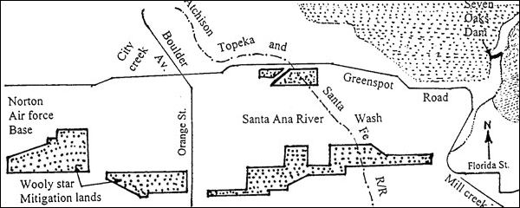

Recovery of woolly-star can be accomplished using public lands and other areas already dedicated for conservation. As with the other listed plants, the goal is to protect populations throughout the species range and representing a variety of topographic positions and community types.

Considering that habitat conversion is ongoing in valley-floor areas and that oil production could increase on public lands, the continued existence of populations cannot be assumed unless a specific commitment is made to protect them from incompatible uses. Some amount of unoccupied suitable habitat is important to allow population fluctuations among years, and a buffer zone is important to minimize external influences.

EFFECTS OF THE SHOT REMOVAL ACTION ON SBKR

Effects of the ERS proposed action refer to the direct and indirect effects of an action on the species or critical habitat, together with the effects of other activities that are interrelated and interdependent with that action that will be added to the environmental baseline. Interrelated actions are those that are part of a larger action and depend on the larger action for their justification. Interdependent actions are those that have no independent utility apart from the action under consideration. Indirect effects are those that are caused by the proposed action, are later in time, and are still reasonably certain to occur.

Direct Effects

The proposed project will impact approximately 3 acres of land within the Santa Ana River floodplain and adjacent upland habitat. A portion of the take will occur within the established Santa Ana River wooly star reserve.

The excavation operation will directly affect 2.6 acres of occupied SBKR habitat and will effectively negatively impact that acreage for use for the life of the project.

ECS will implement specific measures to minimize injury and mortality of individual SBKR within the proposed excavation area and upland refugia habitat during project implementation.

Proposed Project SBKR Mitigation

Prior to commencement of clearing and/or grading for each project element, the construction footprint will be flagged to delineate the boundary of the construction footprint.

All movement of contractors, including ingress and egress of equipment and personnel, as well as any staging and storage areas, will be limited to the designated construction footprint. A qualified biological monitor will be on site during initial clearing activities and on at least a weekly basis during the remainder of activities to ensure that no impacts occur outside the construction footprint.

Prior to vegetation clearance or other ground-disturbing activities, the project footprint will be fenced to provide a barrier that excludes SBKR from the construction area and delineates the work area. A qualified SBKR biologist, approved by the CFWO, will be present when the fence is installed to minimize the disturbance of SBKR burrows from fence installation. The name, contact information, and qualifications of the SBKR biologist will be submitted to the CFWO for approval.

The fence will be constructed of ¼-inch gauge hardware cloth. No gaps greater than 0.5 inches will be allowed within the exclusionary fence, and the SBKR biologist or other designated worker will check the temporary exclusionary fencing at the close of each work day. If gaps greater than 0.5 inches are detected, they will be repaired immediately. The exclusionary fencing will remain in place and be maintained without gaps until project construction is completed. A k-rat proof gate of the same material will be used at the project ingress and egress site. The gate can remain open during daylight hours but must be closed and secured from ½ hour prior to sunset, and not opened until ½ hour after sunrise.

To minimize take of the SBKR, post-fence installation, animals will be trapped and relocated prior to ground-disturbing activities.

Immediately preceding vegetation clearing and/or ground disturbing activities within the fenced areas, pre-construction trapping of SBKR will be conducted by a qualified biologist for a minimum of 5 nights. Trapping locations will be selected at the discretion of the SBKR biologist, in coordination with the CFWO. SBKR trapped within the project footprint will be released in suitable habitat outside and immediately adjacent to the capture location.

Results of the trapping effort will be provided to the CFWO within 24 hours of completing the trapping.

To limit impacts to SBKR and other species ESR and the biological monitor will ensure that work only occurs during daylight hours and that any security lighting used will be directed away from sensitive habitat areas outside of the fence.

The onsite biologist will have the authority to halt work if it is determined that the construction activities have exceeded the authorized footprint or minimization measures are not being followed.

Best management practices to prevent discharge of hazardous materials associated with use and maintenance of construction equipment in the floodplain will be followed.

Post project implementation the fencing will be removed and the habitat restored to its original gradient.

CONCLUSION

After the reviewing the current status of the SBKR, the environmental baseline for the action area, the effects of the proposed action, and the cumulative effects, it is our biological opinion that the proposed action is not likely to jeopardize the continued existence of the SBKR or to result in the destruction or adverse modification of its critical habitat within the Santa Ana River floodplain due to the following:

- Project impacts have been reduced such that the temporary loss of 2.6 acres or 0.15 percent of an estimated 1,725 acres of occupied SBKR habitat within Unit 1. This will not significantly reduce the population size, and we anticipate that the population will remain large enough to survive stochastic events. Therefore, the proposed project is not expected to appreciably reduce the species’ overall number, distribution, or reproductive potential;

- We anticipate that few individual SBKR will be directly lost due to project implementation

- Temporary Loss of 2.6 acres of lead covered breeding, sheltering, and feeding habitat with intact fluvial dynamics will not substantially reduce the function of the primary constituent elements within Critical Habitat Unit because the surrounding acres of breeding, sheltering, and feeding habitat with intact fluvial dynamics will remain unaltered to sustain the Santa Ana River SBKR population.

- Although not quantifiable lead removal from the site should have a direct and positive affect for all wildlife use, survival, and well being.

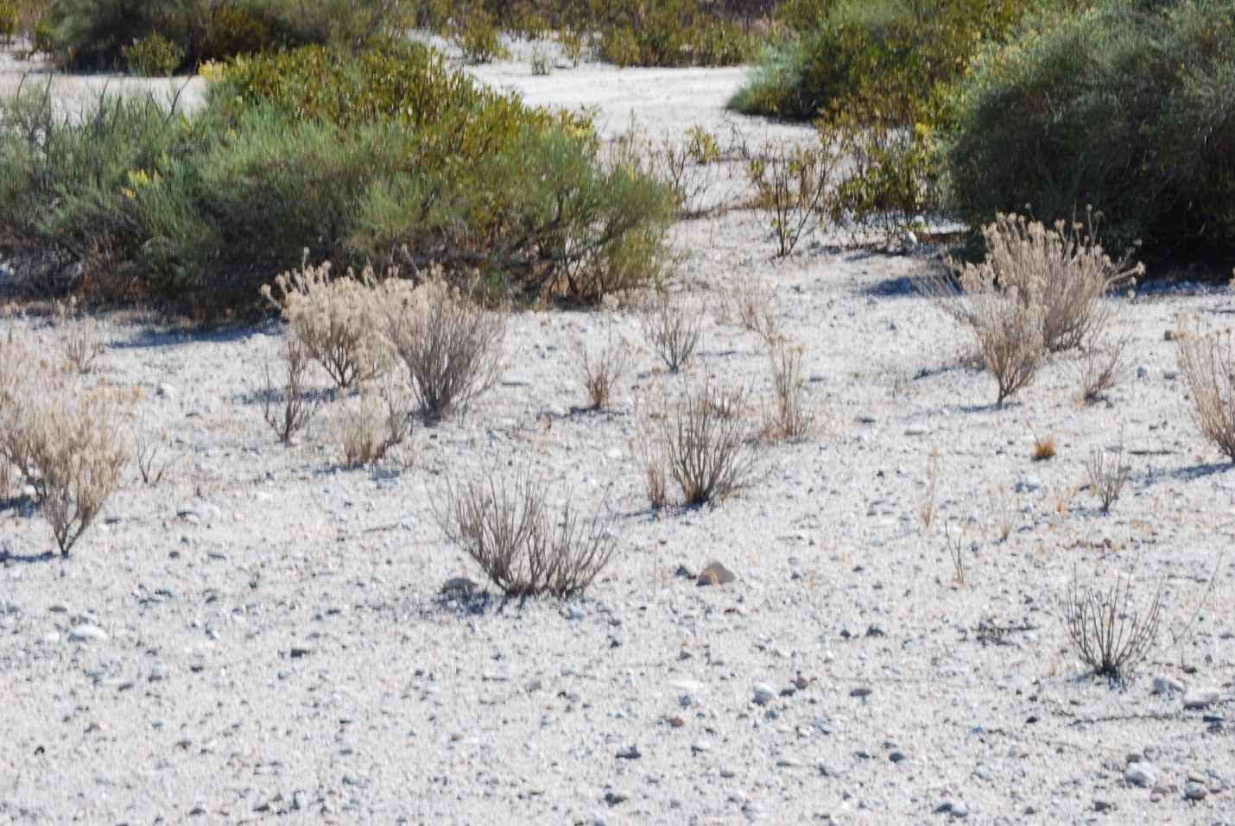

San Bernardino Kangaroo Rat Habitat on-site

EFFECTS OF THE SHOT REMOVAL ACTION ON WOOLY STAR

There are an estimated 275 to 285 Santa Ana river wooly star plants, in twelve clumps, within the proposed project area.

ERS proposes to fence these areas with metal stakes and orange exclusion fencing. A three foot buffer from plant crown to edge of the fence will be added in order to protect the root stock.

Any individual plants found outside the 12 clusters will be removed and transplanted to suitable areas within the project footprint that are not impacted by the shot recovery process (along fence or on berm).

There will not be negative impact to wooly star from the proposed project implementation.

EFFECTS OF THE SHOT REMOVAL ACTION ON SANTA ANA RIVER SUCKER

Although within the proposed critical habitat for the species, there is no habitat on site for occupancy by the Santa Ana River sucker, due to ephemeral nature of the onsite drainage.

The property is however located within the upper watershed that supplies water to downstream occupied habitat.

Removal of lead shot during the dry season will not negatively affect ephemeral water flow.

Removal of lead from the floodplain and drainage should improve water quality.

There are no negative effects from project implementation to the Santa Ana River sucker.

INCIDENTAL TAKE STATEMENT FOR SBKR

Section 9 of the Act and federal regulation pursuant to section 4(d) of the Act prohibits the take of endangered and threatened species, respectively, without special exemption. Take is defined as harass, harm, pursue, hunt, shoot, wound, kill, trap, capture, collect, or attempt to engage in any such conduct. Harm is further defined by us to include significant habitat modification or degradation that actually kills or injures a listed species by significantly impairing essential behavioral patterns, including breeding, feeding, or sheltering. Harass is defined by us as an action that creates the likelihood of injury to a listed species by annoying it to such an extent as to significantly disrupt normal behavioral patterns which include, but are not limited to, breeding, feeding, or sheltering. Incidental take is defined as take that is incidental to, and not the purpose of, the carrying out of an otherwise lawful activity. Under the terms of section 7(b)(4) and 7(c)(2) of the Act, such incidental take is not considered a prohibited taking under the Act, provided that such taking is in compliance with the terms and conditions of this incidental Take Statement.

The measures described below are nondiscretionary and must be implemented by the Corps or applicant, as appropriate, in order for the exemption in section 7(o)(2) to apply. The Corps has a continuing duty to regulate the activity that is covered by this incidental take statement. If the Corps fails to adhere to the terms and conditions of the incidental take statement. If the Corps fail to adhere to the terms and conditions of the incidental take statement through enforceable terms that are added to the permit or grant document, and/or fails to retain oversight to ensure compliance with these terms and conditions, the protective coverage of section 7(o)(2) may lapse. To monitor the impacts of incidental take, the Corps or the applicant must report the progress of the action and its impact on the species to our agency as specified in the incidental take statement [50 CFR section 402.14(I)(3)].

AMOUNT OR EXTENT OF SBKR TAKE

We anticipate that incidental take of individual SBKR will be difficult to detect because 1) SBKR use burrows for diurnal resting sites, 2) finding a dead or impaired specimen is unlikely, and 3) losses may be masked by seasonal or annual fluctuations in numbers.

The following levels of incidental take in the form of harm, death, or injury as defined in 50 CFR section 17.3, are authorized.

- A low, but unquantifiable, number of SBKR will be crushed or buried within the total 3-acre project footprint during fence installation.

- A low, but unquantifiable, number of SBKR will be crushed or buried during ongoing shot recovery operation as not all SBKR are trappable.

Trapping, wounding, or killing of SBKR is also authorized by this incidental take statement as follows:
- SBKR within the fenced 3–acre project area habitat will be trapped and relocated to adjacent habitat avoided by the project; we anticipate that no more than 15 SBKR will be captured and relocated during this effort. The take threshold will be reached at 15 SBKR.

- One capture-related injury or death is authorized during construction-related trapping;

Disposition of Sick, Injured or Dead Specimens

The USFWS Carlsbad office is to be notified within 3 working days if any SBKR are found dead or injured as a direct or indirect result of the implementation of this project. Notification must include the date, time, and location of any SBKR and any other pertinent information. Dead animals should be collected in an appropriate manner only by a biologist approved by the Service. The office contact pesron is Eric Porter, who may be contacted at the letterhead address or at (760) 431-9440.

EFFECT OF THE TAKE

Based on our estimates, we determined that the afore mentioned level of anticipated take is not likely to result in jeopardy to the San Bernardino kangaroo rat.

REASONABLE AND PRUDENT MEASURES

The following reasonable and prudent measures are necessary and appropriate to minimize the take of the SBKR.

- ESR shall ensure that construction activities and other anthropogenic disturbances to the SBKR are minimized.
- ESR shall ensure that impacts to SBKR are minimized during fence installation, pre-construction live-trapping and relocation efforts.

- TERMS AND CONDITIONS
To be exempt from the prohibitions of section 9 of the Act, the Corps or ESR must comply with the following terms and conditions, which implement the reasonable and prudent measures described above. These terms and conditions are nondiscretionary.

  - Prior to vegetation clearing or ground disturbing activities in areas with habitat for listed species, your agency and/or ESR shall provide our office with the name(s), address(es), and telephone number(s) of a field contact representative (biological monitor) responsible for overseeing compliance with protective measures for the listed species. The biological monitor(s) shall have the authority to halt/suspend all associated project activities which may be in violation of if the terms and conditions of the biological opinion, or to avoid or minimize the unanticipated incidental take of listed species, for as long as necessary to resolve the situation through consultation with this office. The biological monitor must be experienced with alluvial fan sage scrub habitats and the SBKR.

  - Prior to any live-trapping of SBKR, your agency and/or ESR shall provide our office with the name(s), address(es), telephone number(s), and at least three references of the biologist conducting the SBKR trapping and monitoring efforts (SBKR biologist). This information will be provided to the Carlsbad Fish and Wildlife Office at least 15 days prior to commencement of surveys. References must be familiar with the relevant qualifications of the proposed biologist. We will provide approval of the biologist within 7 days of receipt.

  - Within upland refugia habitat, project site perimeter fencing will be constructed under the supervision of the SBKR biologist. Once the fencing is in place, the SBKR biologist will proceed with the live-trapping and relocation effort in accordance with measures 2.1-2.4 below. Once the SBKR trapping and relocation effort is accomplished, construction activities can proceed. The biological monitor will be onsite every day for the first week and weekly thereafter to ensure the integrity of the fencing around the well site footprints and the daily placement of covers over any open trenching. If the perimeter fence is breached, that portion of the project site will be shut down for all construction activities, and the SBKR biologist will be summoned. The SBKR biologist will ensure the correct repair of the fence and subject the area to trapping to ensure immigrant SBKR are displaced back into the adjoining habitat.

3.4.With prior notification from us, your agency and/or ESR shall ensure that we are given the right to access and inspect the project site for compliance with the project description and the terms and conditions of the biological opinion during the implementation of the proposed action.

  - Your agency and/or the ESR shall ensure that the limits of operation are marked prior to ground disturbing activities and made clearly visible to personnel on foot and to heavy equipment operators. The biological monitor will contact our office to verify that the limits of construction have been properly staked and are readily identifiable. Your agency shall ensure that all movement of employees, construction limits.

  - Prior to live-trapping and live-trapping for monitoring and management purposes, your agency shall require the project applicant or the Service-approved SBKR biologist to conduct the CFWO to coordinate the appropriate timing of the trapping effort and for approval of appropriate SBKR relocation sites.

  - Pre-construction live-trapping of SBKR shall be conducted for a minimum of five nights. If SBKR are still being detected within a trapping area after 5 nights of trapping, trapping will be continued in this area until there have been 2 consecutive nights of trapping with no captures of SBKR.

  - In order to reduce competition with relocated SBKR outside of the project boundary, all other non-sensitive rodents such as deer mouse (Peromyscus maniculatus), which have been detected during previous trapping efforts in adjacent areas, will either be released within the project footprint or provided to a local vector control agency as determined by the Service-approved biologist. Sensitive species such as the Los Angeles pocket mouse (Perognatus longimembris brevinasus) and San Diego pocket mouse (Chaetodipus fallax fallax) captured within the project area should be relocated outside of the fenced boundary but within appropriate nearby habitat.

  - The Service-approved biologist shall implement the following measures during preconstruction trapping and relocation efforts:

Individual SBKR may be held for up to 1 hour, and then shall be released at the capture site;

All traps must be located in areas that best typify the SBKR habitat, and placed in sufficient numbers to provide adequate coverage of suitable habitat;

Only 12-inch Sherman or wire-mesh live traps shall be used to trap in habitats that are known or suspected to contain SBKR. Models 9 inches in length may be used only if they were purchased before March 13, 1990. All trap models shall be modified to eliminate or substantially reduce the risk of injury (e.g., tail lacerations or excisions) to the animals;

No batting shall be used in the traps, and traps must be checked at least twice per night, once near midnight and again at sunrise. Trapping shall not be conducted if the nightly low temperature is forecast to be below 50 degrees Fahrenheit or if extended wind, rain, fog, or other inclement weather make (or have made) conditions unsuitable for trapping or would unduly jeopardize the lives of the animals;

No mutilation marking scheme (e.g., toe-clipping, ear-clipping) is authorized. No invasive technique (e.g., PIT-tagging) is permitted, unless specifically authorized by the PRO;

Traps used for trapping small mammals outside of Riverside and San Bernardino Counties shall be sterilized before use in Riverside and San Bernardino Counties;

Plastic bags shall be used only for removing SBKR from the traps (for extraction and processing). Trapped individuals shall be processed as quickly as possible to reduce stress to the animals. Under no circumstances shall the individual be kept in plastic bags beyond 5 minutes. Trapped SBKR that must be kept for longer periods of time shall be transferred into a clean, structurally sound, breathable container with adequate ventilation. At no time shall the individual be allowed to become stressed due to temperature extremes (either hot or cold):

Each time the traps are placed, set, and baited, the traps shall be adjusted and set by hand at a sensitivity level appropriate for capturing SBKR. When closing traps, each trap shall be visually inspected and closed by hand;

Translocation activities (i.e., moving SBKR to areas other than outside of the immediately adjacent areas outside the fence) are not authorized; and

Measures to prevent inadvertently missing traps shall, at a minimum, include:

  - All trap locations shall be identified with a unique identification code;
  - While checking traps, a log sheet shall be used. Each time the trap is checked, the surveyor shall note the action on the log sheet. Periodically, the surveyor shall review the log sheet to ensure that no traps were inadvertently missed;
  - The log sheet shall be in addition to (or incorporated into) other field notes or data sheets that are used for noting trap contents. The log sheet and field notes/data sheets (collectively, the “field documentation”) shall be formatted to ensure the surveyor, trap (as identified by the unique identification code), and date/time checked are documented. Field documentation shall be available to Services personnel upon request (including during compliance inspections in the field); and
  - In the field, all trap locations shall be marked with flagging, reflective tape, or other technique that allows the surveyor to readily locate the traps under daytime and nighttime conditions. To the maximum extent possible, the markings shall be visible at a distance of at least 5 meter5s (16.3 feet).

References :

Bean, M.J. 2002. Overcoming unintended consequences of endangered species
regulation. Idaho Law Review. 38: 409-420.

Behrends, P., M. Daily, and M. I. Wilson. 1986. Range use patterns and spatial
relationships of Merriam’s kangaroo rats (Dypodomys merriami). Behavior
96:187-209.

Blair, W. F. 1943. Populations of the deer mouse and associated small mammals in the
mesquite association of southern New Mexico. Contributions to the Laboratory
of Vertebrate Biology, University of Michigan 21:1-40.

Bolger, D. T., A. C. Roberts, R. M. Sauvajot, P. Potenza, C. McClavin, D. Tran, S.
Mazzoni, and M. E. Soule. 1997. Response of rodents to habitat fragmentation in
coastal southern California. Ecological Applications. 7(2):552-563.

Braden, G. and R. L. McKernan. 2000. A data based survey protocol and quantitative
description of suitable habitat for the endangered San Bernardino kangaroo rat.
San Bernardino County Museum report. 35 pp.

Brook, A., M. Zint, and R. De Young. 2003. Landownesr’ responses to an Endangered
Species Act listing and implications for encouraging conservation. Conservation
Biology. Vol. 17, No. 6. pp 1638-1649.

Bury, R. B., R. A. Luckenbach, and S. D. Buskirk. 1977. Effects of off-road vehicles on
vertebrates in the California desert. U.S. Fish and Wildlife Service, Washington,
D. C. Wildlife Research Reoport 8:1-23.

CalMat Company. 1996. Memorandum of Understanding and Implementation
Agreement for the Cajon Creek Habitat Conservation Management Area. July 26,
1996.

Chambers Group, Inc. 1993. Management Plan for the Santa Ana River Woollystar.
Prepared for the U. S. Army Core of Engineesr, Los Angeles, California.

Churcher, P. B. and J. H. Lawton. 1987. Predation by domestic cats in an English
village. Journal Zoological Society of London. 212:439-455.

Conner, C. and N.E. Mathews. 2002. Education in action: an evaluation of the
Endangered Species Act and landowner assurances, special series part I,
Endangered Species UPDATE, 19(1): 11-12.2

Crouse, D.T., L.A. Mehrhoff, M.J. Parkin, D.R. Elam, and L.Y. Chen. 2002.
Endangered Species Recovery and the SCB study; a US Fish and Wildlife
Service perspective. Ecol Appl 12(3): 719-723.
Goldingay, R. L., P. A. Kelly, and D. F. Williams. 1997. The kangaroo rats of
California: Endemism and conservation of keystone species. Pacific
Conservation Biology 3:47060.

Hall, E. R. and K. R. Kelson. 1959. The Mammals of North America, Vol. I. The
Ronald Press Company, New York.

Hall, E. R. 1981. The Mammals of North America, 2nd ed. John Wiley and Sons.

Hanes, T. L., R. D. Friesen, and K. Keane. 1989. Alluvial scrub vegetation in coastal
southern California. In: D.L. Abell (tech. coord.). Proceedings of the California
Riparian Systems Conference: Protection, management, and restoration for the
1990s. September 22-24, 1988. Davis, CA. Gen. Tech. Rep. PSW-110.

Huey, L. M. 1951. The kangaroo rats (Dipodomys) of Baja California, Mexico. Trans.
San Diego Soc. Nat. Hist., 11:205-256.

James, S.M. 2002. Bridging the gap between private landownesr and conservationists.
Conservation Biology 16(1): 269-271.

Jones, W. T. 1993. The social systems of heteromyid rodents. Pages 575-595 in:
Biology of the Heteromyidae (H. H. Genoways and J. H. Brown, eds.). Special
Publication No. 10, American Society of Mammologists.

Kenagy, G. J. 1973. Daily and seasonal patterns of activity and energetics in a
heteromyid rodent community. Ecology 54(6):1201-1219.

Koch, E.D. 2002. The practice of endangered species conservation on private lands; one
federal biologist’s experiences. Idaho Law Review 38(2):505-516.

Lidicker, W. Z., Jr. 1960. An analysis of intra-specific variation in the kangaroo rat
Dipodomys merriami. Univ. of Cal. Publications in Zoology 67:125-218.

Lovell, David. 2007. Correspondence to Nancy Ferguson, Carlsbad Fish and Wildlife
Office, from David Lovell, Department of Public Works Federal Projects/Flood
Control Engineering Division, San Bernardino County, California.

Main, M.B., F.M. Roka, and R.F. Noss. 1999. Evaluating costs of conservation.
Conservation Biology 14(6):1262-1272.

Martha Blane and Associates. 1996. Habitat Enhancement and Management Plan, Cajon
Creek Habitat Conservation Management Area. Prepared for CalMat Company,
Los Angeles, California.

Martha Blane and Associates. 2006. Cajon Creek Habitat Conservation Management
Area, Annual Report. Prepared for Vulcan Materials Company-Western Division.
September 2006.

McKernan, R. L. 1993. Special status rodents: San Bernardino kangaroo rat (Dipodomys
merriami parvus). In: Biology and management of rodents in southern California.
Southern California Chapter of the Wildlife Society, Unpublished report.

McKernan, R. L. 1997. The status and known distribution of the San Bernardino
kangaroo rat (Dipodomys merriami parvus): field surveys conducted between
1987 and 1996. Prepared for U.S. Fish and Wildlife Service.

MEC Analytical Systems, Inc. 2000. Final Biological Assessment, Seven Oaks Dam,
Santa Ana River Mainstream Project, San Bernardino County, California, 2000.
Prepared for U.S. Army Corps of Engineers, Los Angeles District, Los Angeles,
California. August, 2000.

PSOMAS and California State University Fullerton. 2004. Santa Ana River Woollystar
Biological Studies for the Preserve Management Program, Years 4 Through 9.
Prepared for San Bernardino County Flood Control District. April 2004.

Reichman, O. J. and M. V. Price. 1993. Ecological aspects of heteromyid foraging.
Pages 539-574 in: Biology of the Heteromyidae (H. H. Genoways and J. H.
Brown, eds.). Special Publication No. 10, American Society of Mammologists.

Reynolds, H. G. 1958. The ecology of the Merriam kangaroo rat (Dipodomys merriami
Mearns) on the grazing lands of southern Arizona. Ecological Monographs
28(2):111-127.

Reynolds, H. G. 1960. Life history notes on Merriam’s kangaroo rat in southern
Arizona. Journal of Mammology 41(1):48-58.

Service (U.S. Fish and Wildlife Service). 1989. Biological opinion and conference on
the Corps of Engineers Santa Ana River Project in San Bernardino, Riverside, and
Orange Counties, California (1-6-88-F-6). June 22. Laguna Niguel, California.

Service (U.S. Fish and Wildlife Service). 1996. Biological opinion on the closure of
Landfill 2, Norton Air Force Base, San Bernardino County, California (1-6-96-F-
10). November 26. Carlsbad, California.

Service (U.S. Fish and Wildlife Service). 1998a. Endangered and Threatened Wildlife
and Plants; Emergency Rule to List the San Bernardino Kangaroo Rat as
Endangered. (63 FR 3835). 9 pp.

Service (U.S. Fish and Wildlife Service). 1998b. Endangered and Threatened Wildlife
and Plants; Final Rule to List the San Bernardino Kangaroo Rat as Endangered
(63 FR 51005). 13 pp.

Service (U.S. Fish and Wildlife Service). 1998c. Reinitiating of consultation and
revision to biological opinion on mining activities and industrial development at
the CalMat San Bernardino and Cajon Creek properties, Lytle-Cajon Wash, San
Bernardino County, California (1-6-94-F-51R1). April 24, 1998. Carlsbad,
California.

Service (U.S. Fish and Wildlife Service). 1999. Section 7 consultation for the
construction and extension of the north levee at Sunwest’s Lytle Creek Quarry,
San Bernardino County, California (1-6-99-F-42). June 15, 1999. Carlsbad,
California.

Service (U.S. Fish and Wildlife Service). 2000a. Endangered and Threatened Wildlife
and Plants; Proposed Designation of Critical Habitat for the San Bernardino
Kangaroo Rat; Proposed Rule (65 FR 77178). 31 pp.

Service (U.S. Fish and Wildlife Service). 2000b. Formal section 7 consultation for the
San Jacinto Seasonal Storage and Recovery Project, Riverside County, California
(FWS-WRIV-1045.1). October 13, 2000. Carlsbad, California.

Service (U.S. Fish and Wildlife Service). 2002a. Endangered and Threatened Wildlife
and Plants; Final Designation of Critical Habitat for the San Bernardino Kangaroo
Rat; Final Rule (67 FR 19812). 34 pp.

Service (U.S. Fish and Wildlife Service). 2002b. Section 7 consultation for operations of
Seven Oaks Dam, San Bernardino County, California (1-6-02-F-1000.10).
December 19. Carlsbad, California.

Service (U.S. Fish and Wildlife Service). 2003a. Intra-Service formal section 7
consultation on the Lytle Creek North Master Planned Community, San
Bernardino County, California (FWS-SB-1640.11). November 4. Carlsbad,
California.

Service (U.S. Fish and Wildlife Service). 2003b. Formal section 7 consultation for
disposal and reuse of the former Norton Air Force Base, San Bernardino County,
California (FWS-SB-1723.10). August 5. Carlsbad, California.

Service (U.S. Fish and Wildlife Service). 2004. Intra-Service formal section 7
consultation/conference for issuance of an Endangered Species Act section
10(a)(1)(B) permit (TE-088609-0) for the Western Riverside County Multiple
Species Habitat Conservation Plan, Riverside County, California (FWS-WRIV-
870.19). June 22. Carlsbad, California.

Service (U.S. Fish and Wildlife Service). 2006. Formal section 7 consultation on the
Hemet/San Jacinto Integrated Recharge and Recovery Program, Riverside
County, California (FWS-WRIV-4051.5). November 16. Carlsbad, California.
Sidle, J.G. 1987. Critical Habitat Designation: Is it Prudent? Environmental Management
11(4):429-437.

Smith, R. L. 1980. Alluvial scrub vegetation of the San Gabriel River floodplain,
California. Madrono 27(3)126-138.

Stein, B.A., T. Breden, and R. Warner. 1995. Significance of Federal lands for
endangered species. Pages 398-401 in E.T. LaRoe, ed. Our living resources: a
report on the distribution, abundance, and health of U.S. plants, animals, and
ecosystems. National Biological Service, Washington, D.C.

U.S. Air Force. 2002. Former Norton Air Force Base Conservation Management Plan
(CMP). March 2002.

Vulcan Materials Co., Western Division. 2006. Letter from Douglas W. Sprague to
parties of the MOU, Re: Vulcan Materials Company – Extension of Memorandum
of Understanding and Implementation Agreement for the Cajon Creek Habitat
Conservation Management Area. August 11, 2006.

Wilcove, D.S., M.J. Bean, R. Bonnie and M. McMillian. 1996 Rebuilding the ark:
toward a more effective endangered species act for private land. Environment
Defense Fund doc. 483, pp.1-15.

Wilcove, D.S., and L.Y. Chen. 1998. Management Costs for Endangered Species.
Conservation Biology, Vol. 12, No. 6. 1405-1407.

Williams, D. F., H. H. Genoways, and J. K. Braun. 1993. In: Biology of the
Heteromyida (H. H. Genoways and J. H. Brown, eds.). Special Publication No.
10, American Society of Mammologists. pp. 38-196.

Appendix One

Redlands Shooting Park Sensitive Biological Resources
Resource | Habitat And Distribution | Activity Period | Status  Designation | Occurrence Probability
PLANTS
Santa Ana River woollystar  Eriastrum densifolium var. sanctorum | Perennial sub shrub found in alluvial fan sage scrub, coastal sage scrub on alluvial deposits along the Santa Ana River, San Bernardino Co. | June - August flowering period | FED: END END  STATE: END END  CNPS: 1B | Present
Slender-horned spineflower  Dodecahema leptoceras | Sandy and gravelly soils on alluvial fans and old floodplains; 500 to 2000 ft. elevation. Los Angeles, Riverside, and San Bernardino Counties. | Apr – Jun | FED: END END  STATE: END END  CNPS: 1B | Potential but not observed
Spreading navarretia  Navarretia fossalis | Vernal pools, ditches, 30 to 1300 meters. | Not documented | FED: THR  STATE: ND  CNPS: 1B | Not Present
FISH
Santa Ana sucker  Catostomus santaanae | Santa Ana, Santa Clara, San Gabriel and Los Angeles rivers. | Year round | FED: END  STATE: END | Not present but seasonal water from site flows to occupied habitat
AMPHIBIANS
Western spadefoot  Scaphiopus hammondii | Grasslands and occasionally hardwood woodlands; largely terrestrial but for breeding, requires rain pools or other ponded water for 3+ weeks; burrows in loose soils during dry season; Central Valley and foothills, coast ranges, inland valleys, to Baja Calif. | October - April (following onset of winter rains) | FED: ND  STATE: CSC | High Potential.  Occurs nearby
Arroyo toad  Bufo microscaphus | Washes and arroyos with open water; sand or gravel beds; for breeding, pools with sparse over-story vegetation. Coastal and a few desert streams from Santa Barbara Co. to Baja Calif. | Mar - Jul | FED: END  STATE: CSC | Low. No suitable habitat present in nearby stream. Stream has seasonal fast moving watesr. Could occur nearby.
California red-legged frog  Rana aurora draytonii | Streams with slow-moving water and deep pools; dense, shrubby riparian vegetation at pool edges. Coastal streams from Marin Co. to Ventura Co.; between Ventura Co. and Mexican border, known from only four small populations including Santa Rosa Plateau | Dec - Apr | FED: THR  STATE: CSC | Absent. No suitable habitat present in nearby stream or on site; nearby stream has water present only seasonally and does not have deep pools.
Mountain yellow-legged frog  Rana muscosa | Always encountered within a few feet of water. Rocky stream courses in southern California. Tadpoles may require up to two years to complete aquatic development. | Mar - May  breeding period | FED: PE  STATE: CSC | Absent. No suitable habitat present in nearby stream or on site; nearby stream has water present only seasonally and does not have deep pools.
REPTILES
Southwestern pond turtle  Clemmys marmorata pallida | Permanent or nearly permanent water in a wide variety of habitats; requires basking sites such as partially submerged logs, rocks, or open mud banks. Central California to northwestern Baja California. | Year-round  with reduced activity Nov. - Mar. | FED: ND  STATE: CSC | Absent. No habitat on site.
San Diego horned lizard  Phrynosoma coronatum blainvillei | Wide variety of habitats including coastal sage scrub, grassland, riparian woodland; typically on or near loose sandy soils; coastal and inland areas from Ventura Co. to Baja Calif. | April - July (with reduced activity Aug. - Oct.) | FED: ND  STATE: CSC | Present
BIRDS
White-tailed kite  Elanus leucurus | Open country in South America and southern North America. | Year-round | FED: ND  STATE: ND (nesting) | Low. No nesting habitat could forage across site
Bald eagle  Haliaeetus leucocephalus | Winters locally at deep lakes and reservoirs feeding on fish and waterfowl. Locally rare throughout North America. | Nov - Feb | FED: END  STATE: END | Low. Known to winter in area, could fly over site.
Northern harrier  Circus cyaneus | Grassland and marshy habitats in Southern California. Uncommonly in open desert and brushlands. | Year round | FED: ND  STATE: CSC | Low. Not observed during the surveys. Forages over a wide range of open habitat. No nesting habitat on site. Foraging habitat exists on site.
Sharp-shinned hawk  Accipiter striatus | Nests in woodland, coniferous deciduous forest. Winter visitor and migrant to coastal Southern California. Forages over a variety of habitats. | Fall & winter; scarce in summesr | FED: ND  STATE: CSC | Low. Not observed during the surveys, but could forage infrequently over the property in winter.
Cooper's hawk  Accipiter cooperi | Woodland and semi-open habitats, riparian groves and mountain canyons. Uncommon permanent resident in coastal, mountains, and deserts of Southern California. Transients fairly common on coast in fall. | Year round; predominant in summer | FED: ND  STATE: CSC | Low. Not observed during the surveys, but are expected to forage infrequently over the property during migration and in winter.
Golden eagle  Aquila chrysaetos | Grasslands, brush-lands, deserts, oak savannas, open coniferous forests and montane valleys. Nesting primarily in rugged mountainous country. Uncommon resident in Southern California. | Year round  diurnal | FED: ND  STATE: CSC (nesting and wintering) | Low. Not observed during the surveys. Foraging habitat for this species exists over the entire property No suitable nesting habitat occurs on site.
Ferruginous hawk  Buteo regalis | Fairly common in winter in open grassland and agricultural regions in the interior, as well as some valleys along the coast. Rare and uncommon along the coast and in the desert. | Winter | FED: C2*  STATE: CSC | Low. Not observed during the surveys. Poor foraging habitat. No suitable nesting habitat occurs on site.
Merlin  Falco columbarius | Frequents several habitats including coastal sage scrub and annual grassland. Forages along the coast, and in montane valleys and open deserts. | Fall & winter | FED: ND  STATE: CSC | Low. Not observed during the surveys. Can be expected to forage over the site during migration and in winter.
American peregrine falcon  Falco peregrinus anatum | Wetlands near high cliffs; few known to nest in urban settings on tall buildings. Scattered locations in North America; in California coastal areas and inland mountains. | Fall & Winter (in migration and as winter visitor) | FED: ND  STATE: END | Low. Species passes through region during migration and may winter in region; during migration or winter, could forage on site.
Prairie falcon  Falco mexicanus | Nest in cliffs or rocky outcrops; forage in open arid valleys, agricultural fields. Throughout the desert and arid interior portions of coastal counties. Uncommon resident in Southern California. | Year round  diurnal | FED: ND  STATE: CSC | Low. Not observed during the surveys. Foraging habitat exists for this species over the property, but there is no suitable nesting habitat.
Burrowing owl  Athene cunicularia hypugea | Grasslands and rangelands, usually occupying ground squirrel burrows. Resident over most of Southern California. Found in agricultural areas. | Year round | FED: ND  STATE: CSC | Low. Not observed. But this species may forage on site and nest in adjacent areas.
Long-eared owl  Asio otus | Rare resident in coastal Southern California and uncommon resident in desert areas. Breeds from valley foothill hardwood up to ponderosa pine | Nocturnal year round | FED: ND  STATE: CSC | Low. Foraging habitat exists on the property, but no nesting habitat.
Short-eared owl  Asio flammenus | Primarily a rare and local winter visitant to the coast, and a rare fall transient and winter visitant in the desert, including the Salton Sea and the Colorado River. Also recorded at Mystic Lake in the San Jacinto Valley, Rivesride County, in summer 1992, and Harper Dry Lake, San Bernardino County, summer 1993. | Fall - Winter | FED: ND  STATE: CSC | Low. Available information states that short-eared owls are rare fall transients in the desert and, therefore, may forage on the property.
Black swift  Cypseloides niger | Rare and very local summer resident in the foothill canyons of mountains. Most birds arrive after May. Rare and irregular transient (mainly in spring) away from breeding areas, principally west of the deserts. Breeding localities include Santa Anita Canyon, San Gabriel Mtns., Fallsvale in Mill Creek Canyon, San Bernardino Mtns. And Tahquitz Creek, San Jacinto Mtns. | Spring - Fall | FED: ND  STATE: CSC | Not Present
VauxÆs swift  Chaetura vauxi | Fairly common spring and fall transient in southern California. Rare and irregular winter visitor primarily along coast. Nesting sites need protection. | Fall - Spring | FED: ND  STATE: CSC | Not Observed
Southwestern willow flycatcher  Empidonax traillii extimus | Breeds and nests in willow riparian forest. Rare and local in So. Calif. | May - Sept. | FED: END  STATE: END (nesting) | No habitat on site
Bank swallow  Riparia riparia | Nesting habitat is vertical banks of fine textured soils, most commonly along streams and rivesr. In Southern California, fairly common spring and fall transient in interior; very uncommon spring transient and rare fall transient along coast. Casual in winter. | Variable year round | FED: ND  STATE: THR | Low. No suitable nesting habitat occurs within the property limits. May be transient in migration.
California gnatcatcher  Polioptila californica | Coastal sage scrub; occurs only in cismontane Southern California and northwestern Baja California in low-lying foothills and valleys. | Year-round | FED: THR  STATE: ND | Low. No nesting habitat on site. Could occur nearby.
Loggerhead shrike  Lanius ludovicianus | Open fields with scattered trees, open woodland, scrub. Fairly common resident throughout southern California. | Year round | FED: ND  STATE: CSC | Moderate. No nesting habitat. May forage in this area in winter.
Least Bell's vireo  Vireo bellii pusillus | Riparian forests and willow thickets. Breeds and nests only in southwestern California; winters in Baja Calif. | Apr - Sept | FED: END  STATE: END | Not present. No habitat on site
Southern California rufous-crowned sparrow  Aimophila ruficeps canescens | Fairly common resident along the coast of California; breeds very locally on desert mountain ranges. Preferred habitat is slopes with sparse shrubs and open grassy areas intermixed. Coastal sage scrub is the most common plant community used. | Year round | FED: ND  STATE: CSC | Low. Could forage on site.
Tri-colored blackbird  Aeglaius tricolor | Resident year round in the coast and eastern edge of the desert. Occurs in all coastal counties including interior areas west of the deserts. Breeds in dense colonies is reed beds. | Year round | FED: ND  STATE: CSC | Low. Could fly over site.
MAMMALS
California leaf-nosed bat  Macrotus californicus | In California, these bats primarily occupy low-lying desert areas, where they roost in caves, mines, and old buildings. Historic records extend west to near Chatsworth, Los Angeles County, but most populations from the California coastal basins are believed to have disappeared. Occurs from northern Nevada, Southern California, and western Arizona south to southern Baja California and Sonora. | Year round nocturnal | FED: ND  STATE: CSC | Low. Because there are no suitable roost sites in the property limits this species does not roost on the property. However, it may forage over the property if there are roosting sites such as caves in the nearby mountains.
Townsend's western big-eared bat  Plecotus townsendii, two spp.Requires caves, mines, tunnels, buildings or other similar structures for roosting. May use separate sites for night, day, hibernation or maternity roosts. Found in all but subalpine and alpine habitats throughout California. | Year round  Nocturnal | FED: ND  STATE: CSC | Low. Because there are no suitable roost sites in the property limits, this species does not roost on the property. However, it may forage over the property if there are roosting sites such as caves in the nearby mountains.
Pallid bat  Antrozous pallidus | Day roost in caves, crevices, mines and occasionally hollow trees and buildings. Night roosts may be more open sites, such as porches and open buildings. Hibernation sites are probably rock crevices. Grasslands, shrublands, woodlands and forest from sea level through to mixed conifer. Throughout Southern California. | Spring, Summer, Fall  Nocturnal  Hibernates in Wintesr | FED: ND  STATE: CSC | Low. Because there are no suitable roost sites in the property limits, this species does not roost on the property. However, it may forage over the property if there are roosting sites such as caves in the nearby mountains.
Spotted bat  Euderma maculatum | Found in the western North America from southern British Columbia to the Mexican border, at a small number of widely scattered localities. Habitats range from arid deserts and grasslands through mixed conifer forest up to 10,600 foot elevation. Prefesr rock crevices in cliffs, also uses caves and buildings. | Spring, Summer, Fall  Nocturnal  Hibernates in Winters | FED: ND  STATE: CSC | Low. Because there are no suitable roost sites in the property limits, this species does not roost on the property. However, it may forage over the property if there are roosting sites such as caves in the nearby mountains.
California mastiff bat  Eumops perotis californicus | Historically from north-central California south to northern Baja California, eastward across the southwestern United States, and northwestern Mexico to west Texas and Coahuila (Hall, 1981; Williams, 1986). In California, most records are from rocky areas at low elevations where roosting occurs primarily in crevices. |  | FED: ND  STATE: CSC | Moderate. There may be suitable crevices in the more rocky areas of the site. This species may also forage over the property.
Pocketed free-tailed bat  Nyctinomops femorasacca | Spotty distribution in California, ranging from Southern California south to the Baja Peninsula, and through southwestern Arizona to at least central Mexico (Williams, 1986). In California, pocketed free-tailed bats are typically found in rocky, desert areas with relatively high cliffs. | Warmer months. Nocturnal | FED: ND  STATE: CSC | Absent. Not located during the survey. No suitable foraging or nesting habitat occurs within the project area or the surrounding mountains.
Big free-tailed bat  Nyctinomops macrotis | Found from northern South America and the Caribbean Islands northward to the western United States (Williams, 1986). In the southwestern U.S., populations appear to be scattered. Known breeding localities are in parts of Arizona, New Mexico, and Texas. Prefers rocky, rugged terrain. Roosts in crevices in high cliffs or rocky outcrops. Ranges up to 8000 foot elevation. | Nocturnal spring - fall  Hibernates in Winters | FED: ND  STATE: CSC | Moderate. There may be suitable crevices in the more rocky areas of the site. This species may also forage over the property.
San Diego black-tailed jackrabbit  Lepus californicus bennettii | Variety of habitats including herbaceous and desert scrub areas, early stages of open forest and chaparral. Most common in relatively open habitats. Restricted to the cismontane areas of Southern California, extending from the coast to the Santa Monica, San Gabriel, San Bernardino and Santa Rosa mountain ranges. | Year round, diurnal and Crepuscular activity | FED: ND  STATE: CSC | Not observed.
Los Angeles pocket mouse  Perognathus longimembris brevinasus | Prefers sandy soil for burrowing, but has been found on gravel washes and stony soils. Found in coastal scrub. Los Angeles, Riverside, and San Bernardino Counties. | Nocturnal; active late spring to early fall. | FED: ND  STATE: CSC | High potential. Captured nearby
Northwestern San Diego pocket mouse  Chaetodipus fallax fallax | Sandy herbaceous areas, usually with rocks or coarse gravel. Arid coastal areas in grassland, coastal scrub and chaparral. San Diego, San Bernardino, Los Angeles, and Riverside Counties. | Nocturnal; active year round. | FED: ND  STATE: CSC | High potential. Captured nearby
San Bernardino kangaroo rat  Dipodomys merriami parvus | Primary and secondary alluvial fan scrub habitats, with sandy soils deposited by fluvial (water) rather than aeolian (wind) processes. The preferred substrate appears to be sandy and sandy loam soils and very little herbaceous ground cover. In isolated populations along the Santa Ana and San Jacinto drainage systems. | Nocturnal; active year round | FED: END  STATE: ND | Present based on sign and nearby capture
San Diego desert woodrat  Neotoma lepida intermedia | Moderate to dense canopies, particularly in rocky areas. Coastal sage scrub and chaparral. Coastal southern California. | Nocturnal; active year round | FED: ND  STATE: CSC | Not observed
Grasshopper mouse  Onychomys torridus ramona | In the more arid regions of southern California. Especially prefers sandy areas of the Mojave and Sonoran deserts, and parts of the San Joaquin Valley. | Year round | FED: ND  STATE: CSC | Low. Has been captured downstream from site.
INVERTEBRATE
Vernal pool fairy shrimp  Branchinecta lynchi | Grasslands and ponded areas such as vernal pools, cattle watering holes, basins, etc. In Southern California, species found primarily in the interior of western Riverside Co., central Santa Barbara Co., and eastern Orange Co. Also, more recently discovered in Los Angeles Co. | Spring | FED: THR  STATE: ND | No habitat on site. Outside of range.
Rivesride fairy shrimp  Streptocephalus woottoni | Known only from ephemeral pools in southern Orange and western Riverside and San Diego Counties. | Spring | FED:END  STATE: ND | No habitat. Outside of range
SENSITIVE HABITATS
Canyon live oak ravine forest | Steep, narrow canyons in steep mountain areas. | Year round | Declining plant community | Absent
Southern riparian forest | Steep canyons and drainages in the foothills of local mountain ranges. | Year round | Declining plant community | Absent
Southern mixed riparian forest | Steep canyons and drainages in the foothills of local mountain ranges. | Year round | Declining plant community | Absent
Southern coast live oak riparian forest | Steep canyons and drainages in the foothills of local mountain ranges. | Year round | Declining plant community | Absent
Southern cottonwood willow riparian forest | Steep, narrow and shallow, broad canyons and drainages in the foothills of local mountain ranges. | Year round | Declining plant community | Absent
Southern willow scrub | Small, shallow drainages leading into larger streams and rivers. | Year round | Declining plant community | Absent
Southern sycamore alder riparian woodland | Steep, narrow and shallow, broad canyons and drainages in the foothills of local mountain ranges. | Year round | Declining plant community | Absent

