**ERT   
User Manual  
SERAS Scribe Deliverables for EPA Region 2 Superfund**



**Table of Contents**

Background 3

Overview 3

Adding the R2 Superfund Export Custom Data View to an Existing Scribe project 4

Importing the R2 Superfund Export Custom Data View 4

Scribe.NET Auditor 8

Auditing a Scribe project 8

Interpreting the Audit Log File 11

Exporting the R2 Superfund file from Scribe 15

Exporting the R2 Superfund Custom Data View 15

Submitting the R2 Superfund Export file to EPA R2 Superfund 19

Frequency of Submittals 19

Guidelines for Submittals 19

References 21

Check List 22

# Background

In an effort to streamline the electronic submittal of environmental sampling data, the Superfund Program in EPA Region 2 has adopted a standardized electronic data deliverable (EDD) format that is being required for all new and historical data submitted to the region. These standardized EDDs will be uploaded to EPA Region 2’s instance of EarthSoft’s EQuIS™ (Environmental Quality Information System) database. Since EPA/ERT’s Scribe application is widely used throughout all EPA Regions for the collection of environmental sampling data, ERT has worked closely with the EPA Region 2 Superfund/EQuIS team to develop deliverables from Scribe that will be accepted for import into EPA Region 2’s instance of EQuIS.

Another key organization providing support to EPA’s Superfund sampling efforts is the EPA’s Analytical Services Branch. The Analytical Services Branch (ASB) strives to be a premier provider of analytical services for the Superfund Remedial Program and other EPA programs. ASB manages the Contract Laboratory Program (CLP) which provides ready access to analytical services via a wide spectrum of private contracted environmental laboratories and associated data review and assessment tools. Since EPA/ERT had already worked with EPA’s Analytical Services Branch on the development of Scribe’s COC XML deliverable and ASB’s UniversalEDD format, those two standards were used as the starting point for providing data collected in Scribe to EPA’s Region 2 Superfund program for upload to EQuIS.

## Overview

This document will outline the steps necessary to provide deliverables from Scribe that will meet the requirements for upload to EPA Region 2’s instance of EQuIS. In general, the following sections will address:

1. Adding the R2 Superfund custom data view to a Scribe project
2. Running the Scribe.NET Auditor
3. Exporting the R2 Superfund files from Scribe

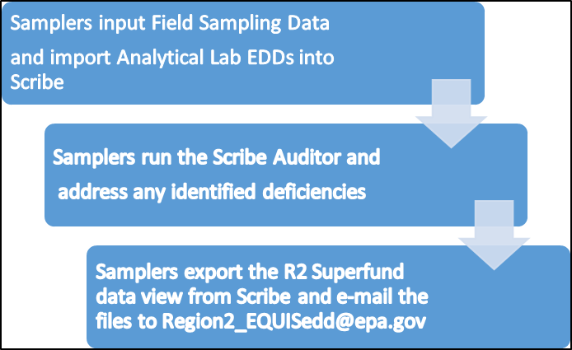

**Basic Workflow for delivering data from Scribe to R2 Superfund EQuIS)**

# Adding the R2 Superfund Export Custom Data View to an Existing Scribe project

The R2 Superfund Export custom data view is not included with the default Scribe3 template (Scribe3.mdb). As such, the custom data view will need to be imported in to any existing Scribe project that will be providing deliverables to EPA Region 2’s Superfund program. If a Scribe project has not yet been started, use the *SERAS\_R2\_Superfund\_scribe3\_Template.mdb* as the starting Scribe template and the R2 Superfund Export custom data view will automatically be included in the Scribe project from the start.

The *SERAS\_R2\_Superfund\_scribe3\_Template.mdb* can be downloaded from the Documents section of the Scribe website under the R2 Superfund category: <https://response.epa.gov/sites/ScribeGIS/files/SERAS_R2_Superfund_scribe3_Template.mdb>

## Importing the R2 Superfund Export Custom Data View

Before beginning this section, the latest version of Scribe needs to be installed (v 3.10) and the *SERAS\_R2\_Superfund\_scribe3\_Template.mdb* needs to be downloaded and saved from the Documents section of the Scribe Website (response.epa.gov\scribe). The file can be found in the R2 Superfund Category of the Documents section. A direct link to the file can be found here: <https://response.epa.gov/sites/ScribeGIS/files/SERAS_R2_Superfund_scribe3_Template.mdb>

Note the location of where this file is saved. A Scribe Template folder exists which can be used as the location to save the template. This folder can typically be found by navigating to: C:\Program Files (x86)\Scribe\Template

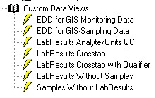

1. In Scribe, Open the Scribe project that requires the R2 Superfund Export custom data view.

Notice that the R2 Superfund Export custom data view is *not* in the list.

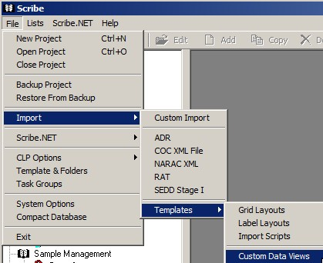

1. From Scribe’s **File menu**, Select:

* **Import**
* **Templates**
* **Custom Data Views**

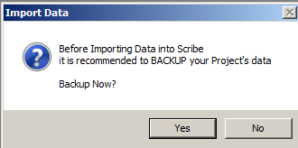

1. When prompted to Backup the project, **Click Yes** and save a backup of the project

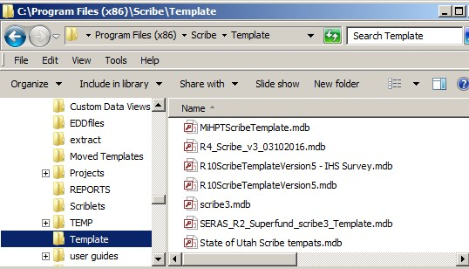

1. Navigate to the folder where the *SERAS\_R2\_Superfund\_scribe3\_Template.mdb* was saved earlier in this section and click **Open** (See the information above step 1 for additional details on downloading the Template)

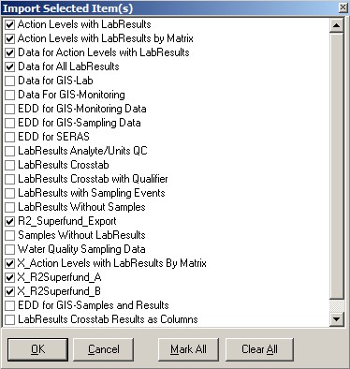

1. **Select the following** Eight (8) **Custom Data Views** by clicking in the box to the left of the Data View Name:

(In addition to the R2 Superfund custom data views, also import the Action Level custom data views and related queries to insure your project has the most up-to-date information)

* **Action Levels with LabResults**
* **Action Levels with LabResults by Matrix**
* **Data for Action Levels with LabResults**
* **Data For All LabResults**
* **R2\_Superfund\_Export**
* **X\_Action Levels with LabResults By Matrix**
* **X\_R2Superfund\_A**
* **X\_R2Superfund\_B**

1. Click **OK**

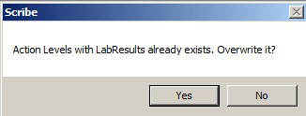

1. Click **Yes** if prompted to overwrite existing custom data views.

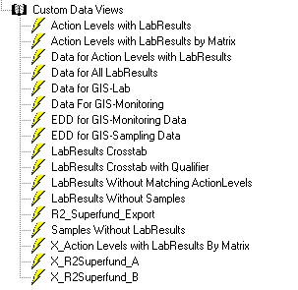

1. The eight Custom Data Views will now be displayed in your Scribe project.

Several of these queries are only necessary for other queries to run. In order to keep the Custom Data Views section clean and to display only the final queries, the next step describes how to hide certain queries from view in Scribe.

1. Hide the visibility of the following Custom Data Views:
   * Data for Action Levels with LabResults
   * Data for All LabResults
   * **X**\_Action Levels with LabResults By Matrix
   * **X\_**R2\_Superfund\_Export
   * **X\_**R2Superfund\_B
   1. ScreenHunter_531 MarClick the **Custom Data Views heading**

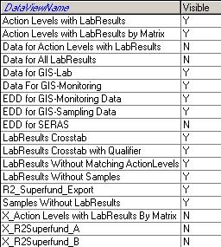

* 1. Change the **Visible** column to **N** for the custom data views listed above
  2. Click **Close**

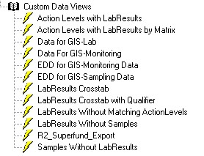

1. The Custom Data Views section should no longer display the queries where the visibility was set to N  
     
     
   This was the last step for adding the R2\_Superfund\_Export Custom Data View to your Scribe project and updating additional custom data views.

# Scribe.NET Auditor

Region 2 Superfund and ERT have developed a list of Valid Values for electronic data submission. ERT has posted these Valid Values to Scribe.NET which allows any Scribe project to run the Auditor Rules and determine if the data meets Region 2’s and ERT’s electronic data submission requirements. In addition to checking for Valid Values, the Scribe.NET auditor also looks for “blanks and nulls” in fields that are required for electronic data submission.

Additional details on the required fields and valid values can be found in the Documents section of the Scribe website under the R2 Superfund category: <https://response.epa.gov/sites/ScribeGIS/files/Scribe-SERAS-DataElementDictionary_and_Valid_Values.xlsx>

## Auditing a Scribe project

Before beginning, connect the Scribe laptop to the internet. Running auditor requires an internet connection.

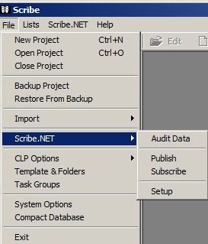

1. Open Scribe
2. From the **File menu**, Select:

* **Scribe.NET**
* **Audit Data**

1. **Scroll** the list of Auditor RuleSets and **put a check-mark in the box next to ERT-SERAS\_R2**.

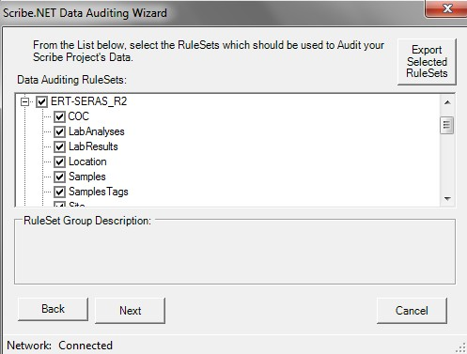

By placing a check-mark in the ERT-SERAS\_R2 box, all auditor rules for ERT-SERAS\_R2 will be selected by default.

If there is a particular subset of rules you don’t want to run, simply remove the check-mark from that subset. For example, if the checkmark was removed from the LabResults subset, the LabResults will NOT be audited against the ERT-SERAS\_R2 rules.

1. Click **Next** to continue

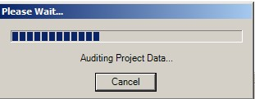

1. The auditor will begin checking the Scribe project against the list of Valid Values and required fields for ERT and EPA Region 2 Superfund data submission.

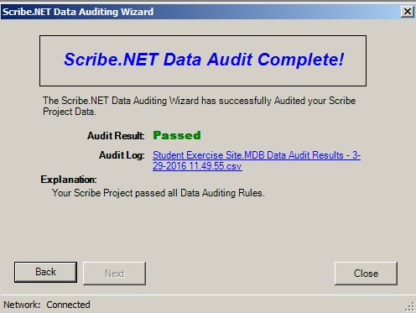

1. When the Auditor is finished, the **Data Audit Complete** window will be displayed. The results of the Audit are either:

* Audit Results: Passed

Passed indicates that the data in the Scribe project meets the valid values and that required fields are complete for submission of data to ERT and EPA R2 Superfund. Click the blue Audit Log link to see a log of the rules that were selected and their audit results. A more detailed explanation of the Audit Log can be found in the next section of this guide.

* Audit Results: Warning

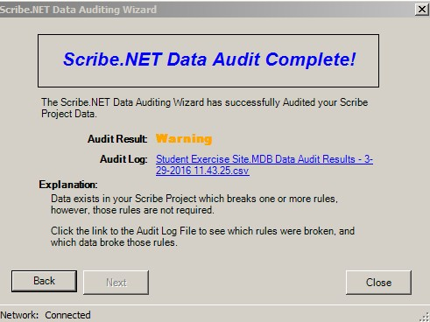

Warning indicates that the values that exist in the Scribe project do not meet R2 Superfund’s list of valid values and/or fields deemed required by R2 Superfund are not complete in the Scribe project. In the case of a Warning, the Audit Log should be used to determine which records *do no*t meet the requirements. A more detailed explanation of the Audit Log can be found in the next section of this guide.

Once updates have been made in Scribe to meet the requirements, run Scribe.NET auditor again until the Audit Result indicates Passed.

* Audit Results: Failed

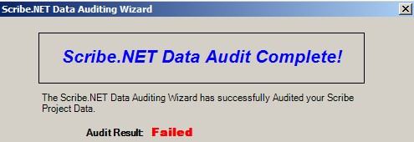

Failed indicates that particular rules have been flagged such that if they do not meet the valid values or are missing required information, the project cannot be published to Scribe.NET until those items have been corrected. In the case of an Audit Result of Failed, the Audit Log should be used to determine which records do not meet the requirements. A more detailed explanation of the Audit Log can be found in the next section of this guide.

Once updates have been made in Scribe to meet the requirements, run Scribe.NET auditor again until the Audit Result indicates Passed.

## Interpreting the Audit Log File

An Audit Log file is produced each time the Scribe.NET Auditor runs. This log file can be accessed by clicking on the blue link that is displayed when Auditor finishes. The Audit Log will open in MS Excel. In addition, the Audit Log Files are stored in the same directory as the Scribe Project file. The audit logs can be accessed at any time from this location.

The information below will discuss how to interpret the Audit Log File to determine which records *do not* meet the Scribe Region 2 Superfund electronic data requirements.

Additional details on the required fields and Valid Values for ERT and Region 2 electronic data submission from Scribe, please reference this document:

<https://response.epa.gov/sites/ScribeGIS/files/Scribe-SERAS-DataElementDictionary_and_Valid_Values.xlsx>

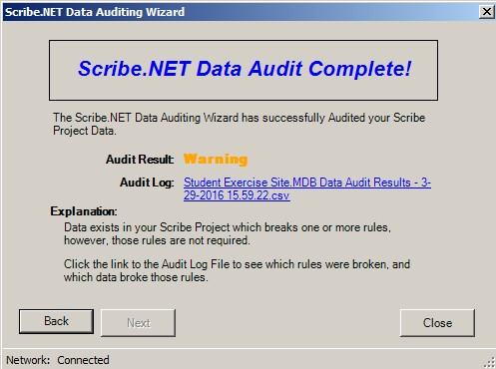

1. When the Scribe.NET Data Audit Complete window is displayed, **click on the blue Audit Log link**

The Audit Log file will open in MS Excel.

The image below is an example of a Scribe.NET Audit Log file

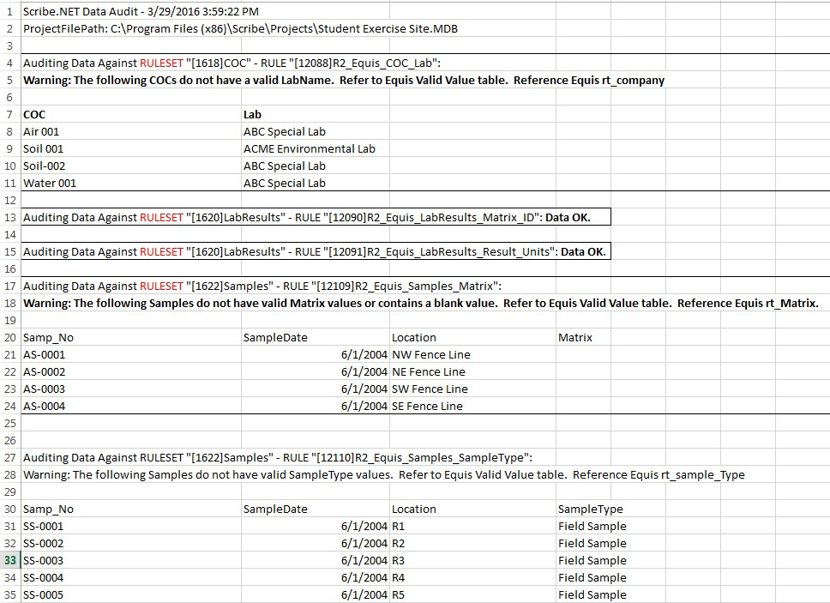

1

2

3

4

The audit log file will list each rule that was checked and display the outcome of each checked rule.

Hint: The audit log file can be lengthy depending on the number of rules checked. One method to move between rules is to use the MS Excel “find” feature. In the example audit log above, notice that the word RULESET appears in each rule. Using the MS Excel “Find” feature and entering the word RULESET in the Find what: box can speed the process of moving from one rule to the next.

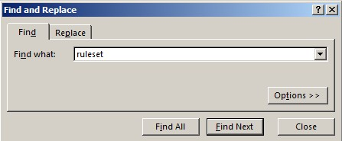



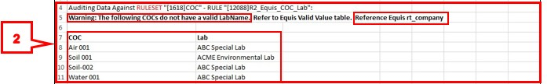The first two lines of the audit log will display the date and time the audit log was created and the full path to the Scribe project file being audited.

The example above depicts what is displayed in the audit log when an audit rule runs but does not meet the requirements being checked.

* Line 4 displays the rule name
* Line 5 indicates ***Warning*** which means that certain data in the Scribe project **did not** meet the requirements being checked. Continuing along line 5, the error indicates that “***The following COCs do not have a valid Lab Name****”.* At the end the error, direction is given as to where to look in the Scribe-SERAS-DataElementDictionary\_and\_Valid\_Values spreadsheet. Region 2 Superfund also has a process to request new Valid Values when necessary. Additional information on requesting a new Valid Value can be found at the following website: <https://www.epa.gov/superfund/region-2-superfund-electronic-data-submission>
* Lines 8 through 11 list the **Lab Names in Scribe that *do not* meet the valid value requirements**, as well as the COCs where those Labs have been assigned.

The next step would be to determine if ABC Special Lab and ACME Environmental Lab need to be added to the Region 2 Superfund valid value list or if those records need to be updated to reflect the naming convention used by Region 2 for those labs if they exist in the valid value list.

The example above depicts what is displayed in the audit log when an audit rule runs and meets the requirements being checked.

* Line 13 lists the rule name. **Data OK** is displayed at the end of the rule name, indicating that the **data in the Scribe project meets the requirements** being checked for that rule.
* Line 15 is another example of an audit log entry for a rule that meets the requirements being checked.

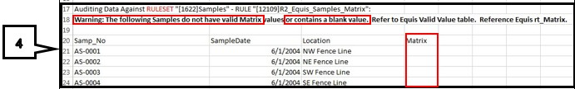The example above depicts what is displayed in the audit log when an audit rule runs but does not meet the requirements being checked.

* Line 17 displays the rule name
* Line 18 indicates ***Warning*** which means that certain data in the Scribe project **did not** meet the requirements being checked. Continuing along line 18, the error indicates that “*The following samples* ***do not have a valid Matrix or contain a blank value****”.* In addition to checking for valid values, the Auditor will also check for missing data in fields that Region 2 Superfund has deemed required for electronic data submission.
* Lines 21 through 24 list the **Samples that have a blank Matrix value**.

The next step would be to determine if valid values exist for the Matrix field and then update the Samples to include a valid Matrix

For a list of which fields are required when using Scribe to provide electronic data submission to ERT and the Region 2 Superfund program, refer to the “Required” column in the Scribe Data Elements tab in the spreadsheet below which is posted to the R2 Superfund category of the Scribe Website:

<https://response.epa.gov/sites/ScribeGIS/files/Scribe-SERAS-DataElementDictionary_and_Valid_Values.xlsx>

**Required Y/N/N-REF**

**Y = Required**. Auditor will check for “blanks” in this field.

**N = Not Required**. Auditor will not check these fields.

**N-Ref = Not required. However, if data is present, it needs to meet valid values**. Auditor will check these fields for valid values, but blanks are also valid.

Continue working from RULESET to RULESET until all of the audit log results have been reviewed/addressed.

IMPORTANT:If a large number of records do not meet the audit requirements, more than one audit log might be produced. Scribe will create an additional audit log if the number of records exceeds 50,000. Check the end of the audit log (Control + End in MS Excel) to see if an additional audit log file was created. If so, navigate to the directory where the Scribe Project is saved and open the additional audit log file. Continue to check each RULESET as above in the additional log file.

The image below depicts the type of message that will be displayed at the end of the first audit log file if an additional audit log file has been created.



# Exporting the R2 Superfund file from Scribe

## Exporting the R2 Superfund Custom Data View

The R2 Superfund Export from Scribe uses field caption names similar to the ASB Universal EDD but also translates certain fields to provide values expected by R2 Superfund.

Follow the steps below to export the R2 Superfund Export custom data view.

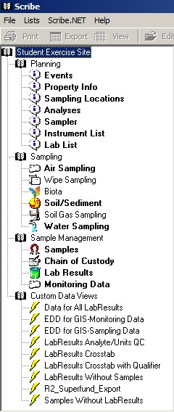

1. Click on **R2\_Superfund\_Export** under Custom Data Views in the left navigation bar.
2. The right side of the screen will display all of the lab results and associated information for the site. The total number of records will be displayed in the blue bar. Steps 3 through 7 below discuss filtering the data to include a particular subset of data rather than all of the data. Skip to Step 8 if filtering is not required.

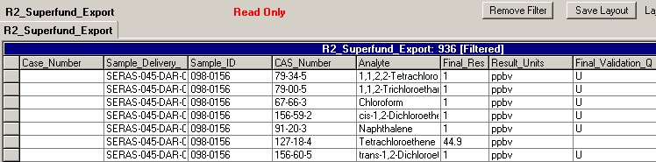

1. Click the **Filter** button in the menu bar



1. Click the drop down arrow next to the first “**And**” field and scroll down to select **EventID.**   
     
   *Note:* Any of the fields that are displayed when the drop down arrow is selected can be used for filtering purposes. For example, to filter by sample number instead of Event Id, select Scribe\_Sample\_Number from the drop down list or to filter on location, select Station\_Location from the drop down list.

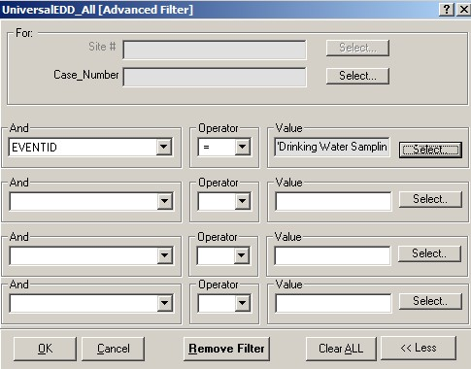

1. Select the **equal sign** (=) in the Operator field

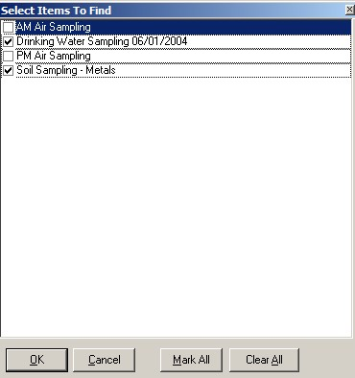

1. **Select the Events to be included** in the R2\_Superfund export by clicking in the box next to the Event name  
     
     
   Click **OK** when all of the desired events have been selected.
2. Click **OK** to apply the filter

Notice that the blue bar indicates that the record set is filtered and the number of records is fewer than what was originally listed before applying the filter.   
  
IMPORTANT. If the same data is loaded with two different units, only data in 1 set of units will be accepted by R2 Superfund. Filter the data for one unit value or the other.

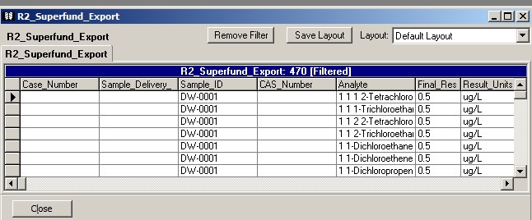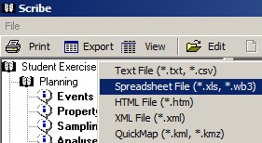

1. When the desired record set is displayed, click the ‘**Export’** button on the top menu bar.
2. Select ‘**Spreadsheet File** (\*.xls, \*.wb3)

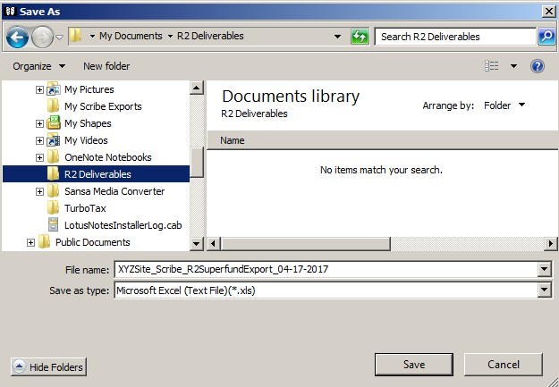

1. Navigate to a folder where the file will be saved. **Name the file.** The file name should include Site Name, Type of File and Submission Date. Click **Save** after naming the file. For example:  
   XYZsite\_Scribe R2Superfund Export\_04-17-2017.xls
2. MS Excel might automatically launch the file saved above. If an error appears after MS Excel starts, click **Yes** to continue. This error is generated because the file is saved with an .XLS file extension and the current version of MS Excel uses a .XLSX file extension. The .XLS format is accepted for submitting deliverables to EPA R2 Superfund.

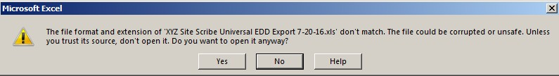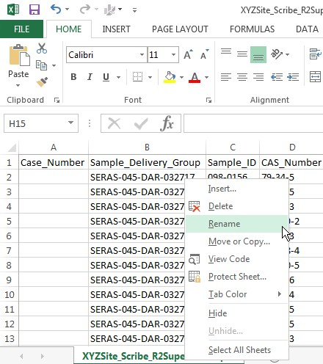

\

1. After the file opens in MS Excel, the worksheet tab name will need to be changed to “**CLP\_UF\_EDD**”  
   1. **Right-Click** on the **worksheet name tab** at the bottom of the screen.
   2. Select **Rename** from the context menu.
   3. ****Input the name **CLP\_UF\_EDD**
2. **Save** and close the file.  
   1. In MS Excel, click **File**
   2. Select **Save AS**
   3. Navigate to the folder where the file was originally saved
   4. Select the filename previously used and make sure to select the **Excel 97-2003 Workbook (\*.xls)** file type



# Submitting the R2 Superfund Export file to EPA R2 Superfund

## Frequency of Submittals

It is recommended that data be submitted to EPA R2 Superfund for each major sampling event. Specifically, when all Analytical Lab Results have been loaded to Scribe for a particular sampling event, the R2 Superfund exports should be generated and sent to EPA R2 Superfund using the guidelines outlined in the next section.

REMINDER: Before generating the files for submission, the Scribe project should be checked against the ERT-SERAS\_R2 auditor rules and any deficiencies should be addressed and remedied before submitting files.

## Guidelines for Submittals

EPA Region 2 Superfund has well-documented steps for submitting files. These steps can be referenced at the following website: <https://wcms.epa.gov/superfund/region-2-superfund-electronic-data-submission>

The steps for Scribe submittals to EPA Region 2 Superfund differ somewhat from the standard guidance referenced above. As such, below is an overview of how to submit files from Scribe to EPA Region 2 Superfund.

1. Preferred submission method:

It is preferred to submit by e-mail to Region2\_EQUISedd@epa.gov. E-mail submittals may be provided with cc: to the Remedial Project Manager (RPM) and ERT Work Assignment Manager (WAM) as appropriate.

1. Information to include with submission:  
   1. **Cover Letter**

Each EDD must be accompanied by a cover letter that specifies the name of the site, the contact for any EDD technical questions regarding file names, any exceptions to the EDD format, and any requests for additional valid values, etc.

* 1. **R2 Superfund** export files from Scribe.

Files should be named with the Site Name, Type of File and Submission Date.  
   
Example R2 Superfund file name: XYZsite\_Scribe R2Superfund\_07-21-2016.XLS

* 1. **New Valid Value Requests**

A request for new valid values should be included along with the cover letter and data files. In addition, the new valid values should be sent to ERTSupport@EPA.Gov to insure the Scribe Auditor is up to date with new values. The following PDF file should be used to request new valid values: <https://www.epa.gov/sites/production/files/2015-10/documents/valid_values_request_form_feb2010.pdf>

The data provider should explicitly state the valid value that she/he would like added, provide a description of the value, and explain why the addition is necessary. In the case of requesting a new laboratory code, the data provider should include the full name of the laboratory and its address. When requesting an addition of an analyte, the data provider must include the appropriate CAS number or ERPMS code along with a description of the analyte.

* 1. **Large Files**

Larger files should be zipped and the file extension renamed from .zip to .piz. The file limit for EPA is 25mb.

1. Additional Information on Submission Types:

There are three possible EDD submittal types: an original submittal, an error correction resubmittal, and an update submittal. These three EDD types are described below.

* 1. **Original Submittal**: An original EDD submittal contains data being submitted for the first time to EPA Region 2. EPA Region 2 will process and check the EDD. If there are no errors in any of the EDD files, EPA will import the data to the permanent database. EPA Region 2 can only import and accept the EDD submittal if all files in the submittal are error-free. If any of the files on the EDD contain errors, EPA will send the data provider a letter specifying the errors that need to be corrected.
  2. **Correction Resubmittal**: In the case where an original EDD submittal contains errors, the entire EDD submittal will be returned to the data provider along with an error report explaining the problems identified. The data provider should then correct the errors, and then resubmit the entire EDD. A response is required within 30 days. It is important that the resubmitted EDD contain all of the files and the SAME FILE NAMES (i.e., use the same site name and submittal date in the file name as was used in the original submittal) as those in the original submittal. Thus, the EDD resubmittal will be identical to the original submittal in every way except the errors are corrected.
  3. **Update Submittal**: This type of submittal updates data that has previously been accepted by EPA Region 2. The files of an update submittal should follow the normal naming convention of an EDD submittal and contain only data for the records being updated. The update submittal would be named using the current submittal date of the update. Note: All required fields need to be populated for the update regardless of whether or not these fields were updated. The reason for the update submittal and the records that have been changed must be clearly indicated in the cover letter accompanying the updated EDD.

# References

Scribe Website: <https://epaosc.org/scribe>

R2 Superfund Scribe Details: [https://www.epaosc.org/site/doc\_list.aspx?site\_id=ScribeGIS&Category=R2 Superfund](https://www.epaosc.org/site/doc_list.aspx?site_id=ScribeGIS&Category=R2%20Superfund)

US EPA Region 2 Superfund Electronic Data Submission

[**https://www.epa.gov/superfund/region-2-superfund-electronic-data-submission**](https://www.epa.gov/superfund/region-2-superfund-electronic-data-submission)

US EPA Analytical Services Branch: [**https://www.epa.gov/clp**](https://www.epa.gov/clp)

* Information on the UniversalEDD and COC XML

EQuIS: [**http://earthsoft.com/**](http://earthsoft.com/)

* Information on the EQuIS software used as a data repository by the EPA Region 2 Superfund program.

# Check List

|  |  |  |
| --- | --- | --- |
| **Checklist for Submitting SERAS Scribe data to R2 Superfund** | | **✓ Completed** |
| **Step 1** | Add the R2 Superfund Export Custom Data Views to the Scribe project (User Manual p. 4 through 7) |  |
| * Download the SERAS\_R2\_Superfund\_Scribe3\_Template.mdb file from response.epa.gov/scribe * Import 4 Custom Data Views |  |
| **Step 2** | Audit the Scribe project using the ERT-SERAS\_R2 auditor rules. (User Manual p. 8 through 14) |  |
| * Correct/Update the Scribe project as needed * Note any new Valid Values that need to be added |  |
| **Step 3** | Export the R2 Superfund Custom Data View (User Manual p. 15 through 18) |  |
| * Filter the export for the appropriate event/s * Filter for one “data set” (if results are loaded in two different units) * Export as a Spreadsheet File (\*.xls) * Name the File (XYZ Site\_ScribeR2SuperfundExport\_07-21-2017.xls) * Open the Spreadsheet and rename the Tab to CLP\_UF\_EDD * Save As Excel 97-2003 Workbook (\*.xls) file |  |
| **Step 4** | Submit the R2 Superfund Export file to EPA R2 Superfund (User Manual p. 19 & 20) |  |
| * Prepare a Cover Letter * Prepare any needed new Valid Value Requests * E-Mail Cover Letter, Scribe Export files, Valid Value Requests to [Region2\_EQUISedd@epa.gov](mailto:Region2_EQUISedd@epa.gov). * Valid Value request should also be e-mailed to [ERTSupport@epa.gov](mailto:ERTSupport@epa.gov) so Scribe Audit files can be updated to include new value/s. |  |